(a) Gary and Jessica are learning about the harmful effects of smoking.
They read the warning on a packet of cigarettes.
How can smoking affect your lungs?
.....................................................................................................
1 mark
(b) Gary and Jessica ask four adults their lifestyles.
The table shows what they find out.

Name | Smokes | Has healthy diet | Takes regular exercise
Sanjay | No | Yes | Yes
Carl | Yes | Yes | Yes
Fatima | No | Yes | No
Helen | Yes | No | No
Which adult listed in the table is most likely to develop heart disease?
...................................................................................................................... 1 mark
(c) This graph shows how the number of adults smoking changed between 1974 and 1994.
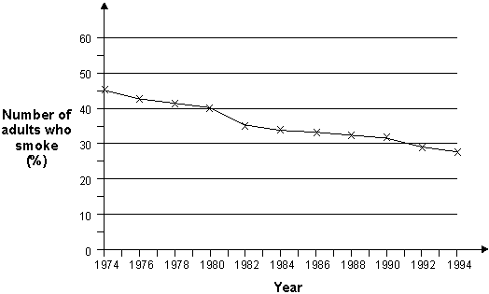
(i) Use the graph to describe the change in the number of adults who smoked
between 1974 and 1994.
...........................................................................................................
............................................................................................................. 1 mark
(ii) Give ONE possible reason for this change.
............................................................................................................
.............................................................................................................. 1 mark

MARK SCHEME
(a) Award ONE mark for describing a long-term, adverse effect of smoking on the lungs:
- Smoking damages the lungs;
- smoking gives you lung cancer;
- smoking causes bronchitis/emphysema;
- it can damage your breathing;
- tar blocks/gets into the lungs;
- it makes you cough;
- it makes the lungs dirty/black.
Allow:
• it stops your lungs working (properly);
• it’s bad for them.
Do not give credit for an insufficient response:
• smoking affects your breathing / smoke gets into the lungs
[not clear whether effects are positive or damaging];
• tar [does not indicate any effect];
• nicotine gets into your lungs
[nicotine does not directly affect the lungs];
• it makes them smaller.
Do not give credit for a response that implies an immediate effect:
• it stops you breathing.
Do not give credit for a response not related to the lungs:
• it kills you;
• it causes heart disease.
1
(b) Award ONE mark for:
• Helen.
1
(c) (i) Award ONE mark for a recognition that the number of smokers has
generally decreased:
• the number of smokers has gone down;
• more people stopped smoking.
Allow:
• a numerical response that implicitly indicates the downward trend:
• it has changed from 46 (± 2) to 27 (± 2);
• it changed/went down by 19 (± 2).
Do not give credit for a response related to how much people smoke [not given on graph]:
• in 1994 people did not smoke as much.
Do not give credit for a numerical response that implies an upward trend:
• it went up by 19;
• it changed from 27 to 46.
1

(ii) Award ONE mark for an understanding that knowledge of the effects of smoking has increased:
• some/many people have realised that smoking is bad for their health
(and have given up);
• people have learned that it is bad for them;
• people are more aware of what it does to you;
• there are warnings on the boxes now.
Allow:
• fewer people have started smoking;
• people cannot afford cigarettes.
Do not give credit for a response that is insufficient or fails to identify a change in people’s decisions about smoking:
• it is bad for you/your health;
• some smokers died;
• some/many smokers got cancer;
• people want to be more healthy;
• ‘no smoking signs’ became more common;
• people have less money [this makes no reference to
cigarettes or smoking];
• cigarettes became more expensive.
1
[4]
EXAMINER COMMENT - Smoking and Health
(a) This question probed understanding of the harmful effects on the lungs of smoking. Overall almost three-quarters gained credit. About a half of those achieving level 3 overall gained credit and three-quarters of those working at level 4. The most common response expressed by about one fifth of children was to suggest that smoking causes cancer. Some suggested smoke blocks the lungs or makes them black. About a sixth suggested that breathing is impaired as a result of smoking. About one sixth of those achieving level 3 overall failed to gain credit because they offered a general response which did not specifically refer to the effects of smoking on the lungs such as ‘smoking kills you’. Others failing to gain the mark tended to indicate that people breathe in smoke without indicating an effect.
(b) This item invited children to compare data presented in a table to judge who in the table would be most likely to develop heart disease. Two-thirds of those at level 3 and almost all of those achieving levels 4 and 5 overall made a correct identification. Most of the error was due to children selecting ‘Carl’ who (along with Helen) was described in the table as a smoker.
(c) (i) This item required children to describe the trend in data presented in a line graph. Overall about three-quarters were awarded the mark for correctly suggesting that the percentage of adult smokers had decreased. About one-third of those achieving overall level 3 scored the mark. Most of the incorrect responses were due to suggestions of an incorrect numerical trend which tended to be offered by children at any of the three overall levels of achievement.
(ii) Children were asked to explain the data presented in the line graph. Overall about half were awarded the mark. The most common creditworthy response was to suggest that an increased awareness that smoking is bad for people had led to a decrease in the number of smokers. Two-thirds of children achieving overall level 5 showed awareness of this health education message. One of the most common errors expressed at all overall levels of attainment was to suggest that smokers had died. This reveals a failure to appreciate that the graph describes a proportion of a changing population, not changes in a fixed graph.

