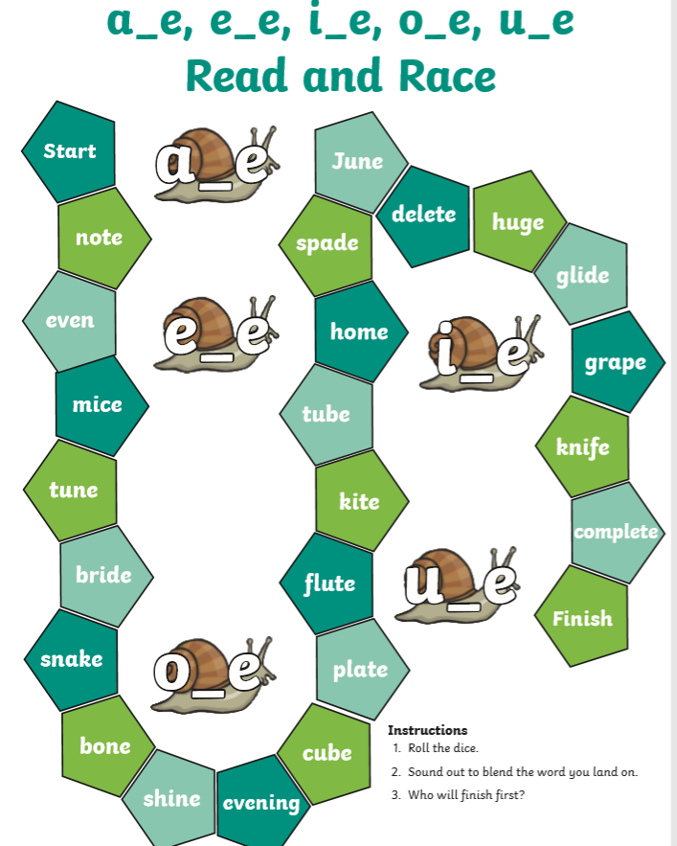
Challenge your brother/sister or parents to this

