2020 Multiples, factors and primes – trickier practice! Try 2 or more
Q1.
Write a cross on the numbers that are not square numbers.
1² 2³ 3³ 4³ 5³
1 mark

Q2.
This three-digit number has 2 and 7 as factors.
2 9 4
Write another three-digit number which has 2 and 7 as factors.

1 mark

Q3.
Put these values in order with the smallest first

 | 5² | 3² | 3³ | 2³
 | smallest |  |  | largest

1 mark

Q4.
The factors of 11 sum to 12
Write the other number whose factors sum to 12
1 mark

Q5.
The three numbers missing from these boxes are all prime numbers greater than 3
Write in the missing prime numbers.

 |  | × |  | × |  | = | 1001

1 mark

Q6.
Here are three digit cards
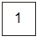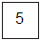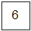
Choose two cards each time to make the following two-digit numbers.
The first one is done for you.

an even number
an prime number
a common factor of 60 and 90
a common multiple of 5 and 13

2 marks

Q7.
Look at this expression.
10y + 2
When y = 0.4, the value of 10y + 2 is an even number because 10 × 0.4 + 2 = 6

Write a value for y so that 10y + 2 is a prime number.
1 mark

Now write a value for y so that 10y + 2 is a square number.
1 mark

Q8.
n and p stand for two numbers.
n is a multiple of 5
p is a multiple of 6
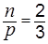
Find numbers that n and p stand for.

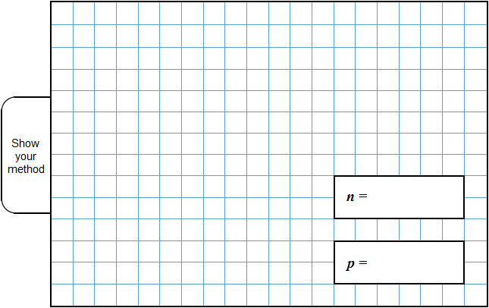
2 marks

Q9.
P stands for a multiple of 3
Q stands for a different multiple of 3
Tick (✔) each statement according to whether it is always true, sometimes true or never true.

 |  | always  true | sometimes  true | never  true
 | The sum of P and Q is a multiple of 6
 | The difference between P and Q is a multiple of 3
 | The product of P and Q is a multiple of 9

2 mark

M1.1³ 4³
Accept any unambiguous indication
[1]

M2. Any 3-difit number that is a multiple of 14, eg:
Any acceptable answers will be even numbers which divide by 7
Do not accept ‘0’ in the hundreds box.
Only three digit numbers are acceptable.
[1]

M3.2³ 3² 5² 3³
Accept 8, 9, 25, 27
[1]

M4. 6
U1
[1]

M5.
OR any permutation of these
Accept answers elsewhere on the page if boxes are blank.
[1]

M6.All three correct
61
15
65
2
or
Any two correct
1
[2]

M7. (a) Gives a value for y such that 10y + 2 is a prime number, eg:
• 0
•
• 1.7
1

(b) Gives a value for y such that 10y + 2 is a square number, eg:
• -0.1
• 0.2
• 0.7
• 1.4
1
[2]

M8.Award marks as shown below for values of n and p
which meet the following criteria:

 |  | n:p
 |  | 2:3 | 3:2
 | n is multiple of 5  and  p is multiple of 6 | 2 marks  [A] | 1 mark  [C]
 | n is multiple of 5  or  p is multiple of 6 | 1 mark  [B] | 0 marks

The following examples are worth 2 marks:
• n = 20 and p = 30 [A]
• n = 80 and p = 120 [A]
! For 2m or 1m, accept multiple answers provided all meet the requirements for the mark(s) and are clearly distinguishable as separate answers, eg for 2 marks
• n = 20, 40, 60
p = 30, 60, 90
2

or
The following examples are worth 1 mark:
• n = 5 and p = 7.5 [B]
• n = 10 and p = 15 [B]
• n = 4 and p = 6 [B]
• n = 90 and p = 60 [C]

OR
Shows or implies a method for rearranging 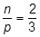
which moves p from the denominator, eg:
• 3n = 2p
• 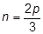

OR
Shows or implies a complete correct method, eg:
• 2 × 5 × 6 : 3 × 5 × 6
! For 1m, condone a list of at least five additional ratios or fractions equivalent to with none incorrect
1
[2]

M9. Award TWO marks for the table completed correctly as shown:
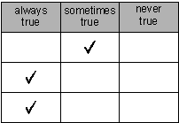
If the answer is incorrect, award ONE mark for two out of three ticks correctly placed.
Accept alternative indications, eg crosses in the table.
Do not accept any row that has ticks in more than one column.
Up to 2
[2]

