2020 Multiples, factors and primes numbers revision
Q1.
Write all the common multiples of 3 and 8 that are less than 50
________________________________________________
1 mark

Q2.
Complete this sentence.
Every number with a factor of 10 must also have factors of

1 mark

Q3.
Here are five number cards.

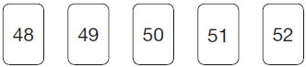

Use each card once to make every statement below correct.

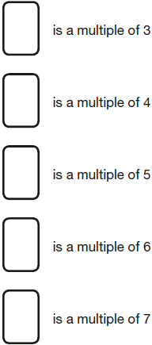
2 marks

Q4.

 | 23 | × | 36 | = | 23 | × | 9 | ×

1 mark

Q5.
Circle one number on the grid which can be divided by 9 with a remainder of 1

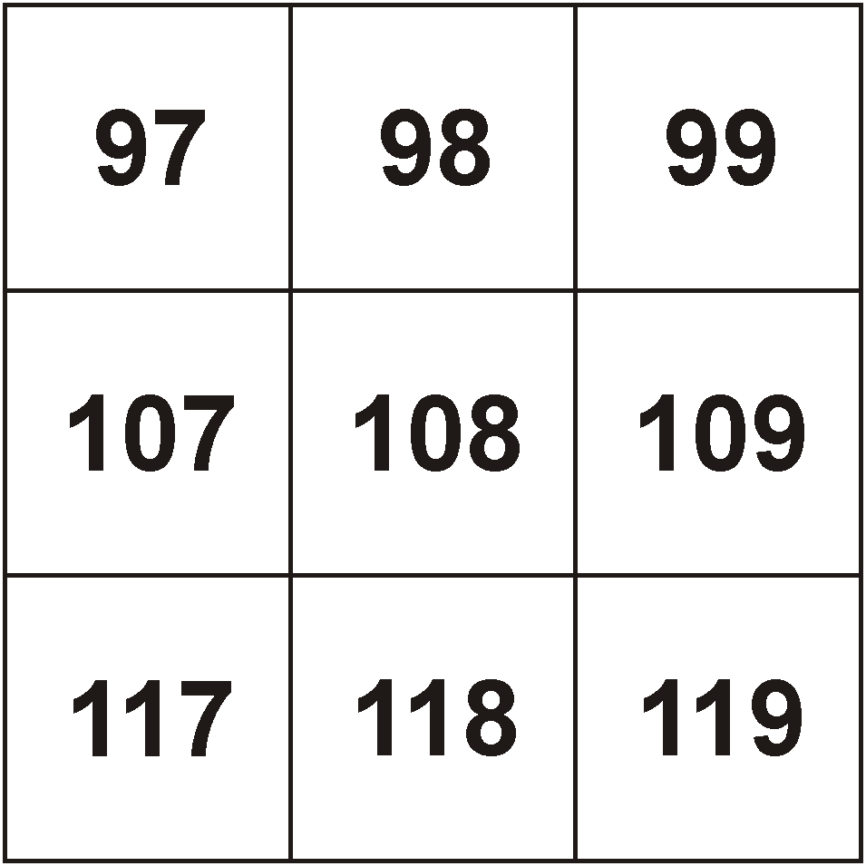
1 mark

Q6.
Here is a Venn diagram for sorting numbers.
Write each number in its correct place on the diagram.

10 11 12 13

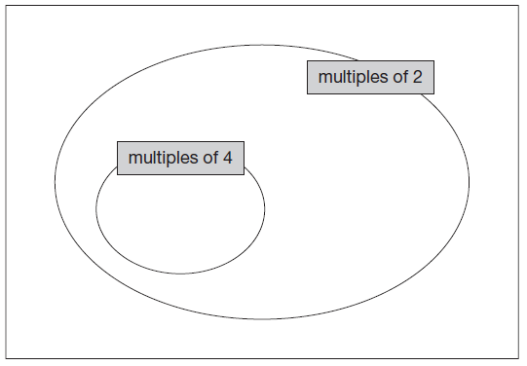
2 marks

Q7.
Here is a diagram for sorting numbers.
Write one number in each white section of the diagram.

 |  | less  than 1000 | 1000  or more
multiples
of 20
not multiples
of 20

2 marks

Q8.
Write all the factors of 30 which are also factors of 20
___________________________________________________________________
2 marks

Q9.
Here is a number chart.
Circle the smallest number on the chart that is a multiple of both 2 and 7

 | 71 | 72 | 73 | 74 | 75 | 76 | 77 | 78 | 79 | 80
 | 81 | 82 | 83 | 84 | 85 | 86 | 87 | 88 | 89 | 90
 | 91 | 92 | 93 | 94 | 95 | 96 | 97 | 98 | 99 | 100

1 mark

Here is the same number chart.
Circle the largest number that is not a multiple of 2 or 3 or 5

 | 71 | 72 | 73 | 74 | 75 | 76 | 77 | 78 | 79 | 80
 | 81 | 82 | 83 | 84 | 85 | 86 | 87 | 88 | 89 | 90
 | 91 | 92 | 93 | 94 | 95 | 96 | 97 | 98 | 99 | 100

1 mark

Q10.
Amir says,
‘All numbers that end in a 4 are multiples of 4’.
Is he correct?
Circle Yes or No. Yes / No
Explain how you know.

1 mark

M1.
24 AND 48 only
Numbers may be given in either order.
[1]

M2. 1, 2 and 5
Numbers may be given in any order.
[1]

M3.Award TWO marks for the correct answer as shown:
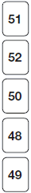

If the answer is incorrect, award ONE mark for 4 true statements
with no number repeated (within those 4), eg:
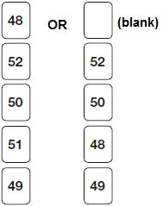
Do not accept numbers other than those given.
(Multiple of 3 can be 48 OR 51)
(Multiple of 4 can be 48 OR 52)
Up to 2
U1
[2]

M4.4
[1]

M5. 109 OR 118 circled.
Accept both 109 and 118 circled.
[1]

M6. Award TWO marks for all four numbers correctly placed as shown:
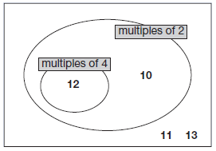
If the answer is incorrect, award ONE mark for three numbers correctly placed.
Accept alternative unambiguous indications, eg lines drawn from the numbers to the appropriate regions of the diagram.
Do not accept numbers written in more than one region
Up to 2
[2]

M7. Award TWO marks for one correct number written in each white
section of the table, eg

 | less  than 1000 | 1000  or more
multiples  of 20 | 100 | 2000
not multiples  of 20 | 19 | 1001

If the answer is incorrect, award ONE mark for three sections completed correctly.
Accept more than one number in each section as long as all are correct.
Up to 2
[2]

M8. Award TWO marks for all four factors, as shown:
1, 2, 5, 10
If the answer is incorrect, award ONE mark for:
• three factors correct and none incorrect

OR
• four factors correct and one incorrect.
Accept factors written in any order.
All four factors and no incorrect numbers must be given for the award of TWO marks.
Up to 2
[2]

M9. (a)
71 | 72 | 73 | 74 | 75 | 76 | 77 | 78 | 79 | 80
81 | 82 | 83 |  | 85 | 86 | 87 | 88 | 89 | 90
91 | 92 | 93 | 94 | 95 | 96 | 97 | 98 | 99 | 100

1

(b)
71 | 72 | 73 | 74 | 75 | 76 | 77 | 78 | 79 | 80
81 | 82 | 83 | 84 | 85 | 86 | 87 | 88 | 89 | 90
91 | 92 | 93 | 94 | 95 | 96 |  | 98 | 99 | 100

Do not award the mark if more than one number is circled.
Accept alternative unambiguous indications, eg numbers ticked, crossed or underlined.
1
[2]

M10. An explanation which gives a counter-example to illustrate that not all numbers
ending in 4 are multiples of 4, eg:
• ‘14 is not a multiple of 4’
• ‘4, 24 and 44 are multiples of 4, but not 14 and 34’
• ‘14 or 34 don’t work’
• ‘54’

OR
an explanation which recognises that only numbers ending in 4 which have
an even number of tens are multiples of 4, eg:
• ‘It has to have an even number of 10s as well, like 20 or 40’
• ‘14, 24, 34, 44, 54, 64 – only half of them are’
• ‘4 doesn’t go into 10 so 14 isn’t’.
No mark is awarded for circling ‘No’ alone.
Do not accept vague or incomplete explanations, eg:
• ‘Some numbers end in a 4 but aren’t multiples of 4’
• ‘16 doesn’t end in 4’
• ‘Not all multiples of 4 end in 4’
• ‘24 is a multiple of 4 but the next one isn’t’
• ‘4, 8, 12, 16, 20, 24 etc’.
If ‘Yes’ is circled but a correct, unambiguous explanation is given, then award the mark.
U1
[1]

