Word problems practice – optional (tricky)
Q1.
6 small bricks have the same mass as 5 large bricks.
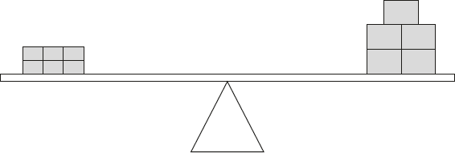
The mass of one small brick is 2.5 kg.
What is the mass of one large brick?
2 marks

Q2.
Lara had some money.
She spent £1.25 on a drink.
She spent £1.60 on a sandwich.
She has three-quarters of her money left.
How much money did Lara have to start with?
2 marks

Q3.
Alfie has two sticks.
He puts them end to end.
Not actual size
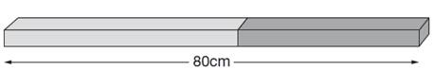
One stick is 10cm longer than the other stick.
How long are the two sticks?

2 marks

Q4.
This fence has three posts, equally spaced.

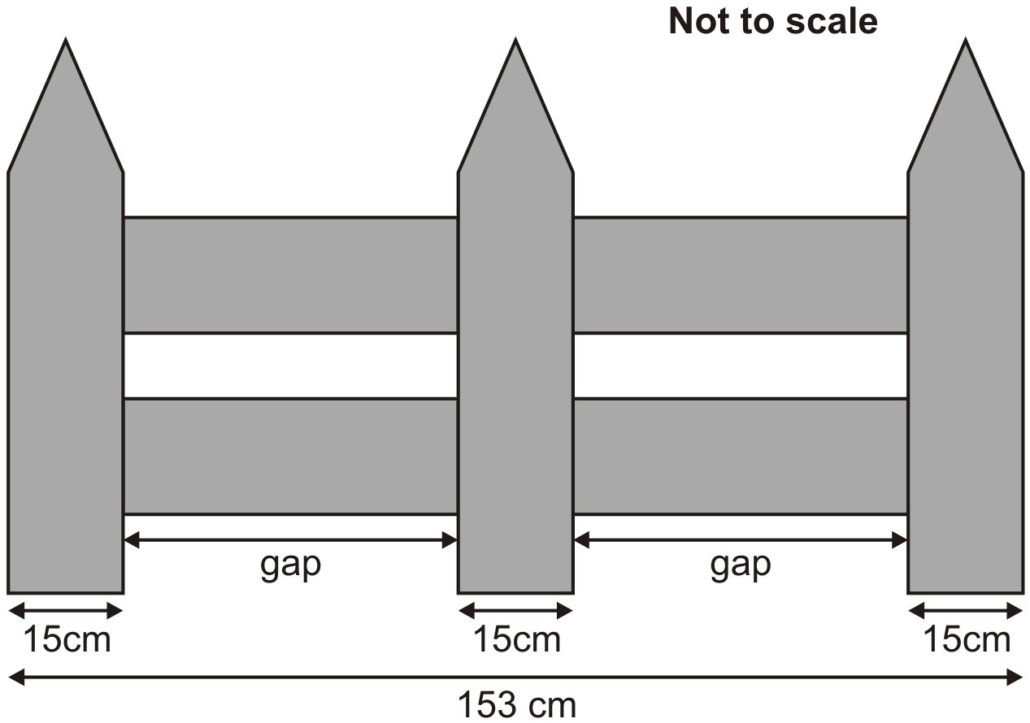
Each post is 15 centimetres wide.
The length of the fence is 153 centimetres.

Calculate the length of one gap between two posts.

2 marks

Q5.
A 5p coin has a diameter of 1.8 centimetres.
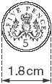
Holly makes a straight line of 5p coins worth £10

 | £10 | 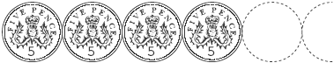

How long is Holly’s line?
Give your answer in metres.

2 marks

Q6.

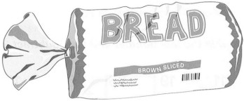
Every 100 g of brown bread contains 6 g of fibre.
A loaf of bread weighs 800 g and has 20 equal slices.
How much fibre is there in one slice?

2 marks

Q7.
Sarah, Amy and Liam stand on some weighing scales two at a time.

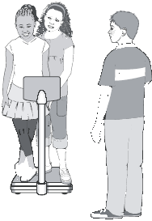
Here are the measurements:
Sarah and Amy 70 kg
Sarah and Liam 80 kg
Liam and Amy 80 kg

How much does Liam weigh?

2 marks

Q8.
 | A school buys some yo-yos as prizes.  The yo-yos cost £4.25 each.  The school has £40 to spend on prizes. | 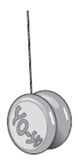

They buy as many yo-yos as they can.
How much money is left?

2 marks

Q9.
The area of a rugby pitch is 6,108 square metres.
A football pitch measures 112 metres long and 82 metres wide.
How much larger is the area of the football pitch than the area of the rugby pitch?

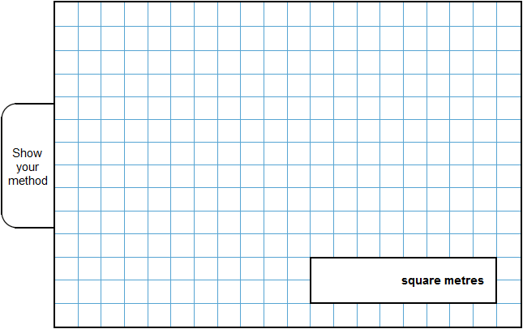
3 marks

Q10.
This is Kirsty’s recipe for breakfast cereal.
50 grams of oats  30 grams of raisins  40 grams of nuts | 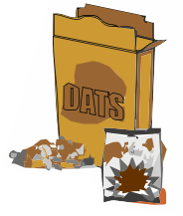

If she uses 125 grams of oats, how many grams of raisins does she need?

2 marks

Q11.
Lili and Julian each start with the same number.
Lili works out half of the number.
Julian works out three-quarters of the number.
The sum of their answers is 275
What was the number they started with?

2 marks

Q12.

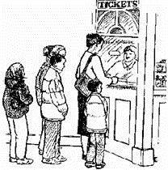
Two families go to the cinema.
The Smith family buy tickets for one adult and four children and pay £19

The Jones family buy tickets for two adults and two children and pay £17
What is the cost of one child's ticket?

2 mark

Q13.
What is the value of u in this equation?
5u – 10 = u + 46

2 mark

Q14.
Here is a trapezium with a height of 10 centimetres.

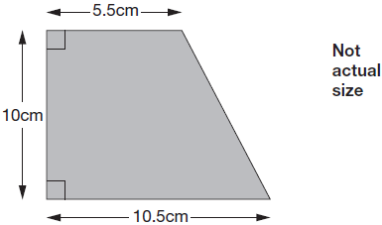
The parallel sides are 5.5cm long and 10.5cm long.

Find the area of the trapezium.

2 marks

M1.
Award TWO marks for the correct answer of 3.
If the answer is incorrect, award ONE mark for evidence of an appropriate method, e.g.
• 2.5 × 6 = 15
15 ÷ 5
Answer need not be obtained for the award of ONE mark.
Misreads are not allowed.
Up to 2m
[2]

M2.
Award TWO marks for the correct answer of £11.40.
If the answer is incorrect, award ONE mark for evidence of an appropriate method, e.g.
• £1.25 + £1.60 = £2.85
£2.85 × 4
Accept for ONE mark an answer of £1,140 OR £1,140p OR £11.4 as evidence of an appropriate method.
Answer need not be obtained for the award of ONE mark.
Up to 2m
[2]

M3.Award TWO marks for the correct answer of 45 AND 35
If the answer is incorrect, award ONE mark for:
■ either 35 OR 45

OR
■ evidence of appropriate working, eg
80 – 10 = 70
70 ÷ 2 = 35
35 + 10 = wrong answer
Numbers may be given in either order.
Working must be carried through to reach
an answer for the award of ONE mark.
Up to 2m
U1
[2]

M4. Award TWO marks for the correct answer of 54
If the answer is incorrect, award ONE mark for evidence of appropriate method, eg
• 153 – (3 × 15) = 108
• 108 ÷ 2
Answer need not be obtained for the award of ONE mark.
Up to 2 (U1)
[2]

M5. Award TWO marks for the correct answer of 3.6
If the answer is incorrect, award ONE mark for evidence of an appropriate method, eg:
• 10 ÷ 0.05 = 200
200 × 1.8 = 360
360 ÷ 100
OR
• 20 5p coins make £1
200 5p coins make £10
200 × 0.018
Answer must be in metres for the award of TWO marks.
Accept for ONE mark 360 centimetres.
If the answer is incorrect, accept for ONE mark an answer of 36 multiplied by any power of 10 with no evidence of an incorrect method.
Answer need not be obtained for the award of ONE mark.
Up to 2
[2]

M6. Award TWO marks for the correct answer of 2.4
If the answer is incorrect, award ONE mark for
evidence of appropriate method, eg
6 × 8 = 48 (48 g fibre in one loaf)
48 ÷ 20
OR
800 ÷ 20 = 40 (one slice weighs 40 g)
6% of 40
Answer need not be obtained for the award of ONE mark.
Up to 2
[2]

M7. Award TWO marks for the correct answer of 45
If the answer is incorrect, award ONE mark for evidence of appropriate method, eg:
• 70 ÷ 2 = 35
80 – 35
OR
• 80 – 70 = 10
70 ÷ 2 = 35
35 + 10
OR
• 80 + 80 = 160
160 – 70 = 90
90 ÷ 2
OR
• 80 + 80 + 70 = 230
230 ÷ 2 = 115
115 – 70
Answer need not be obtained for the award of ONE mark.
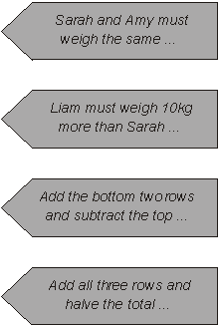
Up to 2 (U1)
[2]

M8. Award TWO marks for the correct answer of £1.75
If the answer is incorrect, award ONE mark for evidence of appropriate method, eg:
• 40 ÷ 4.25 = 9.411…
4.25 × 9 = 38.25
40 – 38.25
OR
• 10 yo-yos cost £42.50
9 yo-yos cost £42.50 – £4.25 = £38.25
£40 – £38.25
Accept for ONE mark £175 OR £175p OR 1.75p as evidence of appropriate method.
Accept for ONE mark sight of £38.25 OR 38.25 OR 3825
Answer need not be obtained for the award of ONE mark.
Up to 2
[2]

M9.Award THREE marks for the correct answer of 3076 square metres.
If the answer is incorrect, award TWO marks for:
• sight of 9184 as evidence of the multiplication for the first step completed correctly.

OR
• evidence of an appropriate method which contains no more
than ONE arithmetical error, e.g:
112
× 82
8960
224
9187 (error)
9187
− 6108
3079

• Award ONE mark for evidence of an appropriate method which contains more than ONE arithmetical error.
Do not award any marks if the error is in the place
value of the multiplication, e.g. the omission of the final zero when multiplying by tens, e.g.
112
× 82
896
224
wrong answer
Commentary: As well as a range of 1 mark and 2 mark questions,
one of the questions in a suite of tests may now attract three marks.
The solution to a 3 mark question may involve more steps or, as in
this example, more complex calculations.
Up to 3m
[3]

M10.Award TWO marks for the correct answer of 75
If the answer is incorrect, award ONE mark for evidence of appropriate working, eg:
■ 125 ÷ 50 = 2.5
2.5 × 30 = wrong answer
OR
■ 50g oats 30g raisins
25g oats 15g raisins (÷ 2)
125g oats wrong answer (× 5)
Working must be carried through to reach an answer for the award of ONE mark.
Up to 2
[2]

M11. Award TWO marks for the correct answer of 220
If the answer is incorrect, award ONE mark
for evidence of an appropriate method, eg
275 ÷ 5 × 4
Answer need not be obtained for the award of the mark.
Up to 2
[2]

M12. Award TWO marks for a correct answer of £3.50
If the answer is incorrect, award ONE mark for evidence of an appropriate
method, eg
• adult + child is £17 ÷ 2 = £8.50
adult + 4 children is £19, so 3
children cost £10.50, so 1 child costs £10.50 ÷ 3
• 2 adults + 8 children = £38.00
6 children cost £21, so 1 child costs £21 ÷ 6
Accept for TWO marks £3 50 OR £3-50 OR £3.50p
Accept for ONE mark £3.5 OR £350p OR £350 OR similar as evidence of appropriate working.
Calculation need not be completed for the award of the mark.
Up to 2
[2]

M13. Award TWO marks for the correct answer of 14
If the answer is incorrect, award ONE mark for evidence of an appropriate
method, eg
algebraic manipulation to reach
4u = 56
Calculation need not be completed for the award of the mark.
Accept for ONE mark trial and improvement showing two convergent attempts or two attempts which straddle the correct value and which are within the range 11–17 OR one error in the collection of terms.
Up to 2
[2]

M14.80
! Measures
2

or
Shows or implies a complete correct method, eg:
• (10 × 10.5) – (× 10 × 5)
• (5.5 + 10.5) × 10
• (10 × 5.5) + (× 10 × 5) = 55 + 22.5 (error)
1
[2]

