Word problems revision 2020
Q1.
Olivia buys three packets of nuts.
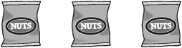
She pays with a £2 coin.
This is her change.
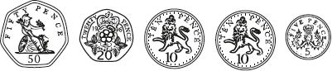
What is the cost of one packet of nuts?
2 marks

Q2.
A toy shop orders 11 boxes of marbles.
Each box contains 6 bags of marbles.
Each bag contains 45 marbles.
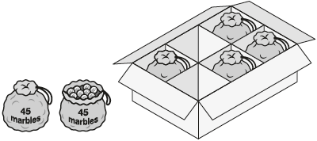
How many marbles does the shop order in total?
2 marks

Q3.
Lara chooses a number less than 20
She divides it by 2 and then adds 6
She then divides this result by 3
Her answer is 4.5
What was the number she started with?
2 marks

Q4.
Large pizzas cost £8.50 each.
Small pizzas cost £6.75 each.
Five children together buy one large pizza and three small pizzas.
They share the cost equally.
How much does each child pay?

2 marks

Q5.
This table shows the distances in kilometres between five towns.

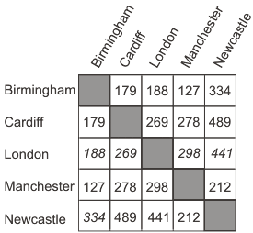
Use the table to find the distance from London to Manchester.
1 mark

James goes from Newcastle to Birmingham, and then on to Cardiff.
How many kilometres does he travel?

2 marks

Q6.
Eggs are put in trays of 12

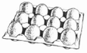

The trays are packed in boxes.

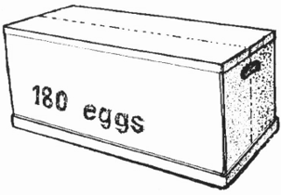

Each box contains 180 eggs.
How many trays are in each box?

2 mark

Q7.
Mr Singh buys paving slabs to go around his pond.

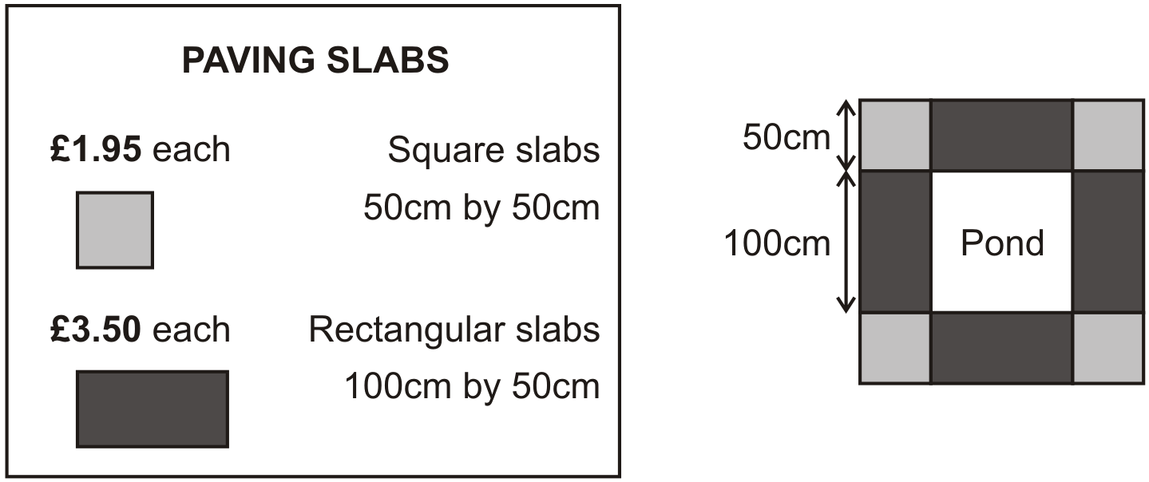

He buys 4 rectangular slabs and 4 square slabs.
What is the total cost of the slabs he buys?

2 marks

Mr Singh says,
'It would cost more to use square slabs all the way round'.
Explain why he is correct.
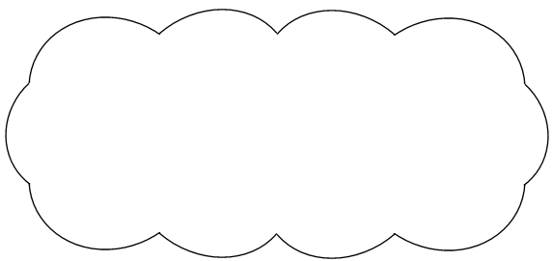
1 mark

Q8.
A shop sells food for birds.

 | 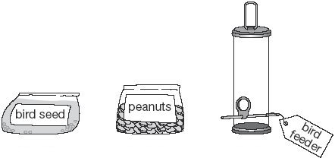
 | £3.79 for a bag | £1.35 for a bag | £8.95 each

Lara has £10 to spend on peanuts.
How many bags of peanuts can she get for £10?
1 mark

Amir has £20
He wants to buy a bird-feeder and 4 bags of bird seed.
How much more money does he need?

2 marks

Q9.
Amir has three parcels.
Parcels A and B together weigh the same as parcel C.
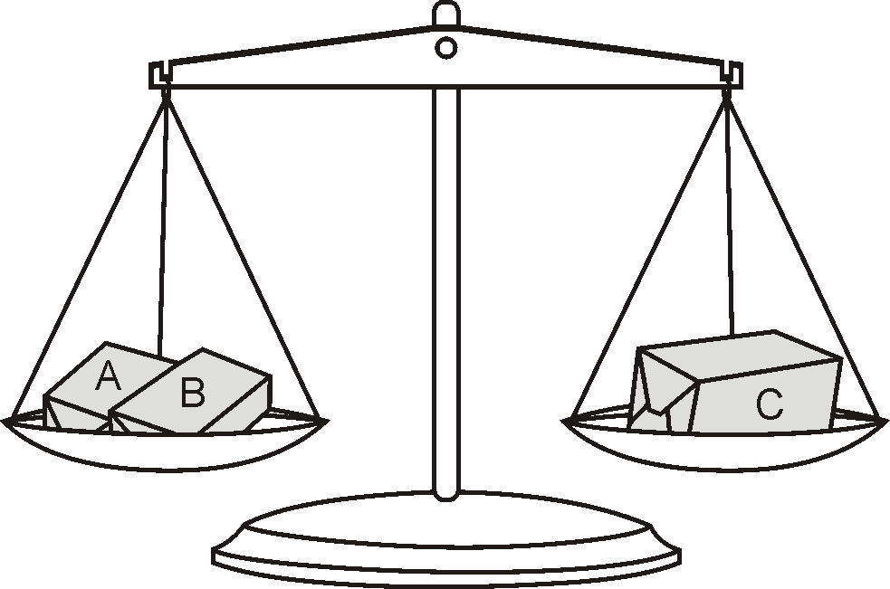

The three parcels weigh 800 grams altogether.
Parcel A weighs 250g.
How much does parcel B weigh?

2 marks

Q10.
An iced cake costs 10p more than a plain cake.
Sarah bought two of each cake.

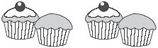
They cost £1 altogether.
What is the cost of an iced cake?

2 marks

Q11.
A shop sells jars of honey and honey dippers.

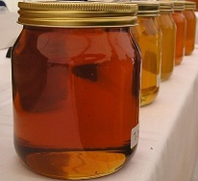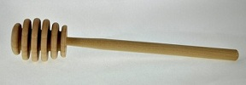
Chen bought three jars of honey and a dipper.
The total cost was £5.40
The dipper cost 75p.
How much did each jar of honey cost?

2 marks

Q12.
200 children went on holiday.
10% of the children went to Wales.
25% of the children went to Scotland.
How many more children went to Scotland than went to Wales?

2 marks

Q13.
Lara chooses a number less than 100
She divides it by 3 and then subtracts 11
She then divides this result by 2
Her answer is 10.5
What was the number she started with?

2 marks

M1.
Award TWO marks for the correct answer of 35p OR £0.35.
If the answer is incorrect, award ONE mark for evidence of an appropriate method, e.g.
• 50p + 20p + 10p + 10p + 5p = 95p
£2.00 − 95p = £1.05
£1.05 ÷ 3
Accept for ONE mark an answer of £35 OR £35p OR 0.35p as evidence of an appropriate method.
Answer need not be obtained for the award of ONE mark.
Up to 2m
[2]

M2.
Award TWO marks for the correct answer of 2,970.
If the answer is incorrect, award ONE mark for evidence of an appropriate method with no more than one arithmetic error, e.g.
• 11 × 6 = 66
66 × 45
Do not accept sight of a correct multiplication only,
e.g. 11 × 6 × 45, for ONE mark.
Misreads are not allowed.
Up to 2m
[2]

M3.
Award TWO marks for the correct answer of 15.
If the answer is incorrect, award ONE mark for evidence of an appropriate method, e.g.
• 4.5 × 3 = 13.5
13.5 – 6 = 7.5
7.5 × 2
Answer need not be obtained for the award of ONE mark.
Misreads are not allowed.
Up to 2m
[2]

M4.Award TWO marks for the correct answer of £5.75
If the answer is incorrect, award ONE mark for evidence of an appropriate method, e.g:
• £6.75 × 3 = £20.25
£20.25 + £8.50 = £28.75
£28.75 ÷ 5
Answer need not be obtained for the award of ONE mark.
Up to 2
[2]

M5. (a) 298
1
(b) Award TWO marks for the correct answer of 513
If the answer is incorrect, award ONE mark for evidence of an
appropriate strategy, eg:
• 334 + 179 OR 179 + 334
Both the numbers must be correct.
Up to 2
[3]

M6. Award TWO marks for a correct answer of 15
If the answer is incorrect, award ONE mark for evidence of appropriate
working, eg
180 ÷ 12 = wrong answer
Calculation must be performed for the award of ONE mark.
Up to 2
[2]

M7. (a) Award TWO marks for the correct answer of £21.80
Accept £21.80p OR £21 80
If the answer is incorrect, award ONE mark for evidence of appropriate working, eg
3.50 × 4 = 14.00
1.95 × 4 = 7.80
14.00 + 7.80 = wrong answer
Accept for ONE mark £2180p OR £2180 OR £21.8 as evidence of appropriate working.
Calculation must be performed for the award of ONE mark.
Up to 2

(b) An explanation which recognises that each square slab costs more than half
a rectangular slab or equivalent, eg
• ‘Half of £3.50 is £1.75, which is less than £1.95’;
• ‘Two square slabs cost more than one rectangular slab’;
• ‘Because 12 squares cost £23.40’;
• ‘Because it would cost £1.60 more’.
Do not accept vague or arbitrary explanations, eg
• ‘Because he would need more slabs’;
• ‘Because square slabs are cheaper than rectangular slabs’;
• ‘Because it costs more’;
• ‘He is right because the square slabs are £1.95 each and the
rectangular slabs are £3.50 each’.
1
[3]

M8. (a) 7
Accept 7 r 55p.
Do not accept 7 r 55
1

(b) Award TWO marks for the correct answer of £4.11
If the answer is incorrect, award ONE mark for evidence of appropriate
method, eg
4 × 3.79 = 15.16
8.95 + 15.16 = 24.11
24.11 – 20
Accept for ONE mark £411 OR £411p as evidence of appropriate method.
Answer need not be obtained for the award of ONE mark.
Up to 2
[3]

M9. Award TWO marks for the correct answer of 150
If the answer is incorrect, award ONE mark for evidence of appropriate
working, eg
800 ÷ 2 = 400
400 – 250 = wrong answer
Working must be carried through to reach an answer for the award of ONE mark.
Up to 2 (U1)
[2]

M10. Award TWO marks for the correct answer of 30p.
If the answer is incorrect, award ONE mark for evidence of appropriate
working, eg
10p × 2 = 20p
£1 – 20p = 80p
80p ÷ 4 = 20p
20p + 10p = wrong answer
OR
£1 ÷ 2 = 50p
50p – 10p = 40p
40p ÷ 2 = 20p
20p + 10p = wrong answer
Working must be carried through to reach an answer for the award of ONE mark.
Up to 2 (U1)
[2]

M11.Award TWO marks for the correct answer of £1.55
If the answer is incorrect, award ONE mark for
evidence of an appropriate method, eg
£5.40 – £0.75 = £4.65
£4.65 ÷ 3
Accept for ONE mark £155 OR £155p OR 1.55p
as evidence of an appropriate method.
Answer need not be obtained for the award
of ONE mark.
Up to 2
[2]

M12.Award TWO marks for a correct answer of 30
If the answer is incorrect, award ONE mark for evidence of appropriate working, eg:
■ 10% of 200 = 20
25% of 200 = 50
50 – 20 = wrong answer

OR
■ 25% – 10% = 15%
15% of 200 = wrong answer
Working must be carried through to reach an answer for the award of ONE mark.
Up to 2m
[2]

M13.Award TWO marks for the correct answer of 96
If the answer is incorrect, award ONE mark for evidence of an appropriate method, e.g:
• 10.5 × 2 = 21
21 + 11 = 32
32 × 3
Answer need not be obtained for the award of ONE mark.
Up to 2
[2]

