2020 trickier measurement revision – try two or more.
Q1.
The diagram shows a shaded triangle inside a rectangle.
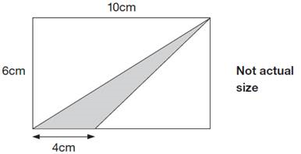
What is the area of the shaded triangle?

2 marks

Q2.
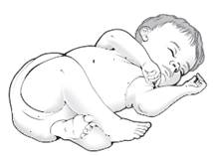
How many days old will the baby be when she has lived for one million seconds?

2 marks

Q3.
 | The grid below is made of right-angled  triangles like this: | 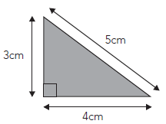

Shade triangles on the grid to make a quadrilateral.

Your quadrilateral must have an area of 24 cm² and a perimeter of 26 cm.

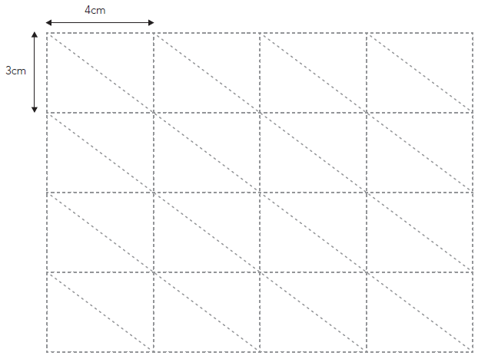
2 marks

Q4.
Here is a centimetre grid.
Draw two more lines to make a quadrilateral with an area of 18 cm².
Use a ruler.

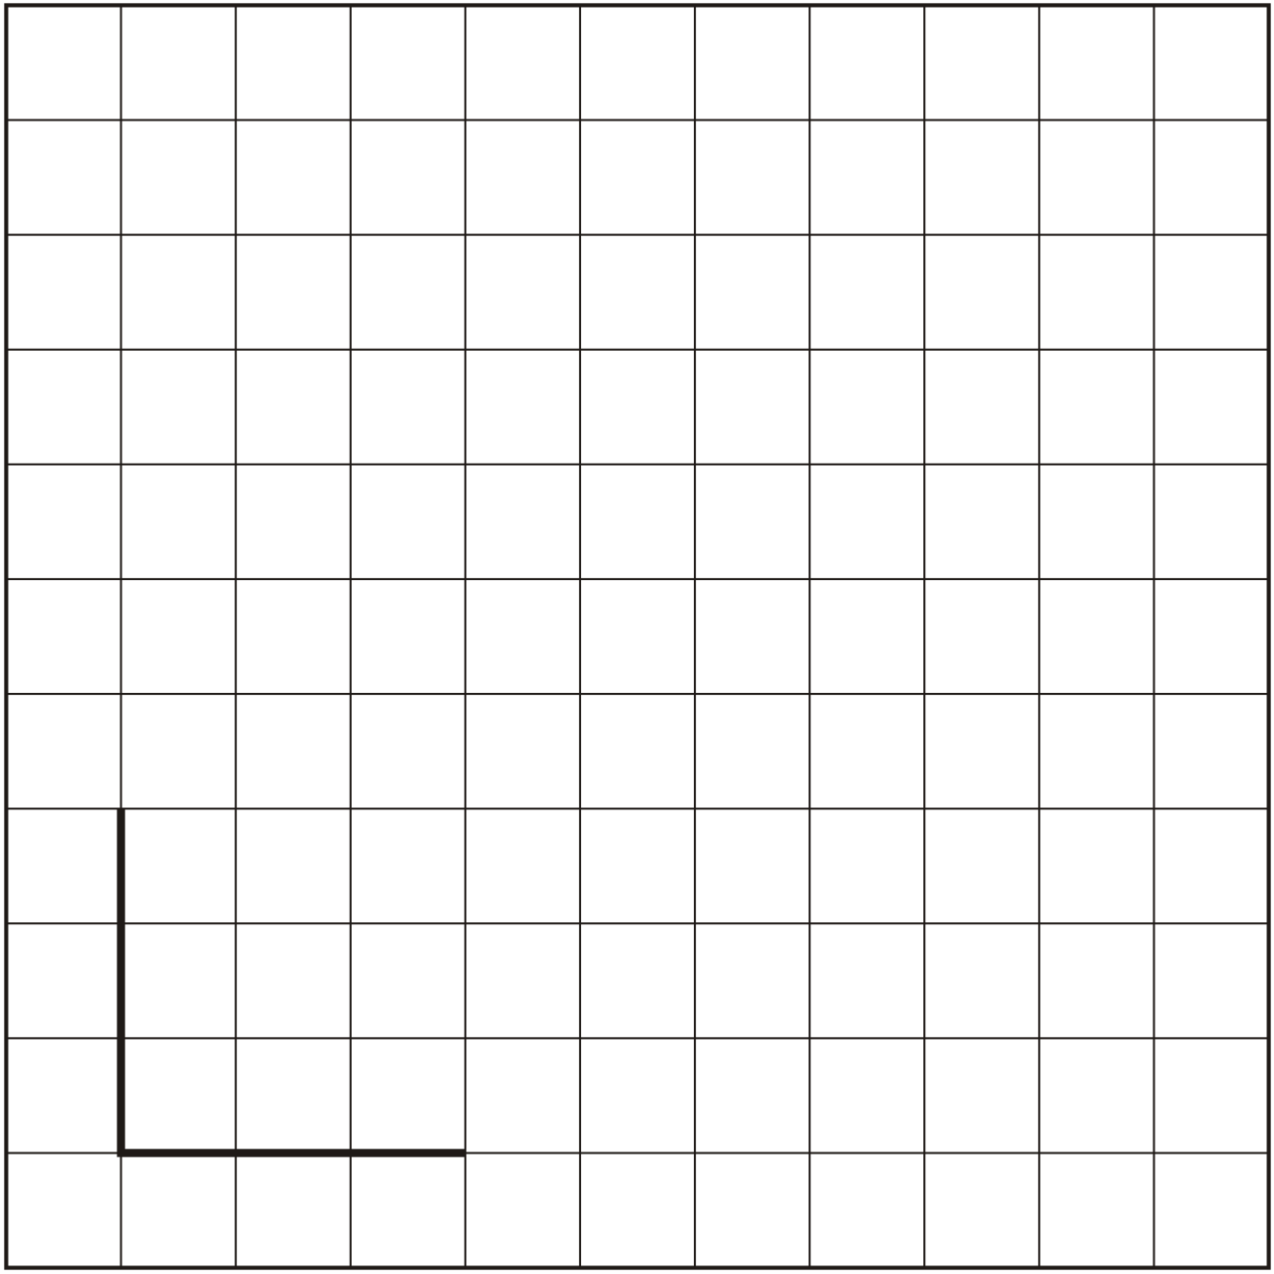
1 mark

Q5.
Salt

(a) What is the volume of this standard size box of salt?

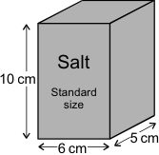
1 mark

(b) What is the volume of this special offer box of salt, which is 20% bigger?

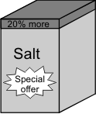
2 marks

The standard size box contains enough salt to fill up 10 salt pots
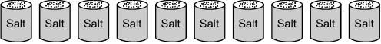

(c) How many salt pots may be filled up from the special offer box of salt?
1 mark

Q6.
The diagram shows 4 identical shaded triangles in a rectangle.

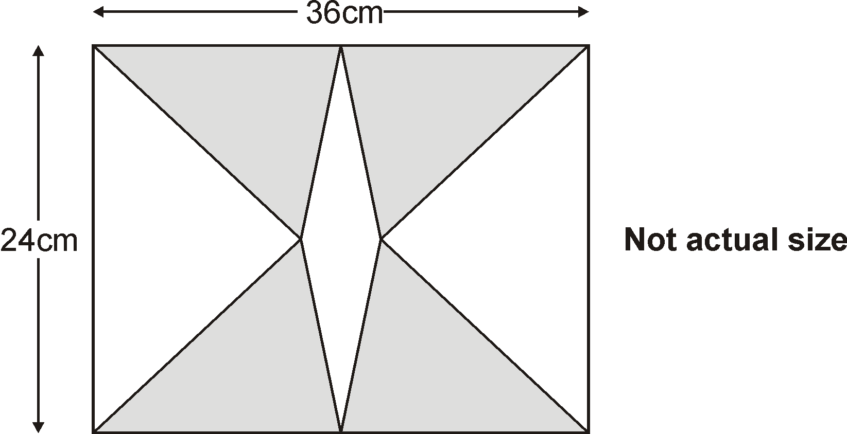

The rectangle measures 36 centimetres by 24 centimetres.
Calculate the area of one shaded triangle.

2 mark

Q7.
A cuboid has a square base.
It is twice as tall as it is wide.
Its volume is 250 cubic centimetres.

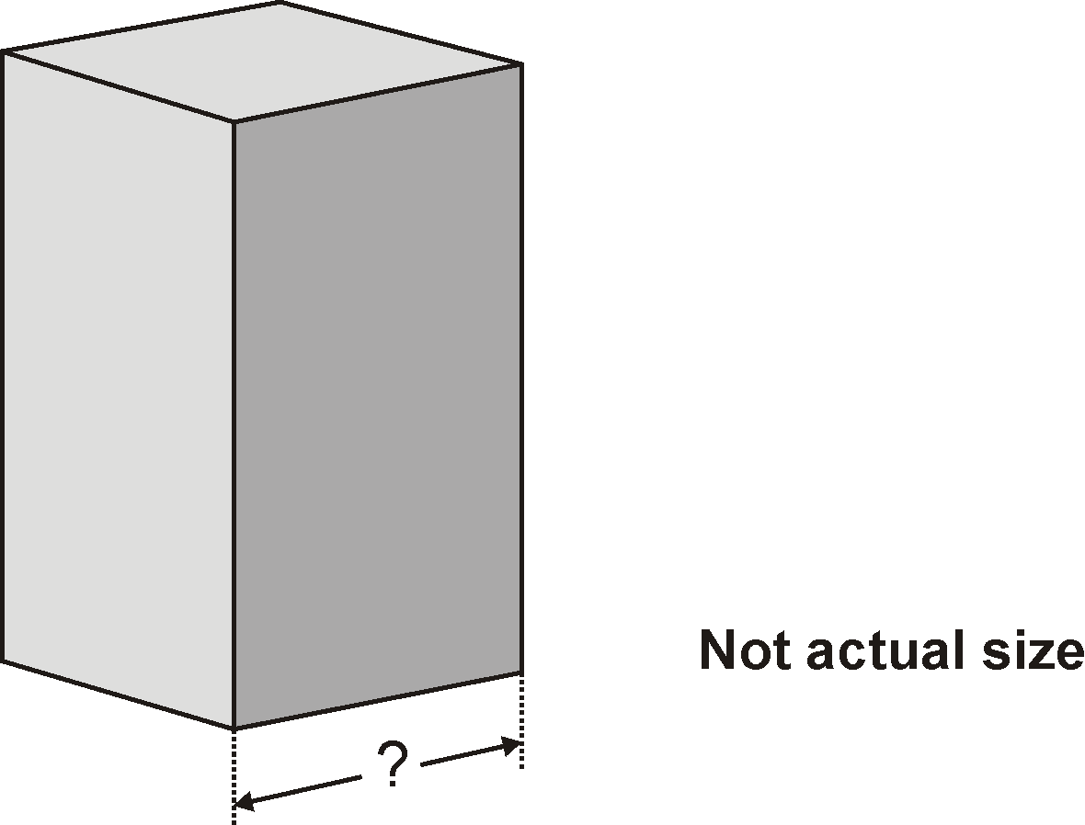

Calculate the width of the cuboid.

2 mark

M1.12
2
or
Shows or implies a complete correct method, eg:
• 4 × 6 ÷ 2 = 13 (error)
• 60 − (10 × 6 ÷ 2) – (6 × 6 ÷ 2)
• 60 − 48
1
[2]

M2.11 OR 12 OR any value between 11.5 and 11.6 inclusive
2
or
Any value between 277 and 288 inclusive seen (value takes account
of seconds in a minute and minutes in an hour)
OR
Any value between 694 and 695 inclusive seen (value takes account
of hours in a day and either seconds in a minute or minutes in an hour)

OR
Shows or implies a complete, correct method, eg:
• 1 000 000 ÷ 60 ÷ 60 ÷ 24
• 1 000 000 ÷ 86 400
• 16 666 ÷ 60 ÷ 24
Do not accept place value errors in the value taken for one million in an otherwise correct method, eg:
100 000 ÷ 60 ÷ 60 ÷ 24
1
[2]

M3. Shows a correct quadrilateral, eg
•
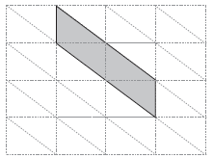
OR
•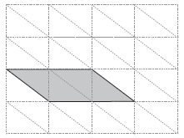
2
U1

or
Shows a quadrilateral with an area of 24 cm² but not a perimeter of 26 cm, eg
•
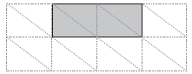
OR
•
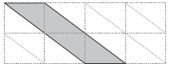
1
! Shading omitted
Accept provided the quadrilateral drawn is unambiguous
! Lines not ruled or accurate
Accept slight inaccuracies in drawing provided the pupil's intention is clear
[2]

M4. Two more lines drawn which intersect at a fourth vertex located
anywhere on the dotted line shown on the diagrams below, eg
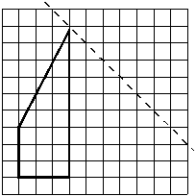
OR
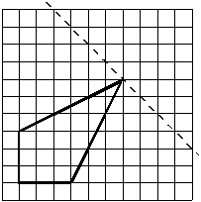
OR
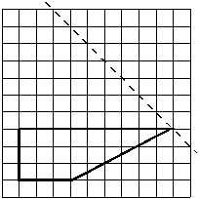
Accept slight inaccuracies in drawing provided the intention is clear.
[1]

M5.
(a) Indicates 300
Working need not be shown for the award of this mark.
Ignore use of cubed sign eg
• 300³
Do not accept incorrect attempt to convert to different units eg
• 3
• 30
1

(b) For 2m indicates 360.
For only 1m shows 60 as 20% of 300 in working or given 60 as volume
of the box.
Working need not be shown for the award of any marks.
For 2m or 1m allow follow through from part (a), with correct rounding or truncation.

Award only 1m for correct calculation indicated but not evaluated or incorrectly evaluated eg
• 12 × 6 × 5 = 432
• 1.2 × 300
• 300 × 20 ÷ 100 + 300
Do not accept height calculated as 12 with no further attempt to find the volume.
2

(c) Indicates 12 salt pots.
Working need not be shown for the award of this mark.
Allow follow through from part (a) or (b) with correct rounding or truncation.
Accept any indication eg
• 2 more salt pots drawn on diagram given.
Accept correct description eg
• 2 more salt pots.
Do not accept fractions of a salt pot.
Do not accept fewer than 10 salt pots eg
• 2 salt pots.
1
[4]

M6. Award TWO marks for the correct answer of 108 cm²
If the answer is incorrect award ONE mark for evidence of an
appropriate method, eg
36 ÷ 2 = 18
24 ÷ 2 = 12
area = ½ × 12 × 18
Calculation need not be completed for the award of the mark.
No mark is awarded for the result of calculating 12 × 18 only.
Up to 2
[2]

M7. Award TWO marks for the correct answer of 5 cm
If the answer is incorrect award ONE mark for evidence of an
appropriate method, eg
2n × n × n = 250
so
n × n × n = 125
The calculation need not be completed for the award of the mark, but n × n × n = 125 OR n³ = 125 must be reached.
Up to 2
[2]

