  - Consolidation work 2020
Q1.
Here is part of a number line.
Write the missing numbers in the boxes.

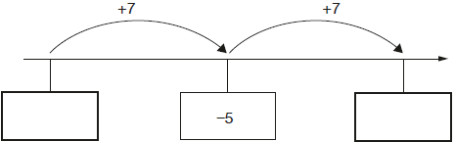
2 marks

Q2.
Here is part of a number line.
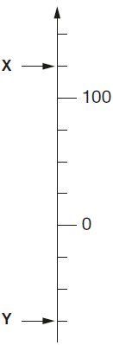

What is the value of X?
1 mark

What is the value of Y?
1 mark

Q3.
Here is part of a temperature scale.

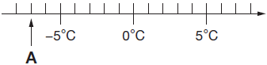
What is the temperature shown at A?
1 mark
What temperature is 20 degrees higher than A?
1 mark

Q4.
Here is part of a number line.
It is divided into equal sections.

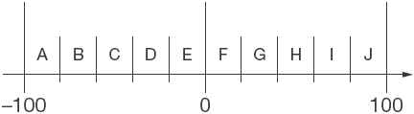
Write the letter of the section where each of these numbers belongs.
The number 99 has been done for you.

 | number | section
 | 99 | J
 | 29
 | –83
 | –15
 | 44

2 marks

Q5.
Circle two numbers with a difference of 8
–5 –4 –3 –2 –1 0 1 2 3 4 5
1 mark
Write two numbers with a sum of –6
1 mark

Q6.
Here is a table of temperatures at dawn on the same day.

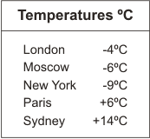
What is the difference in temperature between London and Paris?
1 mark

At noon the temperature in New York has risen by 5°C.
What is the temperature in New York at noon?
1 mark

Q7.
I am thinking of a number that is not zero.
I multiply my number by 5

Tick (✔) the statement below that is true.

The answer must be positive.
The answer must be negative.
The answer could be positive or negative.

Explain how you know.

1 mark

Q8.
Carol has a rule for a sequence of numbers.
Her rule is
"The next number is the sum of the two previous numbers."
Use Carol’s rule to write in the three missing numbers.

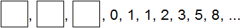
1 mark

Q9.
Paulo makes a sequence of numbers.
He chooses a starting number and then subtracts equal amounts each time.
The third number in his sequence is 45
The tenth number is –32

What is the first number in the sequence?

2 marks

M1.Award TWO marks for both numbers correct as shown.
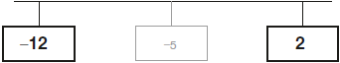
If the answer is incorrect, award ONE mark for one number correct.
Do not accept 12−
Accept +2 in the right-hand box.
Up to 2
[2]

M2.(a) X = 125
1
(b) Y = -75
Do not accept 75−
1
[2]

M3.(a) −7°C
Do not accept 7−
1
(b) 13°C
If (a) is negative allow follow through in part (b)
for ONE mark.
1
[2]

M4. Award TWO marks for all four letters in the correct order as shown:
99 J
29 G
–83 A
–15 E
44 H
If the answer is incorrect, award ONE mark for three letters correct.
Up to 2
[2]

M5. (a) Circling of numbers
–5 AND 3
OR –4 AND 4
OR –3 AND 5
Only these numbers are acceptable. Accept other unambiguous
indications of these numbers.
1

(b) Any two numbers which sum to –6, eg
–5 AND –1
OR –7 AND 1
The numbers need not be from the set given in the question.
Accept –6 AND 0 OR –3 AND –3. Accept fractions
and decimals.
1
[2]

M6. (a) 10
Accept +10 OR –10
Do not accept an incomplete calculation, eg: 4 + 6
1

(b) –4
Accept ‘negative 4’ OR ‘minus 4’ OR ‘4 below’.
Do not accept ‘4–’.
1
[2]

M7. Indicates the answer could be positive or negative and gives a correct explanation
eg
• A positive multiplied by −5 gives a negative answer, but a negative multiplied by −5 gives a positive answer
• Positive numbers will become negative, negative numbers will become positive
• If the number is 10 the answer will be –50, which is negative, but if the number is −10, the answer is 50, ie positive
Accept minimally acceptable explanation eg • 10 becomes negative, but −10 becomes positive • +ve → –ve –ve → +ve • −5 × −3 = 15, −5 × 3 = −15
Do not accept incomplete explanation eg • –5 × 3 = −15 • The original number could be positive or negative so the answer could be positive or negative
! Makes an incorrect decision, or no decision made, but explanation clearly correct Condone provided the explanation is more than minimal
U1
[1]

M8. ‘+’ signs may be omitted.
[1]

M9. Award TWO marks for the correct answer of 67
If the answer is incorrect, award ONE mark for evidence of an appropriate method, eg
7 gaps = 77
1 gap = 11
Answer need not be obtained for the award of the mark.
Up to 2
[2]

