2020 consolidation – enjoy!
Q1.
One gram of gold costs £32.94
What is the cost of half a kilogram of gold?

2 marks

Q2.
Here is part of the morning bus timetable from Winton to Yansley.

 | Winton | 9:35 | 9:55 | 10:15 | 10:35
 | Ingham | 9:45 | 10:05 | 10:25 | 10:45
 | Carston | 10:01 | 10:21 | 10:41 | 11:01
 | Dubley | 10:23 | 10:43 | 11:03 | 11:23
 | Yansley | 10:55 | 11:15 | 11:35 | 11:55

How many minutes does the bus take to get from Ingham to Dubley?
1 mark

Megan is in Carston.
She wants to be in Yansley before 11:30
What is the time of the latest bus she can take from Carston?
1 mark
One morning, the 10:35 bus from Winton gets to Carston 3 minutes early.
What time does it get to Carston?
1 mark

Q3.
This table shows the weight of some fruits and vegetables.
Complete the table.

 |  | grams | kilograms | 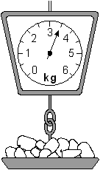
 | potatoes | 3500 | 3.5
 | apples |  | 1.2
 | grapes | 3500
 | ginger |  | 0.03

2 marks

Q4.
Here is some flour on a weighing scale.

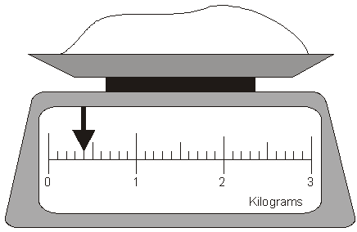

How many grams of flour are on the scale?
1 mark

How much more flour must be added to the scale to make 1.6 kg?
1 mark

Q5.
This shape is made from 4 shaded squares.

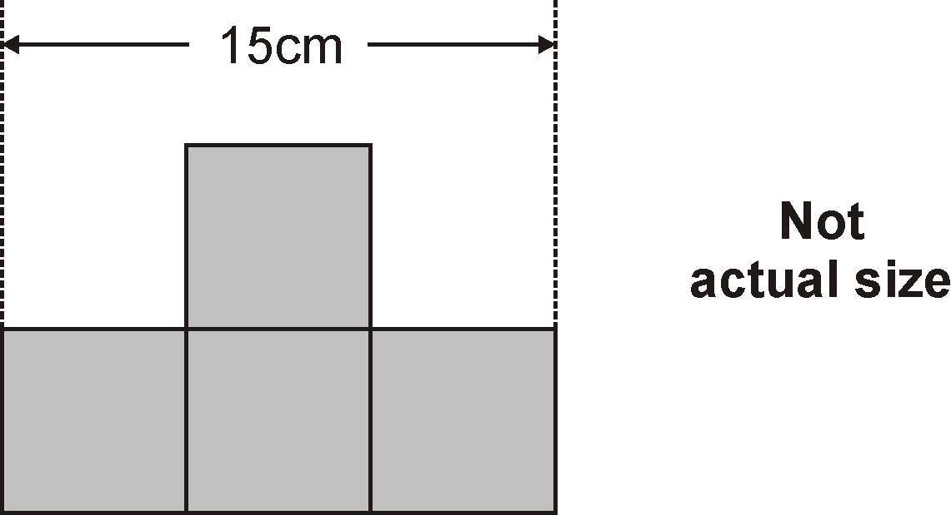
Calculate the perimeter of the shape.

2 marks

Q6.
Rectangle ABCD has a perimeter of 24 centimetres.
Sides AB and DC are twice as long as sides AD and BC.
Not actual size
Calculate the length of side AD.
Do not use a ruler.
1 mark

Q7.
On the grid draw a triangle with the same area as the shaded rectangle.
Use a ruler.

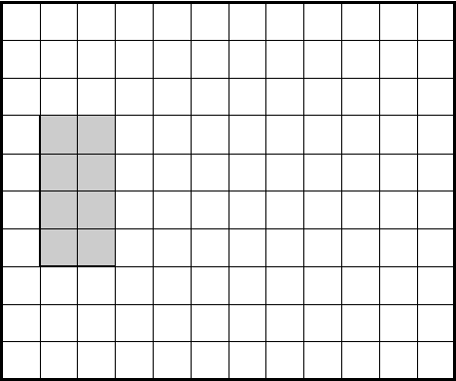
1 mark

Q8.
What is the area of this shape?

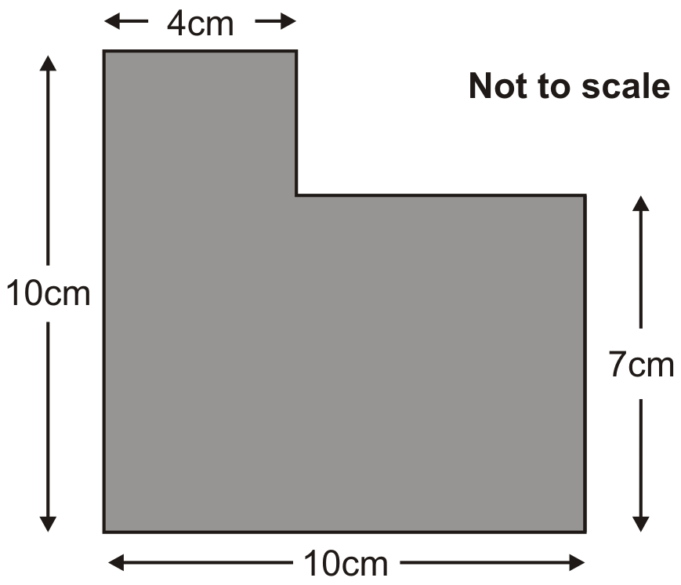

2 marks

Q9.
The perimeter of a square is 72 centimetres.

Not actual size

The square is cut in half to make two identical rectangles.

What is the perimeter of one rectangle?

2 marks

Q10.

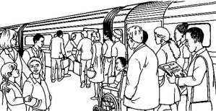
Here is part of a train timetable.

 | Edinburgh | – | 09.35 | – | – | 13.35 | – | –
 | Glasgow | 09.15 | – | 11.15 | 13.15 | – | 13.45 | 15.15
 | Stirling | 09.57 | – | 11.57 | 13.57 | – | 14.29 | 15.57
 | Perth | 10.34 | 10.51 | 12.34 | 14.34 | 14.50 | 15.15 | 16.35
 | Inverness | – | 13.10 | – | – | 17.05 | – | –

How long does the first train from Edinburgh take to travel to Inverness?
1 mark

Ellen is at Glasgow station at 1.30pm.
She wants to travel to Perth.
She catches the next train.
At what time will she arrive in Perth?
1 mark

Q11.
A white square is painted in one corner of a grey square.
Each side of the white square is half the length of a side of the grey square.

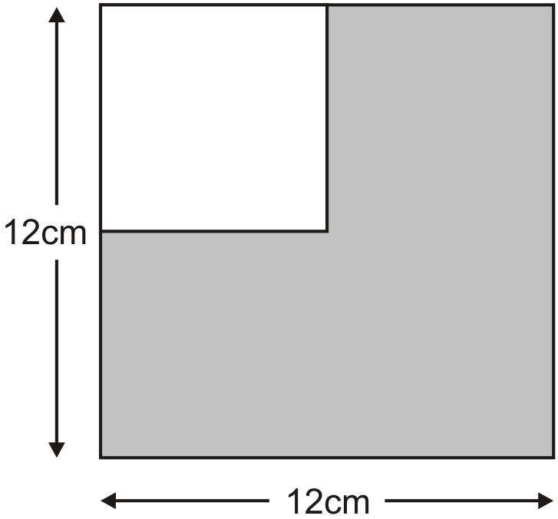
Not actual size

What is the area of the grey section?

Q12.
Kate has some rectangles.
They each measure 16 centimetres by 50 centimetres.

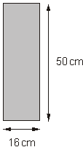
Not actual size

She makes this design with four of the rectangles.

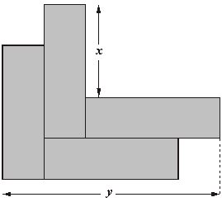

Work out the lengths x and y.
1 mark
1 mark

Q13.
Kim has some rectangular tiles.
Each one is 4 centimetres by 9 centimetres.

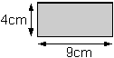

She makes a design with them.

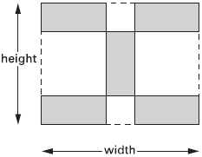

Calculate the width and height of her design.

 | width = |  | Height =

2 mark

Q14.
Nisha’s kettle holds 2 litres of water.

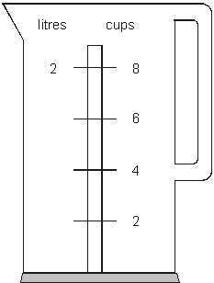
How many millilitres are equal to 1 cup?
1 mark

Q15.
This design has one large square and two identical small squares.
The design measures 36 centimetres by 28 centimetres.

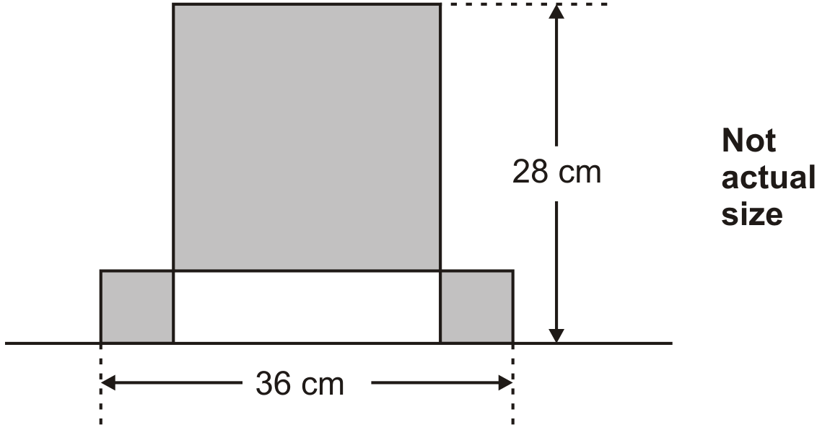

Calculate the length of a side of the large square.

2 marks

Q16.
The following quadrilaterals all have a perimeter of 36cm.
Here is a table to show the length of each side.

Complete the table.
One quadrilateral is done for you.

 |  | Side lengths
 | square | 9cm 9cm 9cm 9cm
 | rectangle | 3cm
 | rhombus | 9cm
 | kite | 10cm

2 marks

Q17.
Alfie has some rectangles.

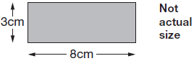

He makes this shape using three of the rectangles.

What is the perimeter of Alfie’s shape?

2 marks

Q18.
Chen is cooking some pasta.  The recipe says he needs 350 grams of pasta for 4 people. | 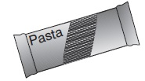

How many kilograms of pasta does he need for 12 people?

2 marks

Q19.
At a petrol station there is a scale for converting litres and gallons.

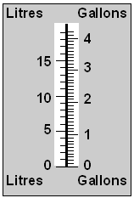
Approximately how many litres are there in 3 gallons?
Give your answer to the nearest litre.
1 mark

Approximately how many gallons are there in 7 litres?
Give your answer to 1 decimal place.
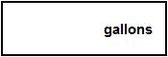
1 mark

Q20.
A spoonful is 5ml.
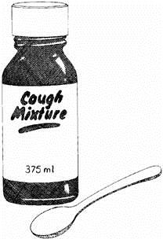
How many spoonfuls can you get from this bottle?
1 mark

M1.Award TWO marks for the correct answer of £16,470
If the answer is incorrect, award ONE mark for evidence of an appropriate method, e.g:
• £32.94 × 1000 = £32,940
£32,940 ÷ 2
OR
• £32.94 × 500
= £3294 × 5
Answer need not be obtained for the award of ONE mark.
Up to 2
[2]

M2.(a) 38
The answer is a time interval.
1
(b) 10:21
The answer is a specific time.
1
(c) 10:58
1
[3]

M3. Award TWO marks for the table completed as shown:
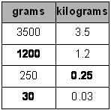
If the answer is incorrect, award ONE mark for two of the three numbers completed correctly.
For 0.25, accept .25 OR
Up to 2
[2]

M4. (a) 400
Answer must be in grams.
1
(b) 1200 g OR 1.2 kg
OR
for finding the correct difference between 1.6 kg and the answer given for (a).
Accept 1200 OR 1.2 OR 1 kg 200 g
1
[2]

M5. Award TWO marks for the correct answer of 50
If the answer is incorrect, award ONE mark for evidence of appropriate
working, eg
15 ÷ 3 = 5
5 × 10 = wrong answer
Calculation must be performed for the award of ONE mark.
Up to 2 (U1)
[2]

M6. 4
U1
[1]

M7. Any triangle with an area of 8 cm², eg
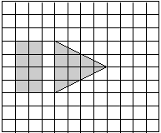
Drawings must be accurate to within 2 mm of appropriate grid intersections.
The triangle need not be shaded and need not have vertices at grid junctions.
Do not penalise drawings done without a ruler, provided
the intention is clear.

OR
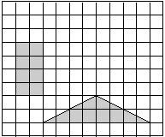

Accept drawings that overlap the given rectangle or use the edge of the grid, eg
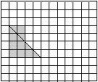

OR
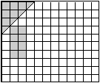
[1]

M8. Award TWO marks for the correct answer of 82
If the answer is incorrect, award ONE mark
for evidence of an appropriate method, eg
(4 × 10) + (7 × 6)
OR
(10 × 10) – (3 × 6)
Answer need not be obtained for the award of the mark.
Up to 2
[2]

M9. Award TWO marks for the correct answer of 54
If the answer is incorrect, award ONE mark for evidence of appropriate
method, eg:
• 72 ÷ 4 = 18
18 ÷ 2 = 9
(18 × 2) + (9 × 2)
OR
• 72 ÷ 4 × 3
Answer need not be obtained for the award of ONE mark.
Up to 2 (U1)
[2]

M10. (a) 3 hours 35 minutes
The answer is a time interval
(see guidance)
1

(b) 15:15
The answer is a specific time
(see guidance)
Accept quarter past three
1
[2]

M11. Award TWO marks for the correct answer of 108
If the answer is incorrect, award ONE mark for evidence of appropriate method, eg
12 × 12 = 144
of 144
OR
(12 × 12) – (6 × 6)
OR
(12 × 12) + (6 × 6)
OR
(6 × 6) × 3
Answer need not be obtained for the award of ONE mark.
Up to 2 (U1)
[2]

M12. (a) 34
1
(b) 82
1
[2]

M13. (a) width = 22
1
(b) height = 17
If the correct answers are transposed, award the mark for 16b only.
1
[2]

M14. 250
Do not accept litre.
[1]

M15. Award TWO marks for the correct answer of 20
If the answer is incorrect, award ONE mark for evidence of appropriate
working, eg
Small square = 36 – 28 = 8
Large square = 28 – 8
= wrong answer
Working must be carried through to reach an answer for the award of ONE mark.
Up to 2 (U1)
[2]

M16.Completes all three rows correctly, eg:

• | rectangle | 3cm | 3cm | 15cm | 15cm
 | rhombus | 9cm | 9cm | 9cm | 9cm
 | kite | 10cm | 10cm | 8cm | 8cm

! Measures
Accept Side lengths in each row may be given in any order
Accept correct values with cm omitted eg, for the rectangle:
• 15 3 15
2

or
Completes two rows correctly
1
[2]

M17.Award TWO marks for the correct answer of 54
If the answer is incorrect, award ONE mark for
evidence of appropriate working, eg
8 × 4 = 32
3 × 4 = 12
5 × 2 = 10
32 + 12 + 10 = wrong answer
Working must be carried through to reach
an answer for the award of ONE mark.
Up to 2
[2]

M18.Award TWO marks for the correct answer of 1.05 kg.
If the answer is incorrect, award ONE mark for evidence of appropriate working, eg:
■ 12 ÷ 4 = 3
350 × 3 = 1050
1050 ÷ 1000 = wrong answer
Do not accept 1050 g
Accept for ONE mark 10.5 or 105 as evidence of appropriate working.
Working must be carried through to reach an answer for the award of ONE mark.
Up to 2m
[2]

M19. (a) 13 OR 14
1
(b) 1.5 OR 1.6 Do not accept 1½
1
[2]

M20. 75 (spoonfuls)
[1]

