Practising how to explain your understanding – 2020
These get increasingly difficult so DO NOT STRESS if you cannot finish – this is all about practice.
Q1.
The numbers in this sequence increase by 10 each time.
3 13 23 …
The sequence continues in the same way.
Write two numbers from the sequence that add to make a total of 96
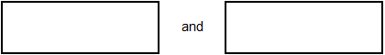
1 mark

Explain why it is not possible to find three numbers from the sequence that add to make a total of 96

1 mark

Q2.
Amy did a survey of what time people get up on a Sunday morning.
This table shows her results for 150 people.

 | Time | number of people
 | before 7 am | 13
 | 7:00 am to 7:59 am | 28
 | 8:00 am to 8:59 am | 59
 | 9:00 am to 9:59 am | 36
 | 10 am and after | 14

Look at the table.
How many people get up at 8 am or later?
1 mark

Amy says,
'Two-thirds of the 150 people in the survey get up before 9 am.'
Amy is correct.
Explain how you know.

1 mark
Q3.
Anna says is greater than
Explain why Anna is correct.

1 mark
Q4.
The diagram shows a pentagon.  Not drawn  accurately | 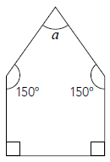

Each side of the pentagon is the same length.
Is the shape a regular pentagon?
Yes or No.
Explain your answer.

1 mark

Work out the size of angle a

2 marks

Q5.
Is greater than ?

Circle Yes or No.

Yes / No

Show how you know.

1 mark

Is half of ?

Yes or No.
Show how you know.

1 mark
Q6.
The rule for this sequence of numbers is ‘add 3 each time’.
1 4 7 10 13 16 ...
The sequence continues in the same way.
Mary says,
‘No matter how far you go there will never be a multiple of 3 in the sequence’.
Is she correct?
Yes / No
Explain how you know.
1 mark

Q7.
Leila knows that
65 × 3 = 195
Explain how she can use this information to find the answer to this multiplication:
165 × 3
1 mark

Q8.
Three children do a sponsored silence.

This is a chart of the money they collected.

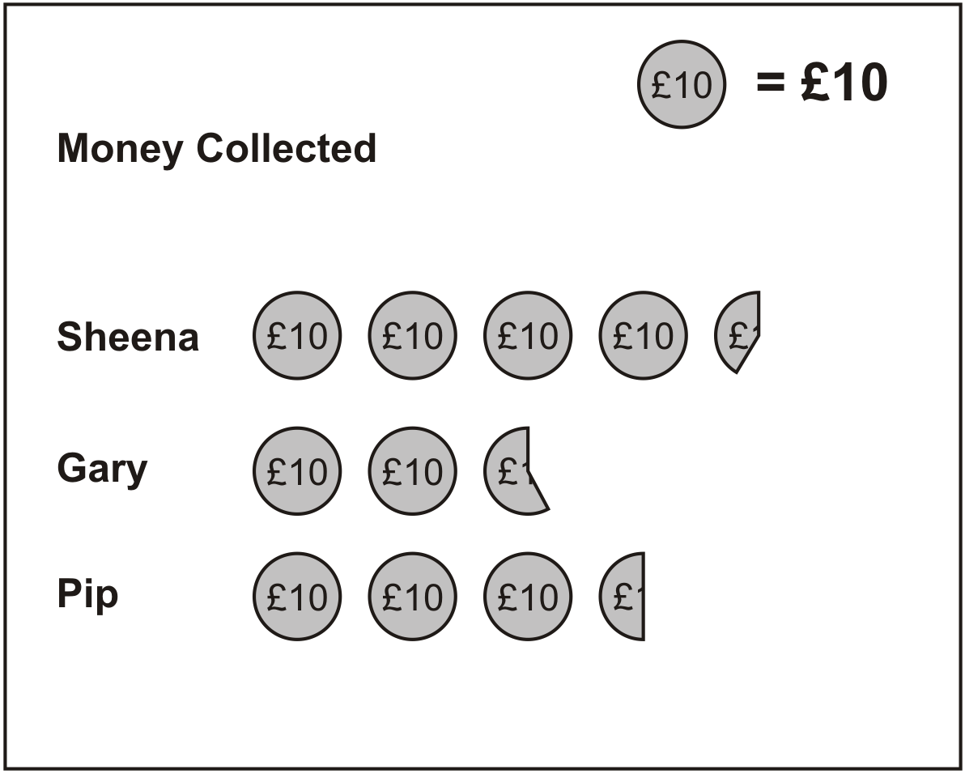

Estimate how much Sheena collected.
1 mark
Together Gary and Pip collected more than £60
Explain how the chart shows this.
1 mark

Q9.
Kelly chooses a section of a newspaper.
It has 50 words in it.
She draws a bar chart of the number of letters in each word.

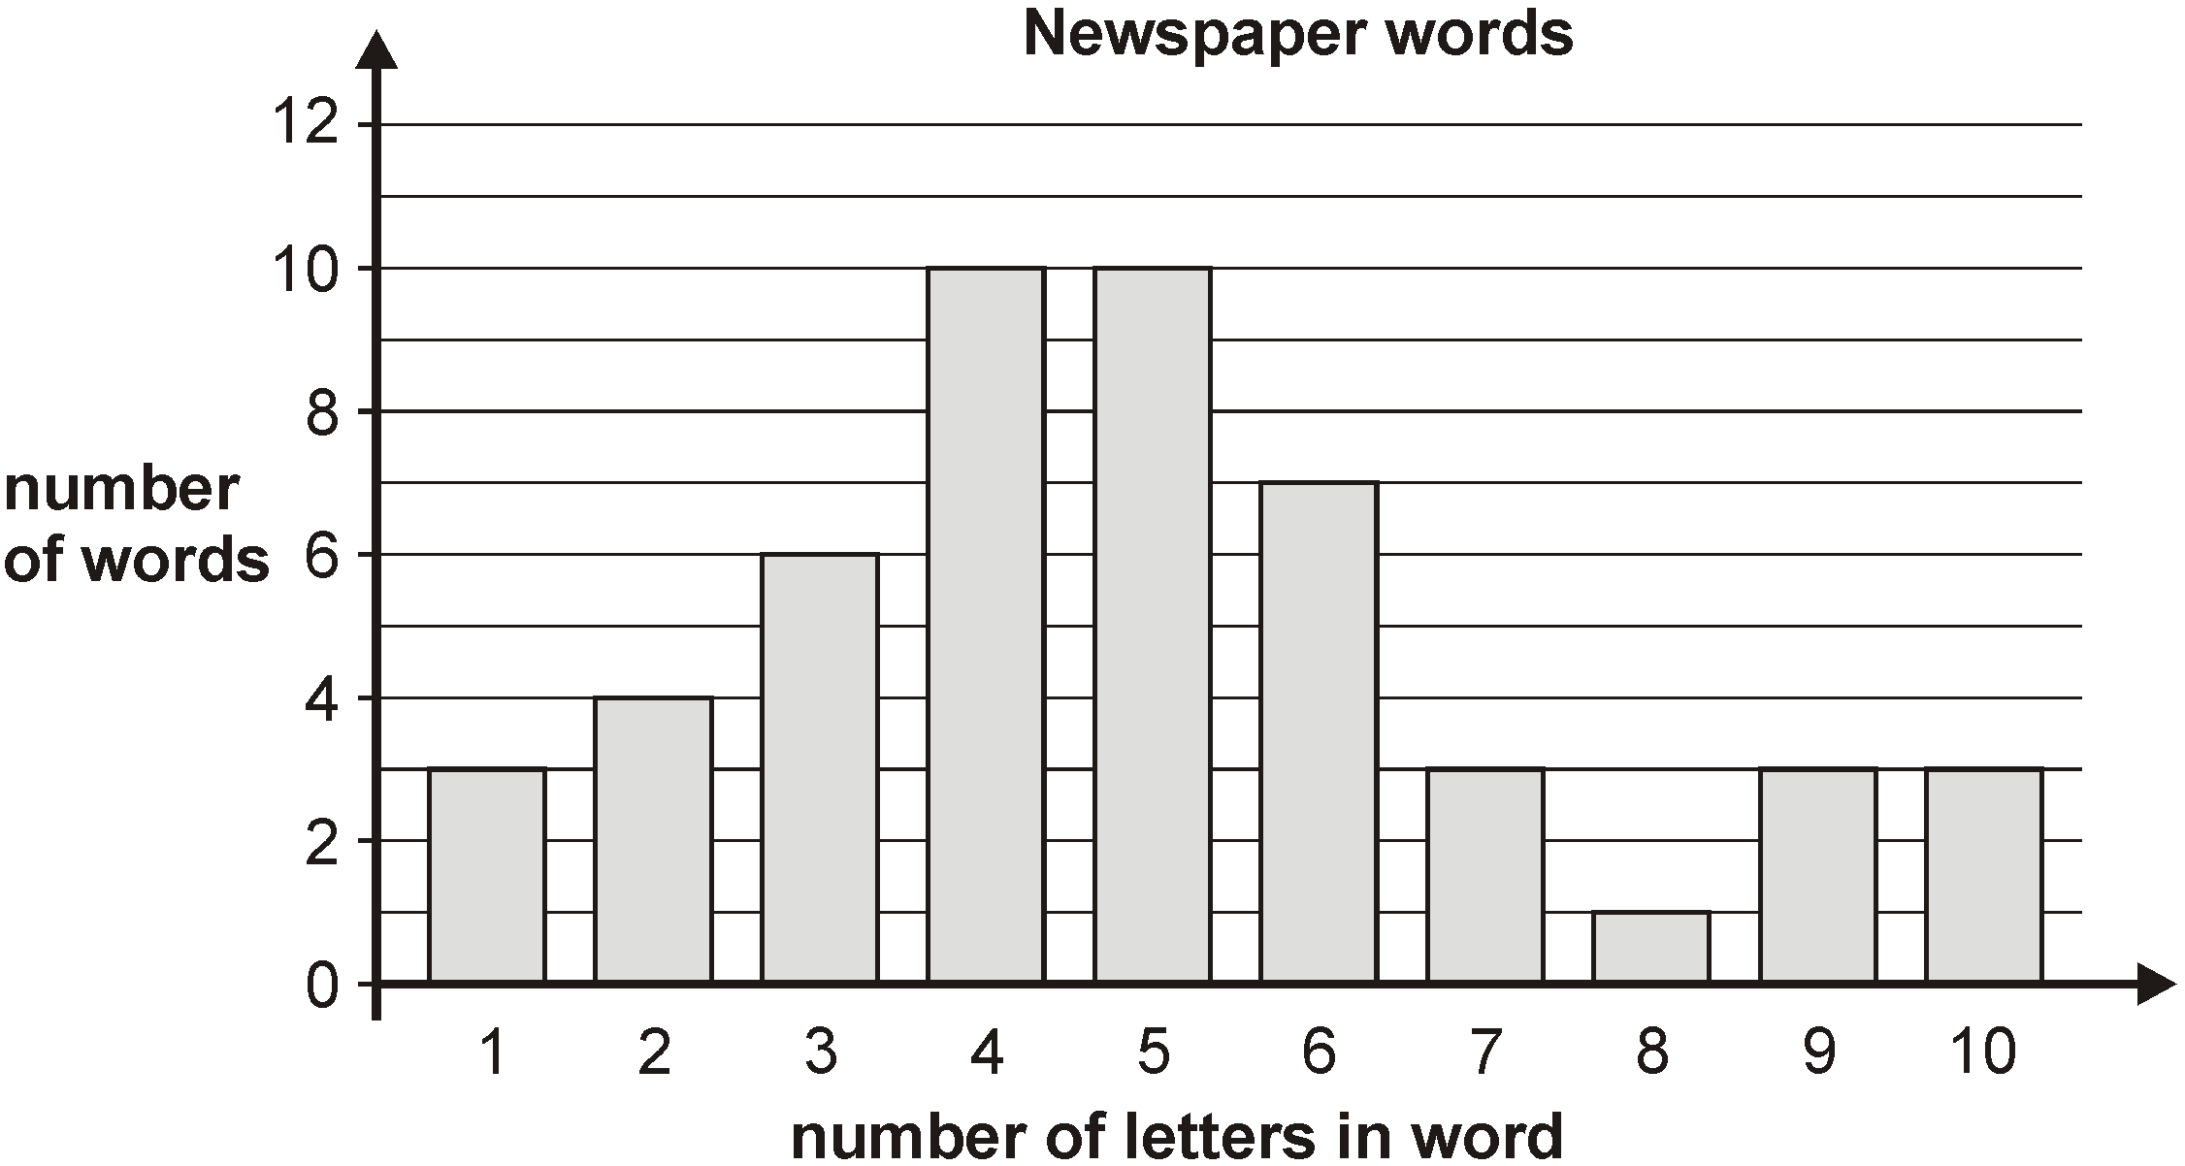
What fraction of the 50 words have more than 6 letters?
1 mark
Kelly says,
23 of the 50 words have less than 5 letters. This shows that nearly half of all the words used in the newspaper have less than 5 letters in them.
Explain why she could be wrong.
1 mark

Q10.
This sequence of numbers goes up by 40 each time.
40 80 120 160 200 ...
This sequence continues.
Will the number 2140 be in the sequence?
Circle Yes or No. Yes / No
Explain how you know.
1 mark
Q11.
Megan says,
‘If two rectangles have the same perimeter,
they must have the same area.’
Is she correct?
Yes or No.
Explain how you know.

1 mark

Q12.
If you know 40% of a number, explain how you could work out the original number.

1 mark

Q13.
Lisa is using trial and improvement to find a solution to this equation.

x² – 3x = 1

Here are her first few trials.
Complete the missing information.
When x = 3, x²– 3x = 0 , so this value of x is too small
When x = 4, x²– 3x = , so this value of x is too
1 mark
When x = 3.5, x²– 3x = , so this value of x is too
1 mark
What value of x should Lisa try next?
x =__________________
Explain why you chose that value.

1 mark

M1.(a) Two numbers from the sequence that total 96, eg:
43 AND 53
OR
23 AND 73
Numbers may be given in either order.
Accept negative numbers, eg −7 AND 103
1

(b) An explanation that recognises that adding three numbers ending in 3
will produce a number ending in a 9 eg:
■ ‘They all end in 3 so adding three will give a number ending in 9’
■ ‘If you add three numbers in the sequence you will always get a
number ending in 9’
■ ‘All the numbers are odd and 96 is even’
Do not accept vague or incomplete explanations, eg:
■ ‘All the numbers end in three’
■ ‘It only works with two numbers’
■ ‘3 odds add to make an even’
U1
[2]

M2. (a) 109
1

(b) An explanation that recognises that 100 people get up before 9am
which is two-thirds of the total (150).
■ ‘13 + 28 + 59 = 100 which is two-thirds of the total’
■ ‘ of 150 = 50 and 2 × 50 = 100’
■ ‘ of 150 is 100’

■ ‘36 + 14 = 50 which is one-third after 9am’
Do not accept vague or incomplete explanations, eg:
■ ‘One-third are 9 o’clock or later’
■ ‘100 got up at 9am’
■ ‘Twice as many got up before 9am.’
■ ‘13 + 28 + 59 = 100’
U1
[2]

M3.Gives a correct explanation that converts the given fractions to decimals or fractions with a common denominator / numerator or percentages, eg:
• = but =
• 0.57142… > 0.55555

• Because there is a difference between the two
For accept:
• 0.57(...) or 57(. ...%)
For accept:
• 0.56 or 0.55(...) or 56(%) or 55(. ...%)

Accept minimally acceptable explanations, eg:
•
• 0.56 0.57

Do not accept incomplete explanations that fail to convert both fractions to a common format, eg:
• is 0.57 so it is bigger
• 9ths are smaller than 7ths and there is only one more 9th
than 7th so is greater

! Condone method of conversion incorrectly expressed in an otherwise correct explanation, eg:
• × 9 =
[1]

M4. Indicates No and gives a correct explanation
eg
• The angles are not the same size
• A regular pentagon looks like this,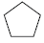 with its angles all the same size
• All the angles should be 108°
• It doesn’t have rotation symmetry
• It’s got more sides than a square so all its angles should be obtuse, but they’re not
1

60°
2

Shows that the 150° angle can be split into 90° and 60°
or
Divides the pentagon vertically and shows that half a is 30°
or

Draws triangles to show a rectangle, labelling the non-right angles on at least one side correctly eg
• 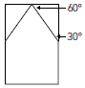

or
Shows or implies that the angle sum of a pentagon is 540°
1
Accept minimally acceptable explanation eg • 90 ≠ 150 • Different angles • A regular pentagon doesn’t have right angles in it • A regular one can’t have 150° angles • It doesn’t look the same when it’s turned • Not all the angles are obtuse

! Incorrect angle size for a regular pentagon given Condone alongside a correct response eg, accept • The angles are different, they should be 60° (error, but all equal implied) • The angles should all be 70° (error) eg, do not accept • The 90° angles should be 60° (does not imply the angles should all be the same)

Do not accept incomplete explanation eg • Not the same • It has two right angles • Two angles are the same
• A regular pentagon looks like this
• A regular pentagon doesn’t have any vertical lines
! Indicates Yes, or no decision made, but explanation clearly correct
Condone provided the explanation is more than minimal
[3]

M5. (a) Indicates Yes and gives a correct explanation, eg:
• = ,
•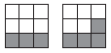
• of 9 is 3 not 4
• should be 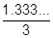, not
• 0.33...
• = ,
• of 27 = 9 and of 27 = 12

Accept minimally acceptable explanation, eg:
•
• ,
• 4 is over a third of 9
• of 9 is 3
• is closer to a half than a third
• 0.33, 0.44
• It is one ninth bigger
• If you divide by a you get
•

! Inaccuracies in diagrams
Throughout the question, condone provided the pupil’s intention to divide into thirds, ninths and/or eighteenths is clearly shown, and the correct sections are shaded

! Indicates No, or no decision made, but explanation clearly correct
Condone provided the explanation is more than minimal
Do not accept incomplete or incorrect explanation, eg:
• If you draw a pie chart for , more than is shaded
• Put them into 27ths and >
• × 3 =
1
U1

(b) Indicates No and gives a correct explanation, eg:
• The fractions are equal; if you multiply the numerator and denominator by the same number the fractions are equivalent
• =
• × 2 = not
• ÷ 2 = which is not
• To double the fraction, you don’t double the numerator and the denominator, you just double the numerator
• To halve the fraction, you don’t halve the denominator, only the numerator

Accept minimally acceptable explanation, eg:
• Equal
• Equivalent
• Same
• is half of
• is half of
• You only double the top number
• You only halve the top number

! Indicates Yes, or no decision made, but explanation clearly correct
Condone provided the explanation is more than minimal

Do not accept Incomplete explanation, eg
• If you double the top and the bottom number of , you get
1
U1
[2]

M6. Explanation which recognises that
each number is one more than a multiple of 3, eg
• ‘It starts at 1 and keeps adding 3 so it misses all the multiples of 3’,
• ‘Multiples of 3 are all 1 less than the numbers’.
No mark is awarded for circling ‘Yes’ alone.
Do not accept vague or arbitrary explanations such as
• ‘They’re too big’;
• ‘It doesn’t go far enough’;
• ‘It is adding 3 all the time’.
If ‘No’ is circled but a correct unambiguous explanation is given then award the mark.
[1]

M7. Explanation which indicates that 300 can be added to 195, eg
• ‘It’s 3 × 100 more’;
• ‘You add another 300 on’;
• ‘3 × 65 = 195, 3 × 100 = 300 so it’s 495’;
• ‘100 has been added to 65, so multiply 100 by 3 and add it to 195’.
An answer to the multiplication is not required and no mark is awarded for it.
Do not accept vague answers such as:
• ‘You work it out’;
• ‘Do a sum’;
• ‘It’s nearly the same except it has 100 in front of it’.
[1]

M8. (a) Answer in the range of £43 to £44 inclusive.
1

(b) Explanation which implies that Gary has an amount greater than £25 but less
than £27.50 and that Pip has £35±1, so that their total is greater than £60, eg
• ‘Gary has 26 Pip has 35’;
• ‘The chart shows that Gary has 2 and ²/₃ and Pip has 3 and a half, so that’s
over 60 pounds’;
• ‘The whole symbols together make 50 and then it’s 2 halves and Pip has
half and Gary has more than half’.
Do not accept vague or arbitrary answers, eg
• ‘By the number of coins’;
• ‘There are 5 ten pounds and 2 halves’;
• ‘A coin = 10 pounds and a broken coin = a fraction of a
coin so a fraction of the money’.
1
[2]

M9. (a) ¹/₅ OR ¹⁰/₅₀
Accept other equivalent fractions, eg: ²⁰/₁₀₀
1

(b) Explanations which imply that the results from a small sample cannot safely
be applied to a large one, eg:
• ‘You could be wrong because every section is different’
• ‘The article is only a small proportion of the whole newspaper’
• ‘The rest could be different’
• ‘You can’t judge a whole newspaper by one article’
Do not accept vague or arbitrary explanations such as:
‘She might not have counted right’;
‘The words in the newspaper might be big’;
‘There are more bigger words than small’.
1
[2]

M10. Explanation which recognises that the numbers in the sequence are multiples of 40 and that 2140 is not OR that only the even hundreds in the sequence have the numbers ending in 40, eg
• ‘it doesn’t divide by 40’;
• ‘140 isn’t in it so 2140 won’t be’;
• ‘it will go 2000, 2040, 2080, 2120, 2160 ... so there’s no 2140’.
No mark is awarded for circling ‘No’ alone.
Do not accept vague or arbitrary explanations, eg
• ‘It’s odd, so it won’t be there’;
• ‘It’s not part of the sequence’.
[1]

M11.Indicates No and gives a correct explanation that
includes indicating two different areas, eg:
• A rectangle with sides 6 cm by 2 cm has a perimeter of 16 cm and
an area of 12 cm² but a rectangle with sides 5 cm and 3 cm has
the same perimeter of 16 cm but it has an area of 15 cm² which
is different so she is not correct

• A square with sides 3 cm by 3 cm and a rectangle with sides 4 cm
by 2 cm have the same perimeter of 12 cm but they have different
areas of 9 cm² and 8 cm²
Accept minimally acceptable explanation, eg:
• 6 × 2 = 12, 5 × 3 = 15
•

! Ignore any incorrect units given in an
otherwise correct explanation, eg:
• 6² for 6 cm²
! Indicates Yes, or no decision made, but
explanation clearly correct
Condone, provided the explanation is more
than minimal

Do not accept Incomplete or incorrect explanation, eg:
• 6 × 2, 5 × 3
• Two rectangles, one with sides 6 cm by
5 cm and one with sides 8 cm by 3 cm have
the same perimeter of 22 cm but they don’t
have the same area
•
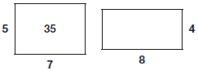
[1]

M12. An explanation which recognises that 40% of the number must be
multiplied by 2, or equivalent, eg:
• ‘You multiply by 2.5’
• ‘Halve it and multiply by 5’
• ‘Divide by 4 to get 10% and then multiply by 10’
• ‘Divide by 40 then multiply by 100’
• ‘If you had 100, quarter of 100 is 25, then times by 10 to get 250’
• ‘Double it and add half of it’.
Do not accept vague or incomplete explanations, eg:
• ‘Start with the original number and find 40% of it’
• ‘Find 10% and multiply by 10’
• ‘Divide by 4 to find 10% and then you can find 100%’
• ‘Find 1% and multiply by 100’
• ‘If you had 20 it would be 50’
• ‘Add 60%’
U1
[1]

M13. Gives correct information for x = 4, eg
• 4, too big
• 4, too high
• 4, too much above 1
Do not accept incomplete information that does not link to the value of 1, eg • 4, too incorrect
1
Gives correct information for x = 3.5, eg
• 1.75, too big
! In both the first and second answers, shows correct values but omits or gives incorrect further information, eg • 4, too small 1.75, too __________ Do not award the first mark, but award the second mark
! Value rounded Accept 1.8 Do not accept 1.7
1
Gives a logical value for the next trial, and justifies their decision, eg
• 3.2, because I know it is between 3 and 3.5
• 3.25, it is half way between 3 and 3 and a half
• 3.3 because it is bigger than 3 which was too small but smaller than 3.5 which was too big
• 3.4, it has to be smaller than 3.5 (that it is greater than 3 is implicit)
! Logical values Accept any of the following: 3.1 3.2 3.3 3.4 3.25 Also accept any value between 3.3 and 3.4 provided their justification shows why the solution is between these values eg, accept (since a further trial has clearly taken place) • 3.35, 3.3 is too small • 3.302, because 3.303 is just over 1 eg, do not accept • 3.35, because I know it is between 3 and 3.5
Accept minimally acceptable justification, eg • 3.2, 3.5 is too big
Do not accept incomplete justification, eg • 3.3, it gets closer to 1 • 3.25 because it is at an appropriate interval
! For the third part, follow-through If their calculation in the second part for x = 3.5 was too small, accept x = 3.6, 3.7, 3.75, 3.8 or 3.9 alongside an explanation comparable with those given in the mark scheme
1
[3]

