Angles revision 2020.
If you don’t have a protractor / angle measurer at home – don’t worry, you only need it for one question!
Q1.
This is a design for an arrowhead.

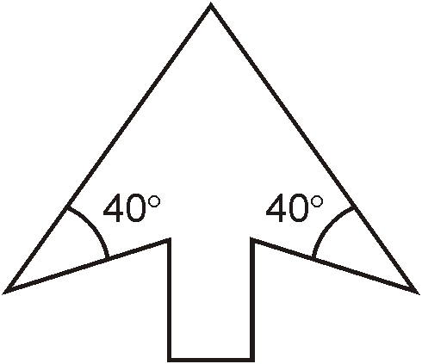
Below is part of a larger scale drawing of the arrowhead.
The drawing has the same size angles as the design.

Draw two more lines to complete the arrowhead accurately.
Use an angle measurer (protractor).
2 marks

Q2.
Here is a shape on a square grid.

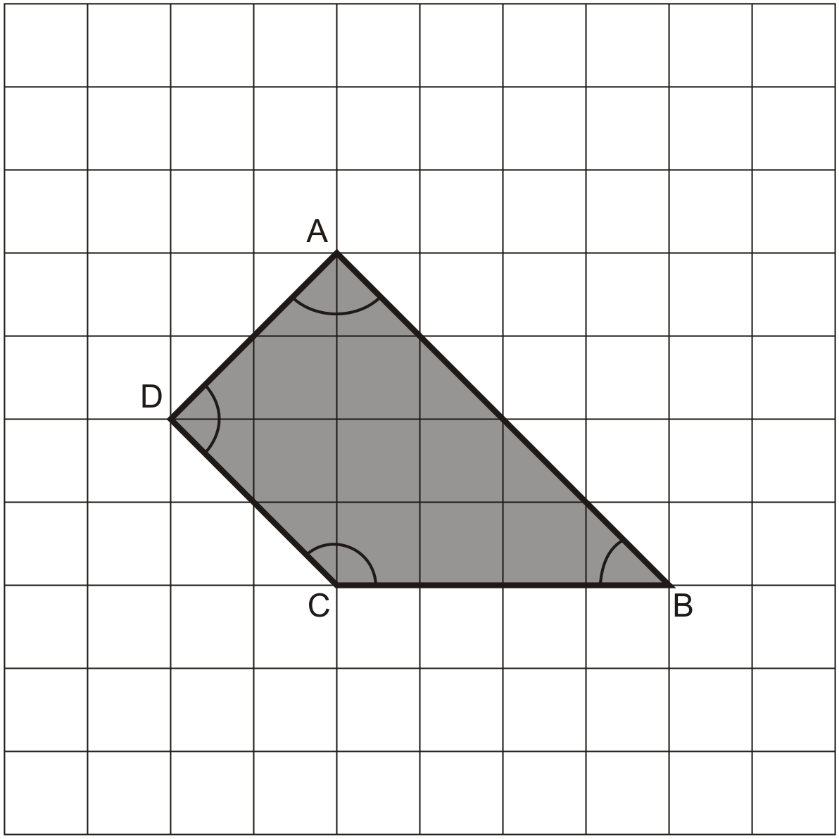

For each sentence, put a tick (✔) if it is true.
Put a cross (✘) if it is not true.

Angle C is an obtuse angle.
Angle D is an acute angle.
Line AD is parallel to line BC.
Line AB is perpendicular to line AD.

2 mark

Q3.
Here is a dial.

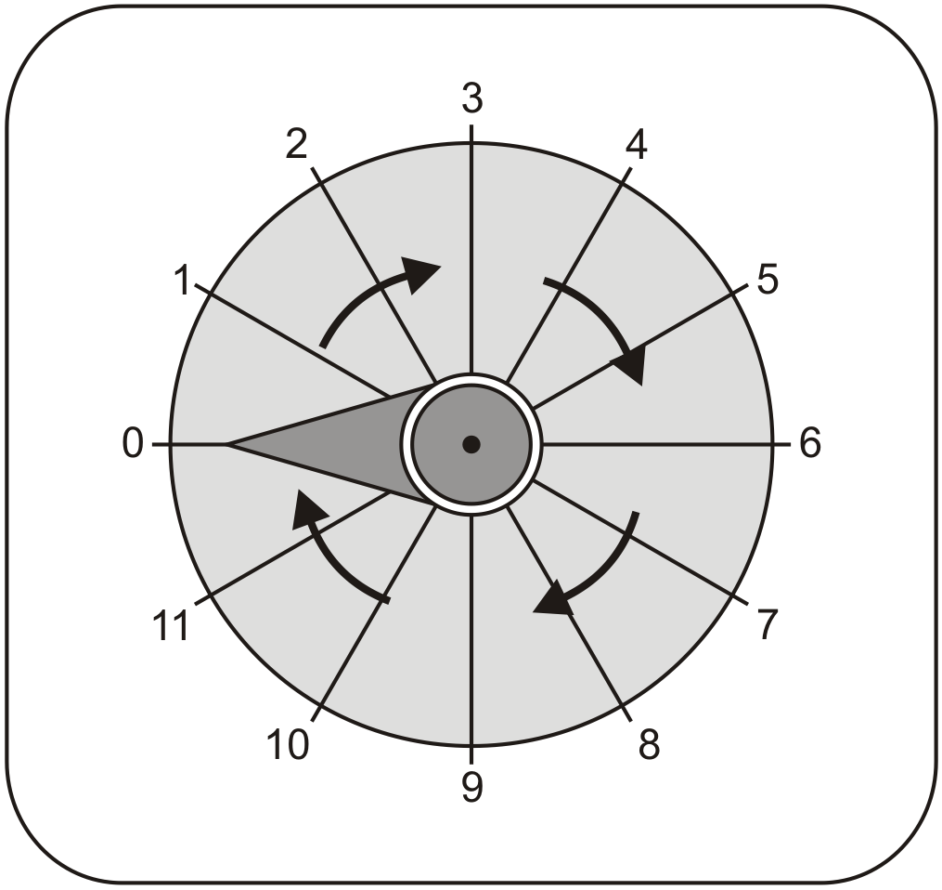

The pointer on this dial turns in a clockwise direction.
The pointer is at 0.
Which number does it point to after a turn of 270°?
1 mark

The pointer moves from 10 to 11
How many degrees does it turn through?
1 mark

Q4.
The diagram shows three identical isosceles triangles.
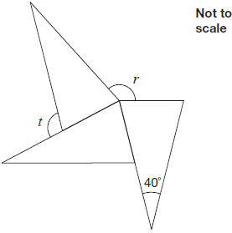

What are the sizes of angles r and t?

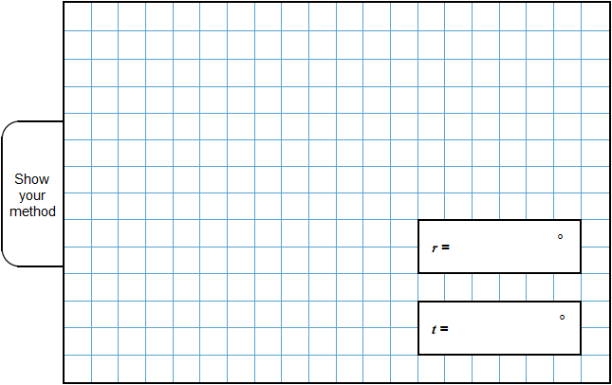
2 marks

Q5.
PQ is a straight line.
Not drawn
accurately
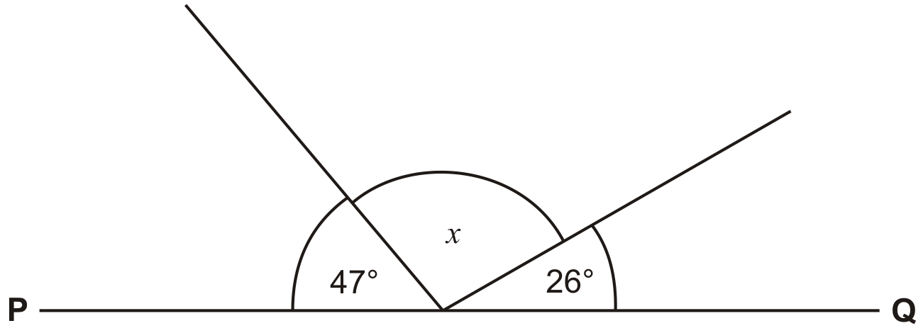

Calculate the size of angle x.
Do not use a protractor (angle measurer).
1 mark

Q6.
Here is an isosceles triangle.

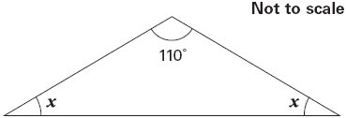

Calculate the size of angle x.
Do not use a protractor (angle measurer).
1 mark

Q7.
In this diagram AB is parallel to CD.

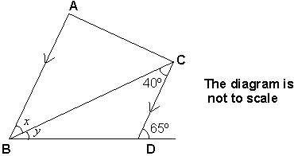
Work out the value of angle x.
Do not use an angle measurer.
1 mark

Calculate the value of angle y.
Do not use an angle measurer.
1 mark

Q8.
The shape ABCD is a rectangle.
BD is parallel to EF.

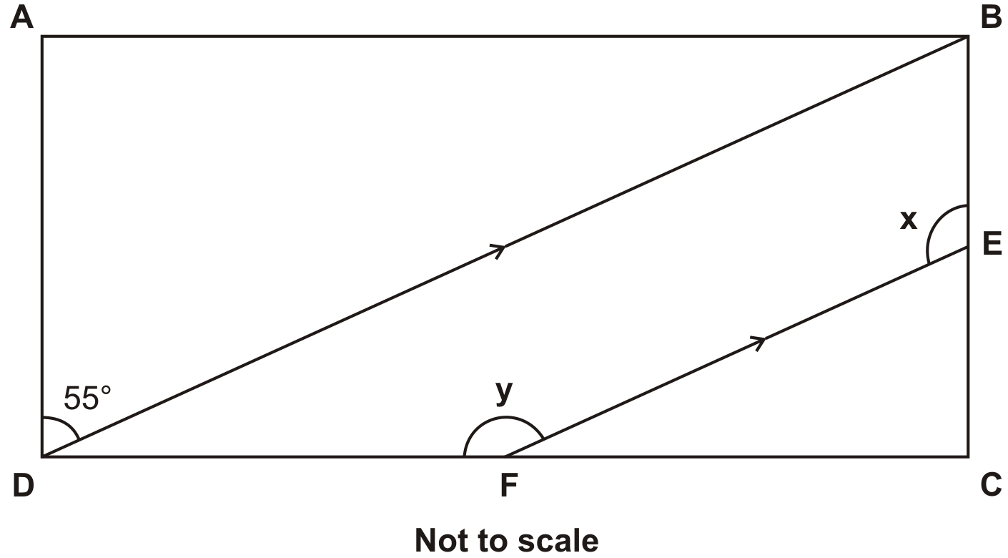

Calculate the sizes of the angles x and y.
Do not use an angle measurer (protractor).
2 mark

M1. Markers will use an acetate overlay of this page to mark children’s answers to this question.
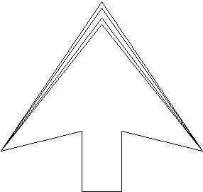
Award TWO marks for completed diagrams which have BOTH
angles in the range 39° to 41° inclusive, ie all lines drawn
within the inner boundary on the above diagram.

If this is not the case, award ONE mark for diagrams which
have BOTH angles in the range 38° to 42° inclusive, ie all
lines within the wider boundary on the above diagram. The
diagram need not be completed.
Accept slight errors in the completion of the diagram, provided
the intention is clear, eg if the lines meeting at the tip of the
arrow are slightly too long or too short.
[2]

M2. Award TWO marks for the boxes ticked and crossed as shown:
If the answer is incorrect, award ONE mark for any three boxes ticked or
crossed correctly OR two boxes correctly ticked and the other two boxes left blank.
Up to 2
[2]

M3. (a) 9
1
(b) 30
1
[2]

M4.r = 150 and t = 110
Values must be unambiguously associated with the correct letter for the award of 2m or 1m
2
or
r or t correct

OR
Shows or implies a complete, correct method for both angles, eg:
• 40 + 50 + 50 = 180 (error)
360 − 50 − 50 − 50 = 210
180 − 50 = 130
! Answers for r and t transposed
If r is 110 and t is 150, then award 1m
! Follow-through from incorrect base angle seen on the diagram

Award 1m if both r and t correctly follow through from an incorrect angle seen at base of an isosceles triangle, eg:
•
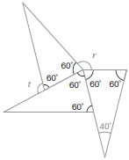
r = 360 − 180 = 180
t = 180 − 60 = 120
1
[2]

M5. 107
[1]

M6. x =
[1]

M7. (a) 40°
1
(b) 25°
1
[2]

M8. Award TWO marks for the correct answers x = 125 AND y = 145.
If the answers are incorrect award ONE mark for either x = 125 OR y = 145
OR the sum of x and y being 270.
up to 2
[2]

