Year 3 Homework w/c 4th May
Numeracy
Monday
Let’s start off the week with another quick recap on Odd and Even numbers to warm our maths brains up! Please complete the 2Do assigned to you. (I have assigned an extra challenge for some of you!)
You are then going to be looking at number sequences. Begin by watching the video:
https://www.youtube.com/watch?v=BSjKovDaY4w
Then, complete the resource ‘Monday Number Sequences’. You can choose which challenge you want to complete, Mild or Spicy. There is a Piri Hot challenge too!
Tuesday
Begin with completing the number sequence 2Do to consolidate your learning from yesterday. You are then going to be focusing on Roman Numerals. Earlier on in the academic year, we learnt Roman Numerals to 12. I think some of you could maybe even move onto Roman Numerals to 100 (which is a Year 4 target!) Watch this video to start:
https://www.youtube.com/watch?v=49oWYxExWKE
The video goes up to 1000! Do not panic! Just focus on how to work out Roman Numerals i.e. IV = 4 and the different ways to remember I, V & X.
Then complete the resource ‘Tuesday Roman Numerals’. Again, choose your challenge! You have Mild, Spicy OR Hot to choose from.
Wednesday
Today, you are going to be recapping how to round numbers. Let’s start with rounding to the nearest multiple of 10. Begin by practising your 10 times tables – these are the multiple of 10! You could watch this to help you (you’re welcome parents!):
https://www.bbc.co.uk/teach/supermovers/ks1-maths-the-10-times-table-with-webster-the-spider/zm32cqt
Then watch the below video on rounding numbers :
https://www.bbc.co.uk/bitesize/topics/zm982hv/articles/zdvdwty
Complete the resource ‘Wednesday Rounding to 10’. Again, there is a choice of challenge.
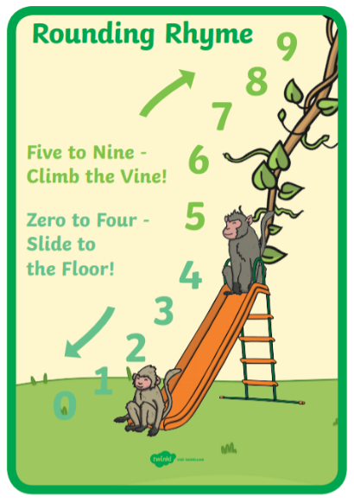
This little rhyme may help you:

Thursday
Today, you are going to be rounding to the nearest multiple of 100. As the video above says, to do this you need to look at the tens digit. Then apply the same rule to round to the nearest multiple of 100.
Please complete the Purple Mash activity assigned to you.
Friday
With our Place Value knowledge refreshed, let’s now move onto ‘Addition and Subtraction’. We will start off by adding ones, tens and hundreds to 3-digit numbers. Please complete the 3 2Dos assigned to you.

Literacy
This week, you will be writing a newspaper article about an exciting event – this could be something that has actually happened, or you could use your imagination! You could even link it to your favourite book or game. Some ideas:
- A UFO has landed in someone’s garden.
- A lion has escaped from a zoo.
- Superman is spotted saving a man from drowning in the sea.
If you search for ‘newspaper’ on PurpleMash there are lots of ideas and relevant templates too! I have included some extensions activities on the resource ‘Literacy Extension Activities’. These can be complete throughout the week and will need the newspaper article from Monday’s lesson.
Monday
Let’s remind ourselves of what a newspaper article is and how it is presented using the reading comprehension ‘Americans Have Done it: Men Land on the Moon’. You can wither type the answers or use this as an opportunity to practice your handwriting. I would love to see your work, so try to email it across to me. There are some extension questions for those eager children who would like a Piri Hot challenge!
Tuesday
You are again going to be using the newspaper article ‘Americans Have Done it: Men Land on the Moon’ for today’s literacy work. You should recognise some of the features of a newspaper from previous lessons this year. Please complete the worksheet ‘Sorting Features of a Newspaper Report’ on which you will sorting the different features into a table.
Wednesday
Some important things to remember when writing a newspaper article are the 5Ws (see below). Please use these to build some ideas on what your newspaper article is going to be about and the different information you are going to include in your article. Remember, you are writing this as a non-fiction text, even though it may be about a made-up situation. I would like you to include a direct quote in your article, so have a think about who this could be from and what they could say.

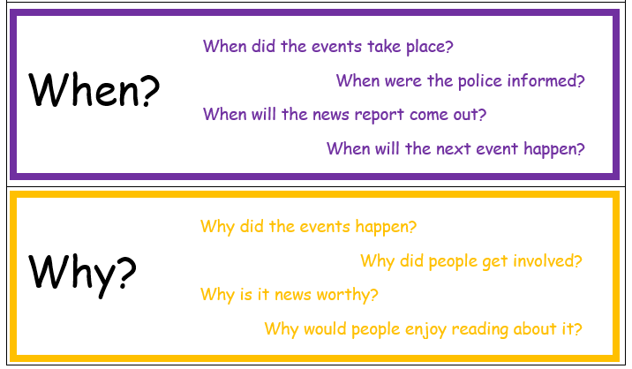
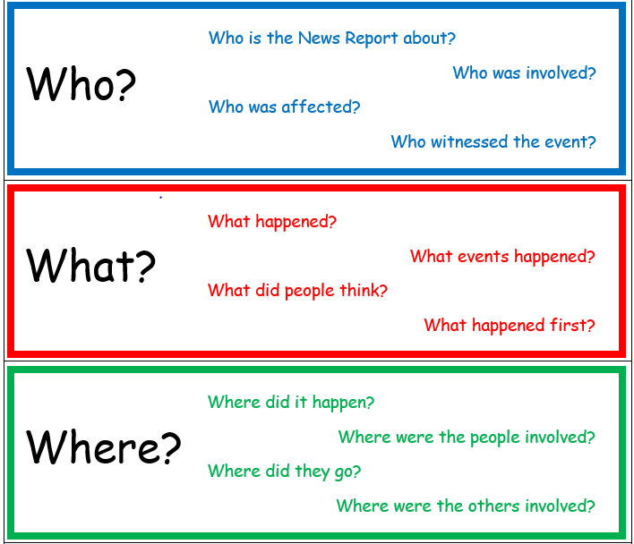
Thursday
You are going to start off this lesson with a quick recap on proper nouns. Proper nouns are the names of people, place and things that need a capital letter. Try the lesson and then games using the link below:
https://www.turtlediary.com/game/proper-noun.html
Then complete the ‘Thursday Proper Noun’ resource.
Friday
Today you are going to be writing your newspaper article using the Purple Mash 2Do ‘Blank Newspaper’. (I will release the activity on Thursday in case you would like a head start!) Don’t forget to include all of the features of the newspaper you sorted on Tuesday.
Here is a word mat you could use. Make you vocabulary as interesting as possible!
\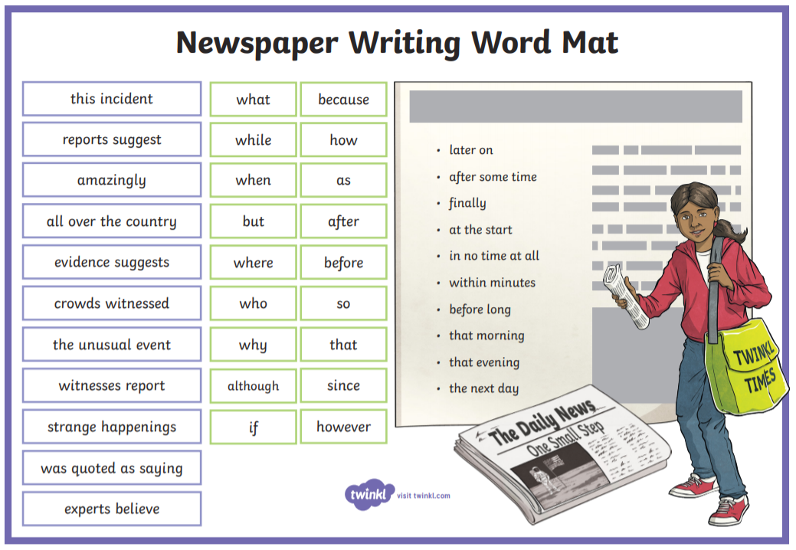

Science and Foundation Subjects
For your additional projects this week, please look at the resource ‘Science and foundation subject activities’ from last week. You should have completed 1 or 2 of the activities. Please email these across to me – or if you have completed them on Purple Mash – let me know so I can check your individual folder. To add onto this I have planned a fun French activity for you to complete.
French
This is your first school year learning French and you have all done a brilliant job! We have focused on introductions and basic personal information. Please create a poster titled ‘All About Me’ in French. Mrs Parnell has kindly completed her own poster for you to have a look at to inspire and give you ideas of some things you could include. I am not expecting you to remember everything on the poster so feel free to as a parent for help!

VE day
As you may know, VE day is on Friday 8th May. To celebrate check out the website below to sing a long to some old war songs! There will be a live broadcast at 11am on Thursday 7th May aimed specifically at primary school aged children. I hope you enjoy it!
https://www.carradinescockneysingalong.co.uk/ve-day

Spelling
I hope you are keeping up with your spelling practice. For those children who would like to challenge themselves here is a list of all the Year 3 & 4 rules for you to work through. Please continue working through the Year 3 & 4 common exception words too.
https://www.theschoolrun.com/spelling-in-year-3-and-year-4
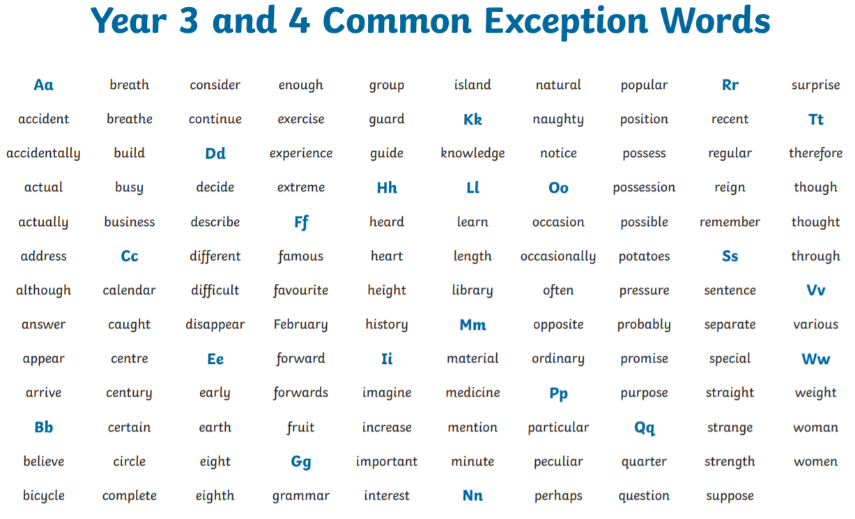

As always, if you have any questions/concerns at all, please give me an email on:
g.brennan@henhamugley.essex.sch.uk

Mrs B

