Year 3 Homework w/c 1st June
Dear parents and kids,
I hope you have all had a brilliant half term and enjoyed the glorious sunshine! This is what we have planned for this week.

Numeracy
This week we are going to try something new! As I previously mentioned, at school we follow the White Rose Maths scheme. They have released some tutorial videos with accompanying resources which I hope you find useful. The videos are packed full of information so feel free to watch them a few times.
We are going to be starting the new topic ‘Multiplication and Division’. As I’m sure you are aware, children should already be secure in their 2x, 5x & 10x tables (from Year 2) and be focusing on their 3x, 4x and 8x tables in Year 3. You will be following the link below and using the website to watch the educational videos:
https://whiterosemaths.com/homelearning/year-3/
Extra challenges! If you find that your child is shooting through the maths work, please use the ‘Extension Questions’ resource to challenge them!
Monday
On the White Rose website link above click on Summer Term Week 3 (w/c 4th May) – Lesson 4 - Multiply and Divide by 3.
Watch the video and work through the examples (Have a go). Then select the ‘Get The Activity’ to access the questions. The answers are on the website if you would like to use them.
Tuesday
First, complete the Purple Mash activity assigned to you so I can see how you’re getting on with your 3 times tables.
Then, using the white rose link above please click on Summer Term – Week 4 (w/c 11th May) – Lesson 1 – Multiplying and dividing by 4 and 8.
Again, please watch the video then answer the questions on ‘Tuesday maths resources’ on the school website.
Wednesday
Before moving onto some trickier multiplication problems, let’s consolidate our learning of the 3, 4, and 8 times tables.
Please complete the Purple Mash activities assigned to you.
Some of you have been given an extra third challenge.
Thursday
You are going to be using the White Rose website again. Please click on Summer Term – Week 4 (w/c 11th May) – Lesson 2 – Multiply 2 digits by 1 digit.
In this lesson you will be drawing to help you with your calculations. You will also be using your place value knowledge and, where relevant, exchanging.
This website has a useful video to watch too if you are finding this a little tricky:
https://www.bbc.co.uk/bitesize/articles/zb4gcqt
Please then complete ‘Thursday Numeracy Resources’.
Friday
Times tables focus! Please complete your daddy grid and see if you have beaten your previous score/time. If you find that you are struggling with a particular times table you can use ‘2Simple Table Toons’ on Purple Mash to help you learn them. Simply search for ‘2Simple Table Toons in the search bar and select the relevant times tables.
Again, I will be online on Purple Mash at 11am to play a multiplication game with you all! Please search for ‘2Race’ and select the room Golden!
Hope to see you all there!

Literacy
This week you will be writing a poem! This poem can be about anything that interests you. It might be about your favourite animal, holiday, sport or even how you are spending lockdown! There are a few activities to complete first!
Monday
Today you are going to be looking at similes and metaphors. Use the link below to access the BBC website:
https://www.bbc.co.uk/bitesize/articles/zmmpscw
Watch the 2 videos, complete Activity 1 then move onto ‘Inventing New Similes’ resource on the school website. This is your chance to create your very own similes! I would love to see these! You could even draw some funny pictures with them!

Tuesday
Today you are going to be using the poem ‘Dragonfly Out in the Sun’ by David Windle to work on your reading comprehension skills. Please find resource ‘Tuesday Poetry Comprehension’ on school website.

Wednesday
Today you are going to be adding your own verse to a poem about the ocean, following the same structure. Please use ‘Wednesday Literacy Resources’ to do this. Feel free to add more than one verse! Please send them to me as it would be lovely to put all of your verses together to make a class poem!

Thursday & Friday
You are now going to be writing your own poem! As you have seen from the poems this week, they do not have to rhyme! You could write an acrostic poem, shape poem or a free verse poem! (See examples below). It would be brilliant to receive a recording of you performing your poem!
Shape Poem
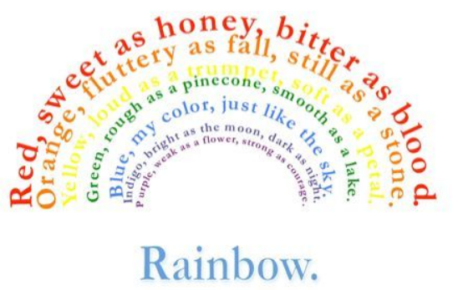

Acrostic poem
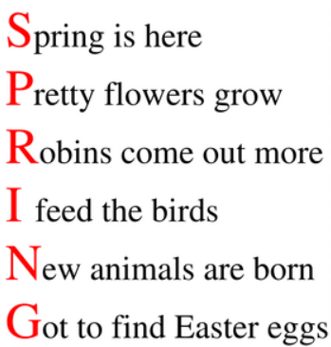

Free Verse
Spellings
We are going to continue working through the Year 3 Common Exception words using Purple Mash. Again, I will assign the test to you on Monday and then again on Friday, giving you a chance to practise the words that you got incorrect. This week you will only be focusing on one set of words and will therefore only have one test to complete on Monday and Friday.
If you are signed up to the Spelling Frame website you will not have been set these 2Dos. Please just focus on you Spelling Frame words.

Foundation Subjects
We have put together another Foundation Subject grid for you to complete throughout this half term. Please choose 1 or 2 of these cross curricular activities per week. Feel free to send me pictures of your brilliant work – I would love to see it!

Have a brilliant week everyone and I hope to see you all very soon!

Take care,

Mrs B

