Year 3 Homework w/c 11th May

Just a quick note to say how brilliant all of your home-school work has been. I know this is a bit of an odd time but you (and your families) and doing an amazing job and I’m the proudest teacher in the world!
Numeracy
We are going to be continuing with the Addition and Subtraction topic. At Henham we follow the White Rose Maths scheme. If you would like to have a look at it here is the link:
https://whiterosemaths.com/resources/schemes-of-learning/primary-sols/
It shows the different years groups and topics covered. When you click on the topics, it will show the sequence of lessons that I follow and give examples of Fluency, Reasoning and Problem-Solving questions for each lesson.
Please be aware that if there are a choice of challenges (Mild, Spicy or Hot) your child only needs to complete ONE of the them. This is how some of our maths work is set out in school so the children should already be familiar with this. If your child is finding Mild too easy then they can move onto a harder challenge, and equally, if they are finding a challenge too tricky, then can then move down one. The Peri-hot challenge is an additional activity for those children who want an even trickier challenge.
Monday
Building on your Place Value knowledge, you will be subtracting ones, then tens, then hundreds from 3-digit numbers. Please complete the 2Dos assigned to you.

Tuesday
Now you have completed lots of Fluency problems let’s have a go at some problem solving and reasoning questions! Complete the resource ‘Tuesday Problem-solving and Reasoning’. These are a bit tricky so you need to read each question carefully. Please feel free to email me your work!

Wednesday
Today you are going to be looking at related number facts. Understanding the relationship between addition and subtraction (they’re commutative) will help children with their mental maths and problem-solving skills. For example:
Bar mode:
15
7 | 8
7 + 8 = 15 8 + 7 = 15
15 – 7 = 8 15 – 8 = 7

Part-whole model:

100 65 + 35 = 100 100 – 35 = 65
35 + 65 = 100 100 – 65 = 35
35 65

Please complete the resource: Wednesday Numeracy Resources. I have also attached the answers for you to self-correct when you are finished.

Thursday
Today you are going to continue looking at Fact Families. Please complete the 2 Dos assigned to you.

Friday
Let’s work on our mental maths skills together with addition and subtraction. You will be using the Purple Mash game – 2Race. I will set some 2dos for you to complete – you have either 2 or 3.
At 11am on Friday morning (15th) I will be setting up some live rooms so we can all compete against each other! You will need to search ‘2Race’ on the search bar then select it. Follow the instructions to join the room ‘Golden’.
I hope to see you all there!

Literacy
This week in literacy, you will be creating your own ice cream flavour and container! You will need to promote your amazing new ice cream using a brilliant advert. A big thank you to Mrs Richardson for coming up with this brilliant idea and the planning!
Monday
Start the week with some recap 2Dos on tenses. You will be identifying different tenses and rewriting sentences in different tenses. One of the activities is Ice Cream themed!

Tuesday
With all the lovely weather we have been having, I’m starting to think about all the yummy ice cream I like to eat on hot, sunny days.
Do you know how ice cream is made? This video looks at just that, as well as how the sea makes waves. (The waves bit is interesting but if you wanted to skip straight to the bit about ice cream it starts at 07:15)

https://www.bbc.co.uk/iplayer/episode/m0008dxp/maddies-do-you-know-series-3-18-waves-and-ice-cream

Can you design your own ice-cream flavour? It could either be in a cone, lolly, tub or a new container of your own design (this could be edible!). Think about the flavours you like and get creative! Orange ice cream with swirls of chocolate sauce and jelly-beans maybe? Or chocolate ice cream with raspberries and marshmallows?
You might want to look here for some ideas and inspiration
https://www.benjerry.co.uk/flavours/ice-cream-tubs

Draw a picture of your design and label the different parts. You can do this on paper or using the Tuesday 2do (you will not be able to add text to label your design but it’s a fun tool for drawing your ice cream!).
Try to use lots of descriptive words. Can you include some expanded noun phrases? What name would you give your creation?

Some vocabulary you might need:
Ice cream | Fruity | Chocolate
Flavour | Sauce | Fudge
Taste | Crispy | Caramel
Texture | Crunchy | Biscuit
Swirl | Chewy | Honeycomb
Chunks | Creamy | Delicious

Wednesday
Today you are going to be looking at adverts and use these as inspiration for ways to make your advert stand out. If you have any magazines at home, look through them and think about what makes an eye-catching advert. What makes you stop to look at a particular page? Here are some adverts for food and drinks from a magazine.
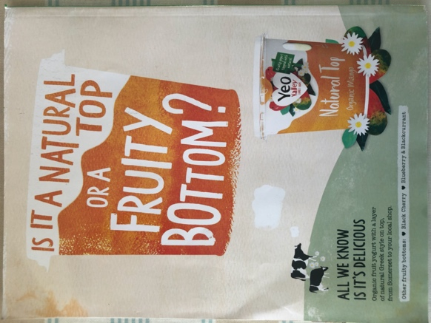 | 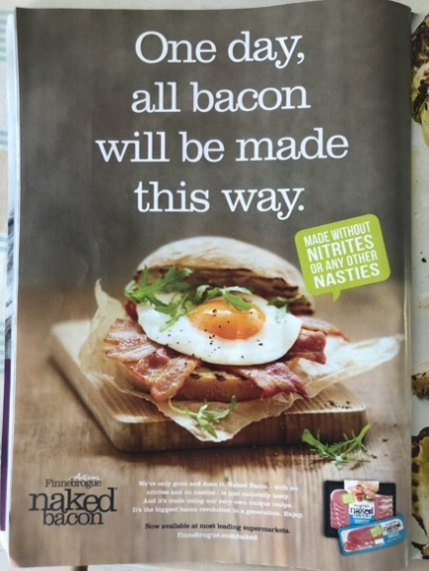
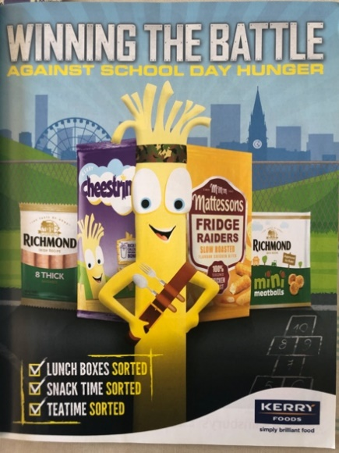 | 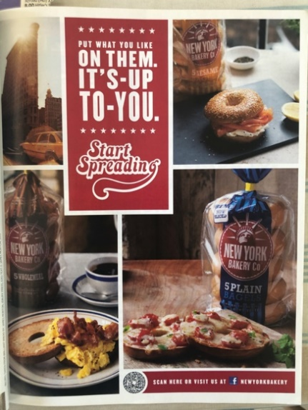 | 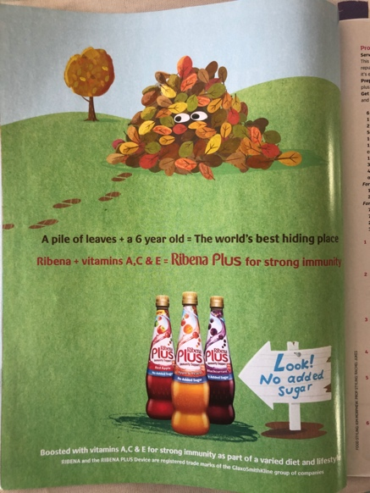
What do you notice about them? Are there more words or pictures? Are there long sentences or short catchphrases? Are they funny? Do they have lots of details, like lists of ingredients, or just a short description? Would you buy it?
Make a quick plan of how you want your advert to look, ready for tomorrow.
Thursday & Friday
Today you are going to be making your advert! Again, you can either do this on paper, or using the Thursday 2Do. If you use the 2Do, you can add your picture of your ice cream from earlier on in the week using the green arrow. Use the resource ‘Advert Help’ to help you remember what to include.
Please send me a picture of your advert if you have done it on paper.

Science and Foundation subjects
For your additional projects this week, please look at the resource ‘Science and foundation subject activities’. You should have completed 3 or 4 of the activities. Please email these across to me – or if you have completed them on Purple Mash – let me know so I can check your individual folder.
Music
Myleene Klass has a YouTube channel on which she uploads music lessons. Have a go at the one below (parents – I apologise in advance). She shows you how to use household objects as instruments and how to drum out basic paradiddles to form a rhythm. Good luck!
https://www.youtube.com/watch?v=hA2Z-GVNdxo

Spellings
I hope you have all been practising your common exception words! I have set 2 tests using Purple Mash. Please practice the words that you have got wrong (if any!). You can do this in bubble writing, multicoloured, using a pyramid or even create a wordsearch!
Mindfulness
As we have been learning at school, mindfulness is a really important tool we can use to look after both your physical and mental health. Mrs Parnell has very kindly created a document with lots of different activities you could do to keep you feeling calm, focused, fit and entertained – you could even get your family to join in! Please see resource – Mindfulness Activities. There is also a Mindfulness colouring that you could print off and do – I find these really relaxing. A big thank you to Mrs Parnell for providing this!
We miss you all very much and think that you are all doing such an amazing job of your home schooling! Keep up the good work everyone

Mrs B, Mrs P and Mrs R

