Writing Challenge!
Which writing opportunities here take your fancy? You can complete as many as you like!

Draw a map of your dream bedroom.  Label 12 items you’ve included | Write a very short scary story | Write the first half of a story for a family member to finish | Write outdoors
Write a letter to the main character of the last book you read | Write a recipe for the most delicious ice cream sundae | Create a poster sharing ideas for being kind to others | Write the instructions explaining how to play an outdoor game
Make a list of the top ten books you have ever read | Write a story featuring a rollercoaster | Write a list of 101 things that make you happy! | Create a paragraph in response to, ‘If I were my teacher…’
Create a comic strip | Write a story featuring your oldest toy | FREE CHOICE  Write for 20 minutes without stopping | Plan your dream holiday
Write a tongue twister | Create a secret code and write coded messages | Write about a time you felt super excited! | If you opened a restaurant, what food would you serve? Create a menu
Write a letter to a friend of relative | Create a series of quiz questions about a topic of interest | Write a list all about YOU | Write a review of the last film you watched

There are also SPAG activities set on Purple Mash. Some of these activities I know you have already completed; they have been set again for you to revisit and recap.
Purple Mash:
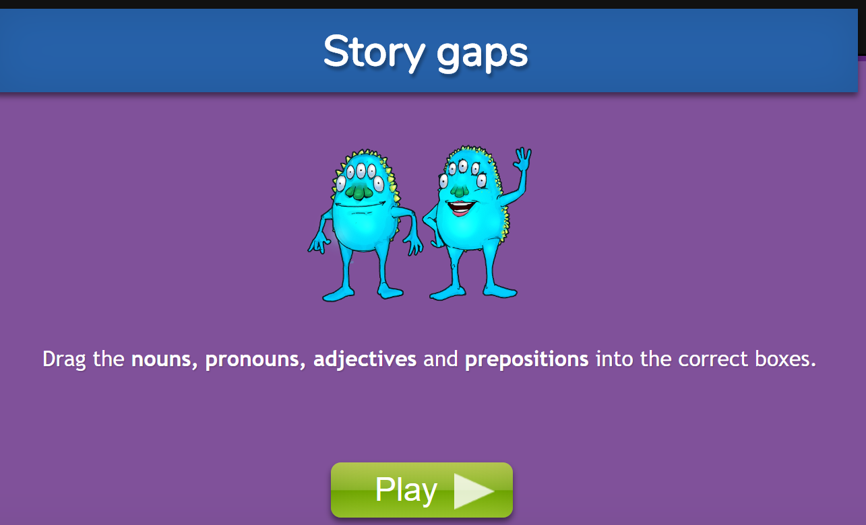 | 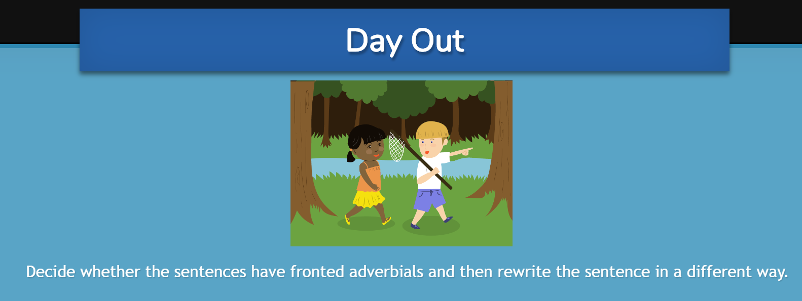 | Spelling list for this week:  Prefix inter (means ‘between’ or ‘among’)  interact  intercity  international interrelated interchange interconnected  internet intermediate intermission interweave
Choose 8 words from the Year 3 / 4 Common Exception Word List to concentrate on this week. You can always dip into the Year 5 and 6 list if you feel you you are ready for an extra challenge! | You could also complete some of the 60 second reading comprehensions that are included for you to use too.

