Wednesday Rounding to the Nearest Multiple of 10
Mild
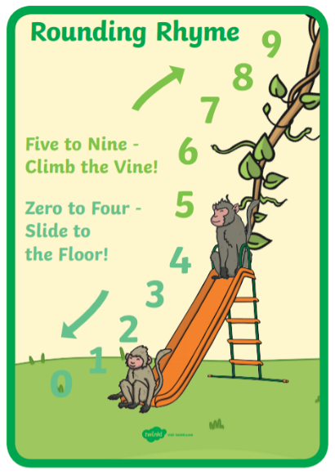
Fluency
- Complete the table

Number | Rounded to the nearest multiple of 10.
39
71
20
6
89
124
168

Reasoning
Which numbers are incorrectly placed in the table below? Explain why
Nearest ten is 110 | Nearest ten is 120
105  114  109  113  104 | 118  119  124  126  122

Spicy
Number | Rounded to the nearest multiple of 10.
67
32
158
845
624
996
1248

Reasoning
Which numbers are incorrectly placed in the table below? Explain why.
Nearest ten is 740 | Nearest ten is 750
Seven hundred and thirty-eight  744  736  741  Seven hundred and forty six | 747  Seven hundred and fifty-three  745  Seven hundred and fifty-six  755

Problem Solving
The numbers represented by the place value counters that are hidden behind the splat can be rounded to 120.
There are fewer that 6 counters. What could they be? Show all possibilities by drawing the place value counters.

