VE Day Celebrations!
This week’s learning is a little different. Friday is a bank holiday, as it is the 75th anniversary of Victory over Europe (VE Day). Our nation will come together to commemorate the service and sacrifice of the WWII generation then and now. This is a themed week for you, so our focus here will mainly be English and History, though many of the activities will be cross curricular too.
This list is not exhaustive at all – maybe you have your own ideas for different tasks you could undertake? Maybe your family have ideas about different activities you could do altogether. Maybe you want to find out more about evacuees, or what clothing was like? Twinkl also has a wide range of resources and power points for other learning activities you could undertake.
Don’t forget to celebrate your learning with me – email it across and I promise I will reply when I can.
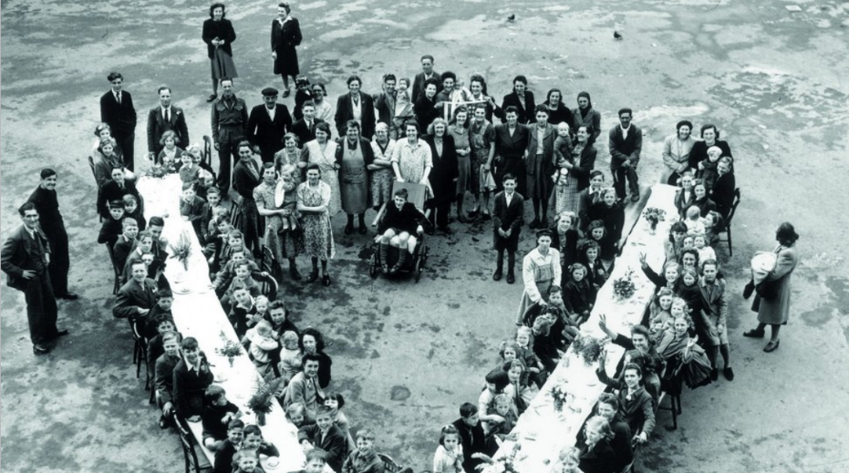
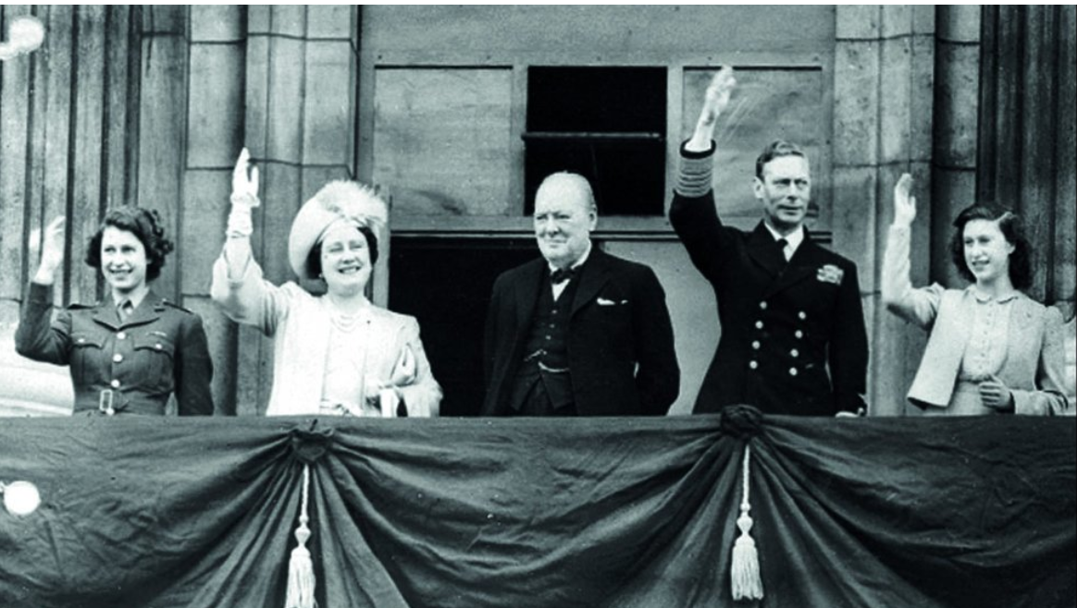

https://www.bbc.co.uk/teach/class-clips-video/history-ks2-ve-day/z7xtmfr  This is a short clip explaining what VE and VJ day are.  May I suggest parents watch it first / watch it with your child. | Research the Blitz. How did people try to keep themselves safe? Investigate the different types of shelters that could be used in the home, e.g. Anderson shelter, Morrison shelter. Were these effective? What other things did people do? At home? In London? Can you find photographic evidence to show that all people had to carry a gas mask, even babies, and that during wartime people even used the top of their Anderson shelters to grow vegetables! | Investigate and learn some of the simple songs that were made famous during Wartime Britain, e.g. Run, rabbit, run, or The White Cliffs of Dover. | Find out about co-ordinates.  Play battleships.  Use the grid and instructions included.
What is Morse code?  http://www.crayola.co.uk/free-coloring-pages/print/morse-code-message-coloring-page/  Can you write/send me a message in Morse code? | Plan a VE day party. Can you create a food and drink menu? Maybe your parents can give you a budget.  How many people can you afford to hold a party for? | During the war, many homes had blackout curtains, which helped to block out the light. Streetlights also had to be turned off. This was to prevent enemy planes from using the lights as guides to locate British cities in order to bomb them.  Using a torch and a selection of materials you can find at home, investigate which materials are best at blocking light and why. | Use nets of shapes to make a gas mask carrier. Make sure you use a ruler to measure accurately in centimetres. Don’t forget to include tabs so you can fix the sides together.

Use a range of primary and secondary sources that are available online to investigate why the Second World War started. What happened to Germany after World War One? Why did Hitler become so popular? Identify that both Czechoslovakia and Poland were invaded, and Britain protested. Listen to Neville Chamberlain’s speech. What does that tell us? | Create a simple timeline showing the major events of the Second World War. What were the significant events? Who were the leaders of the Axis Powers and the Allied countries? | Listen to a range of songs from the period, including In The Mood and Boogie Woogie Bugle Boy. What do you like/dislike about them? What instruments were used? | Design a propaganda poster. What message will you send? What are the popular images and colours that are used?
Investigate and make some war time recipes, then write your own versions of the recipes.  Which key ingredients are missing? How does this affect the taste and | Identify and label the countries on a world map that were involved in the conflict. | Use a map of the United Kingdom to identify where was bombed. Identify the major cities of London, Manchester, Birmingham, Manchester, Plymouth, Glasgow, Coventry and Hull. Why were those cities the main targets? Look at the population of these places and what was produced there. | Taken from the Royal Legion website, there will be:  - A live VE Day 75 livestream at 11.15am  - National moments of Remembrance and thanksgiving, including a Two Minute Silence at 11am  - A UK-wide singalong to Vera Lynn’s ‘We’ll Meet Again at 9pm
As your English Task this week, keep a double page spread / power point / diary telling me about and share some of the learning activities and experiences you have undertaken for VE day. Try to write a short explanation and add to it every day as a record of your weekly learning.

