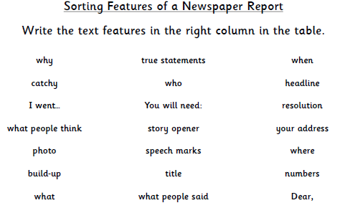
I would find these in a newspaper report | I would NOT find these in a newspaper report

