Tuesday Roman Numerals
Mild
Use your knkowledge of Roman numerals to help you colour in the below table.
Remember!
I = 1 V = 5 X = 10

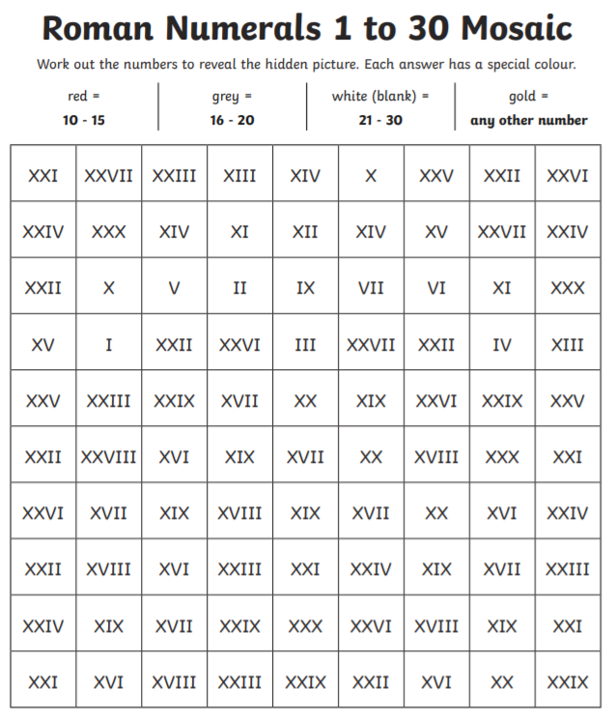
Spicy
Use your knkowledge of Roman numerals to help you colour in the below table.
Remember!
I = 1 V = 5 X = 10 L = 50

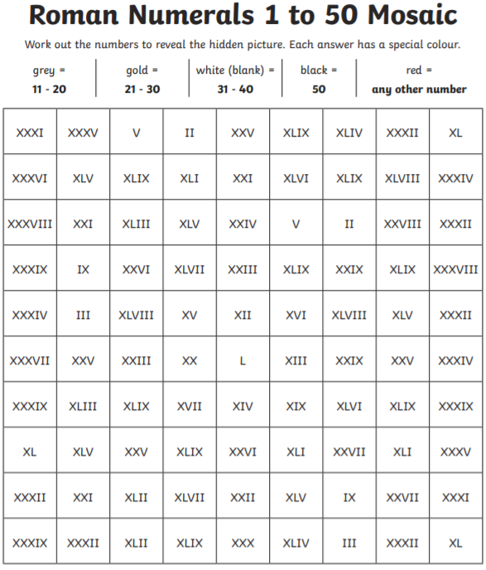

Hot
Use your knkowledge of Roman numerals to help you colour in the below table.
Remember!
I = 1 V = 5 X = 10 L = 50 C = 100
