Tuesday Resources
Please choose EITHER the Mild or Spicy challenge to complete. There is also a challenge!
Mild
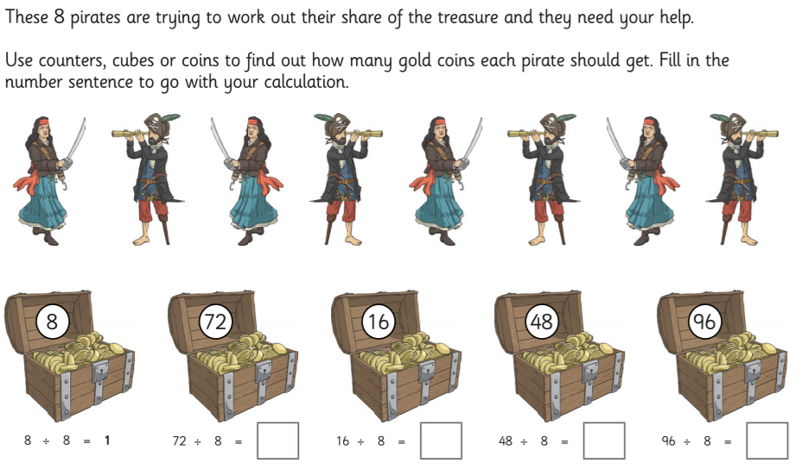
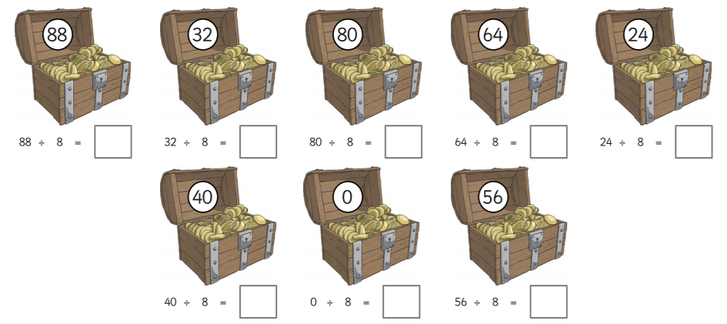

Spicy
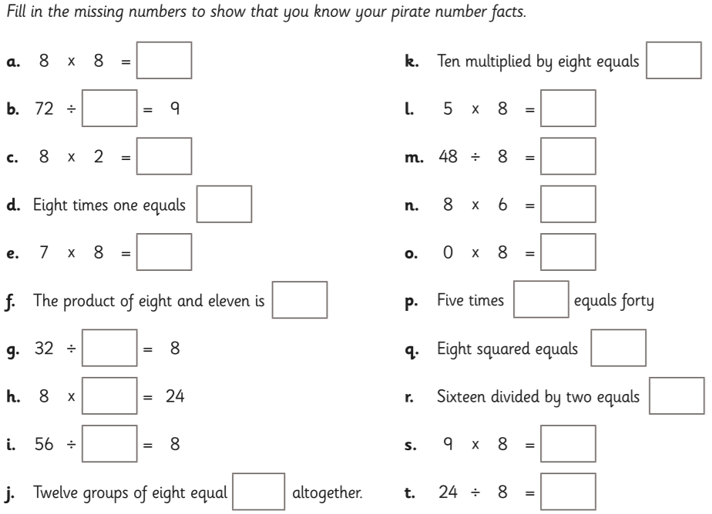

Challenge
