**100**

G

**Grammar**

P

**Punctuation**

S

**Spelling**

3

marks

marks

5

5

marks

**1**

Put in the inverted commas to show what the people are saying.

**a)**

I’m so hungry!

**b)**

T hat’s fantastic news.

**c)**

I had a brilliant weekend.

**2**

Mark in the missing inverted commas to show the direct speech.

**a)**

Stop that!” shouted Jacob.

**b)**

I was so frightened,” explained Maya to her best friend.

**c)**

Why didn’t you tell me before?” asked Mum.

**d)**

If only you knew the full story,” Rory whispered.

**e)**

I’ve lost my pencil,” Bessie told the teacher.

**3**

Mark in the missing inverted commas to show the direct speech.

**a)**

“Remember not to go near the bonfire, Dad warned.

**b)**

“It’s my birthday soon, Sebastian said excitedly.

**c)**

“Don’t be too late back, Grandpa called.

**d)**

“Friday is my favourite day of the week, Amin told Owen.

**e)**

“I don’t like peas! shouted Carlos.

Writing - Vocabulary, Grammar and Punctuation

Using Inverted Commas for Direct Speech

Challenge 1

P

Marks ........./13

**1**

Tick the correctly punctuated sentences.

**a)**

Blake said, “I love going fishing.”

**b)**

“Finn shrieked, this is great!”

**c)**

I don’t want to fish, explained Layla.

“I don’t like fishing.”



Challenge 2

P

**101**

2

marks

marks

5

marks

6

marks

11

Using Inverted Commas for Direct Speech

Writing - Vocabulary, Grammar and Punctuation

**d)**

“Please may I have a turn”? asked Abdullah.

**e)**

“ Please be careful,” warned Mum. “It’s very dangerous.”

**2**

Mark in the inverted commas to show the direct speech.

**a)**

Today is going to be so much fun, yelled Panjit.

**b)**

Lily whispered, Has it gone yet?

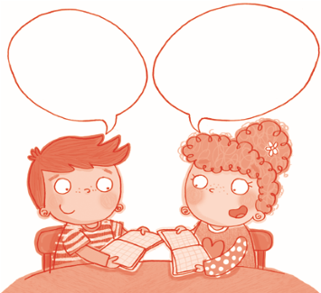

**c)**

I’m not sure about this at all! moaned Ed.

**d)**

I love swimming, explained Belinda. I’m quite good at it too!

**e)**

I’m tired, said Hamish. At least we can rest when we get home.

Marks ........../7

**1**

Insert the missing punctuation in this paragraph. There are

**four**

inverted commas,

**one**

full stop and

**one**

question mark missing.

**2**

Insert all the missing punctuation in this paragraph.

Is it nearly time to go

” asked Horace.

“I hope so,

replied Alfie

I’m so excited.”

“I think it will be even better than we think!

shrieked Horace.

When I get home I’m going to have a big drink of water said

Megan. I’m very thirsty!

“It’s been a great day but I’m exhausted now Bethan replied

“Shall we go again tomorrow” Megan asked.

Definitely! shouted Bethan.

Challenge 3

P

Total marks ............./37

How am I doing?

Marks ........./17