While you are at home, pick 1 or 2 activities a week to complete.
To commemorate the 75th Anniversary of VE day, I have listed some activities to celebrate this special occasion.
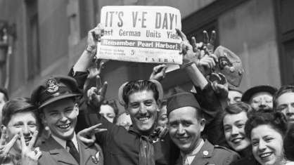  History  Create an informative poster about why we celebrate VE day. I have attached a reading comprehension so you can find out some facts from there! Have a go at doing your own research as well using factual books. | Art  Design and make your own war time medal!  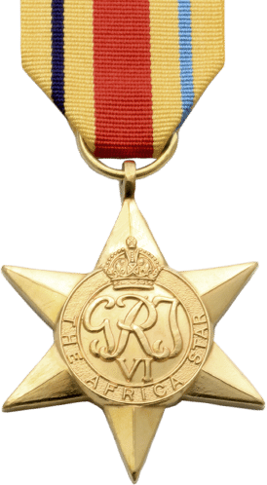 | Science  Can you carry out an experiment to see if this statement is true or false?  The older you are, the faster you are.  (Hint: You might want to think of a way to collect your data so you can refer back to it.)
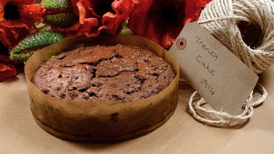  Design and Technology (Food)  During the War people in Britain would bake and post a fruit cake to loved ones on the front line. Some traditional cake ingredients were hard to come by. So they came up with a new recipe that didn’t include eggs called Trench cake. Research the recipe on the internet, have a go at making it and maybe send it to one of your loved ones who is in isolation. | Geography  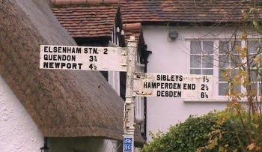  Compare your locality with a small area in a contrasting non-European country. Draw examples of any differences or similarities and write down why this might be the case. | 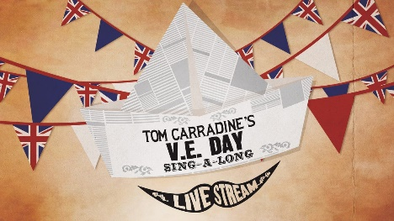  Music  Join in with Tom Carradine’s sing along on Thursday 7th May at 11.00am to commemorate the 75th Anniversary of VE Day! There are videos and lyrics so you can learn the songs before-hand and be well rehearsed.  https://www.carradinescockneysingalong.co.uk/ve-day

