Tiles on a Patio

Imagine that round the back of where you live is a piece of ground that your family want to change. Instead of grass or plants growing there you want to have a patio. To prepare to change it the ground is dug up and levelled, it is then measured and found to be a square 10 by 10 [this could be feet, metres or yards it does not really matter for this challenge]. You then go to a large store that sells tiles to go on the ground. To your surprise you find that they sell tiles in ten different sizes; 1 by 1, 2 by 2, 3 by 3, etc. up to 10 by 10. You decide to go back home for a while and work a few ideas out.
You start by drawing a 10 by 10 square; and then you think about what sizes of tiles to use to cover it.
If you use 1 by 1 tiles then you find [or know already!] that you will need 100 of them. So your shopping list would look like :-
100 tiles @ 1 by 1 > Total number of tiles 100
If you use 10 by 10 tiles then you find [or know already!] that you will need 1 of them. So your shopping list would look like :-
1 tiles @ 10 by 10 > Total number of tiles 1
If you use 2 by 2 tiles then you find [or know already!] that you will need 25 of them. So your shopping list would look like :-
25 tiles @ 2 by 2 > Total number of tiles 25
You could of course use a mixture of different sized tiles.
If you use 12 tiles 2 by 2 and 4 tiles 3 by 3 and 1 tile 4 by 4 your shopping list would look like :-
12 tiles @ 2 by 2
4 tiles @ 3 by 3
1 tile @ 4 by 4 > Total number of tiles 17
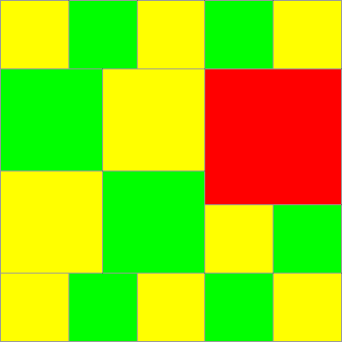
So you could, with these examples use 1,17,25 or indeed 100 tiles.
Your challenge starts by asking you to try to find lots of different numbers of tiles that could be used to cover this 10 by 10 patio.
You could think about the artistic appearance of it as well if you like. However all the patio must be covered and no cutting any of them to make different sizes or shapes ... they're actually very, very hard to cut anyway.

You could now think about these kinds of questions and perhaps you would think of other questions of your own to pursue.
- Are there some numbers of tiles used that actually are made up of different mixtures of tiles? [For example in our one that used 17, could you get to use just 17 tiles but they require a different shopping list from the one above?]
- Are there some numbers between 1 and 100 that cannot be used as the total number of tiles required?
- Is there some system for getting new examples that use different numbers of tiles?

You might then think about how all this might or might not change if the patio had been 9 by 9 [8 by 8, 7 by 7 etc ...]
Well good luck, and if you're artistically inclined I guess that you may have some results that would look really good displayed. Since you're sitting at a computer it may be that you could use a "draw/art" package to do all the work on the screen for you. But have a break from the screen every hour ... your body deserves it!

For example / possible solutions, please visit https://nrich.maths.org/35/solution

