Giant Sports!
This week I have used Pobble 365 to create a series of writing tasks around the illustration above. The writing opportunities you undertake may not be linked to tennis – choose your own favourite sport if you would prefer. Choose 2-4 to complete during the week. Don’t forget to celebrate your learning with me during the week - email it across and I promise I will reply as soon as I can.
You could complete some of these activities on Purple Mash. If you search sports, there are various templates you can use such as:
- Sports Star Profile
- Player Profile
- Game Rules
- You will need to save them into your own work file on Purple Mash. You could then send them to me as a PDF if you wish.

Imagine you are going to interview your favourite sporting role model  What questions would you ask them? | What are the rules of your chosen sport?  Produce a leaflet or poster to display these. | Who is your sporting role model? Why do you aspire to be like them? | Story Starter:  It was the greatest match the world had ever seen! The boy’s colossal legs waded through the water, sending shockwaves through the city engulfed in shadow. With a loud grunt, the enormous child lunged towards the sun, ready to take the shot…
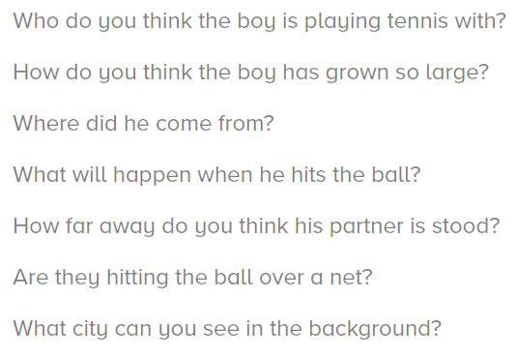  Question Time: | Can you produce an alphabet of sports / teams / sports men/women associated with your chosen sport?  If your words begin with the same letter, can you arrange them into alphabetical order by looking at their second/third letters too? | Design a new strip/outfit for your chosen sport.  Then write a paragraph to persuade me to buy it! | For all these tasks where necessary, please try to think about and include:  - Write in paragraphs, grouping related material together.  - Expanded noun phrases with prepositional language  - Fronted adverbials  - Ensure standard English forms for verb inflections, e.g. we were instead of we was, I did instead of I done.  - Proof read your work for spelling and punctuation errors  - Subordinate clauses
Look very carefully at the Year 3 / 4 Common Exception Word List.  Identify 8 spellings that you are still working on and focus on these this week. Think about some of the strategies we have learnt in class. How creative can you be in how you practise them?  If you think that you are very secure with the Year 3 / 4 spellings, challenge yourself you learn some from the Year 5/6 list. | Produce a fact file about your chosen sporting role model. | Produce a training circuit.  Write a short instruction for what to do at each station of your circuit.  Maybe you can persuade your family members to take part with you! | Spelling rule  https://spellingframe.co.uk/spelling-rule/21/18-Words-with-the-/s/sound-spelt-sc-(Latin-in-origin)  https://spellingframe.co.uk/spelling-rule/13/8-The-suffix-ly  Along with tasks linking to these rules set on Purple Mash

