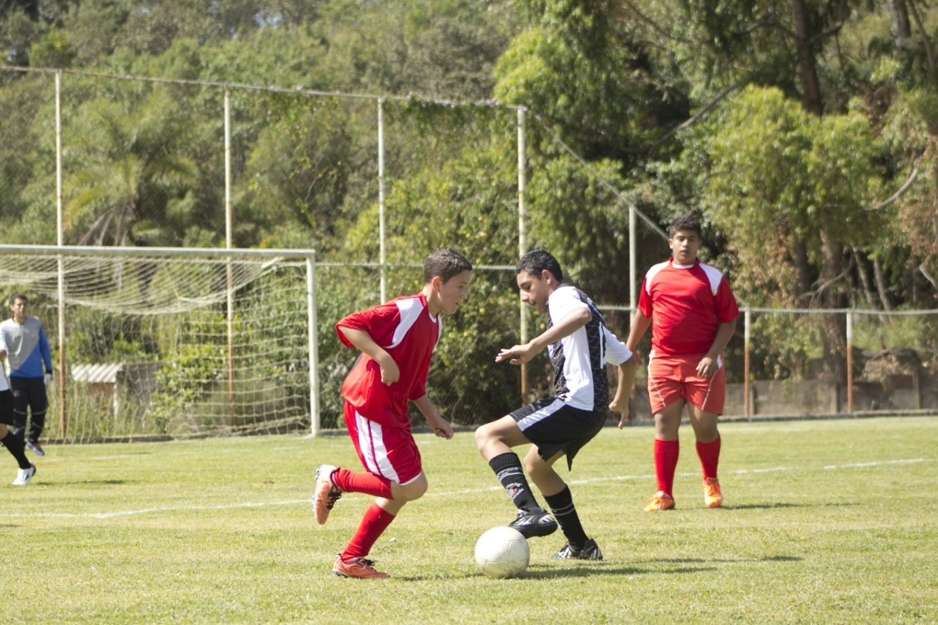
Reading task 1
Have a look at the picture and then answer the questions below.
What do you think is happening in the picture?

Why are the boys wearing different coloured shirts?

Why is the man in the grey and blue jumper stood in the background?
What do you think that the boy in the black shorts is thinking?

Possible answers:
I think that the boys are taking part in a football match.
I think that the boy in the black shorts is thinking, ‘I’m going to stop him from getting the ball’.
I think that the man in the background is the goalkeeper and he is waiting in the net to defend against goals.
They are wearing different coloured shirts because they are on different teams.

Drawing a picture using information
Can you read the following information and draw what is being described?

It has 8 candles on top.
My mum has made a bright pink cake for me.
It is decorated with a colourful design of dots.
Around the bottom, there are yellow circles.
On the sides, there are four stars poking out on sticks.

