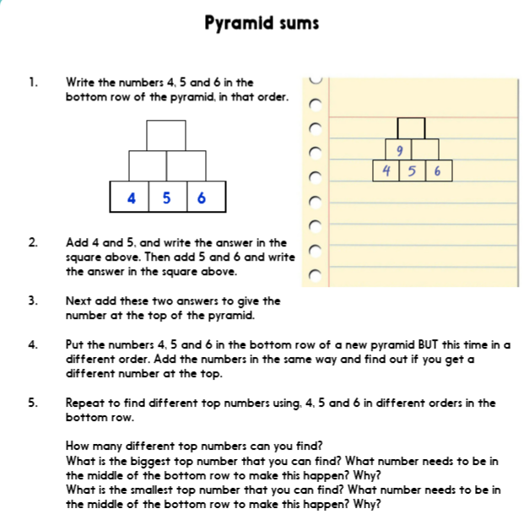

Extension:
Can you create another pyramid. This time adding an extra row to the bottom and using the numbers 1,2,3 and 4.
Move the numbers around once you have made the first pyramid and see what happens.
Things to think about: which order of numbers will give you the largest number at the top?
Which order of numbers will give you the smallest number at the top?

