Phonics week beginning 18th May
The graphemes we are looking at this week are:
ph, ew, au and oo.

Once again these are ones we have covered in class so these are a recap of those.

Activities to complete:
- Read through the power point of different words containing these graphemes
- ph grapheme activity – see separate resource
- au grapheme activity – see separate resource
- ew grapheme activity – see next page
- ‘oo’ as in u grapheme activity – 3 different activities – pick one; answers are included in the same resource.

Extension/extra activities:
- Can you continue writing out the alphabet using lower case letters and then capital letters?
- Can you continue practise saying and writing the days of the week? – Could use different coloured pens for the different days of the week; write them using chalks; think of different ways to practise writing them.
- Can you practise saying and writing months of the year? Same activities could be completed to days of the week or could draw pictures next to each month of the year to remind children about what happens during this month – maybe a particular event etc.
- See Twinkl Tricky words booklet for extra activities on the tricky words covered in phase 5 phonics.

‘ew’ grapheme activities

Circle all the words which have the ‘ew’ grapheme in them.

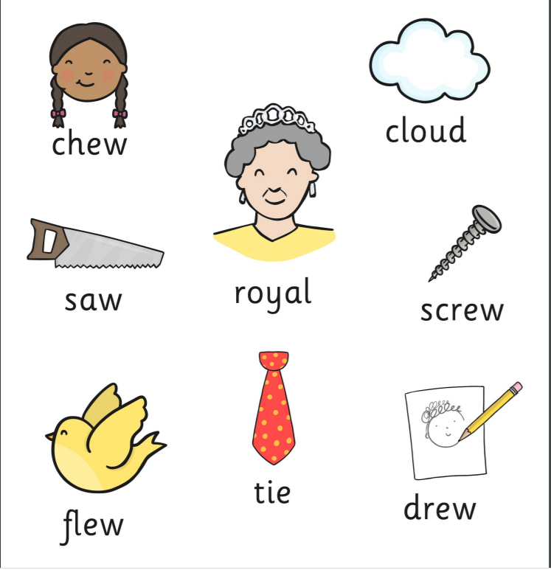

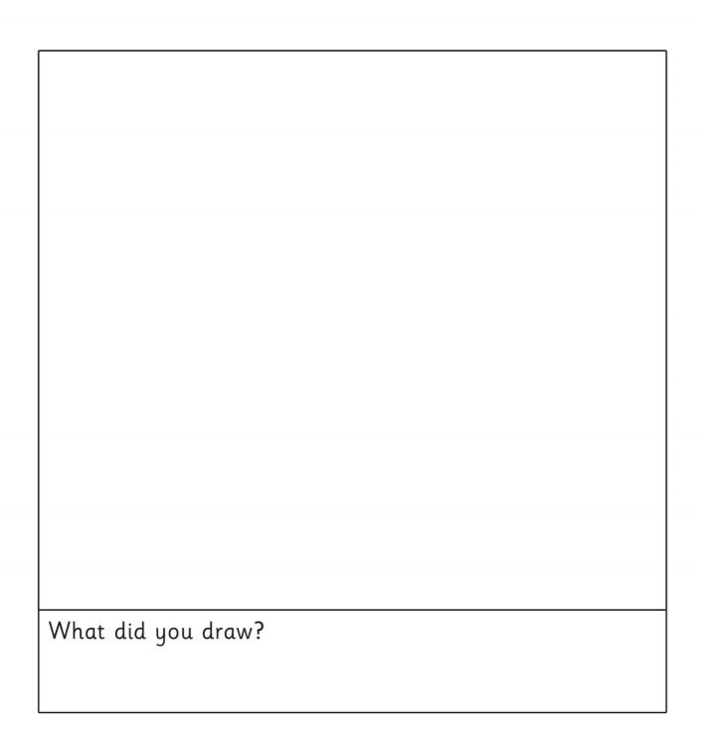
Draw a picture using the ‘ew’ grapheme.

