Phonics wb 1st June
For phonics, keep going with the phonics power points posted previously to recap the different graphemes.
Here are some activities for this week, again recapping what we have covered in class:
- Split digraph read and race game
- Spot the split digraph activity – see below
- Split digraph colouring activity – see below
- See separate resource for split digraph writing activity

Extra activities: Can you write silly sentences containing different words with split digraphs in? How many can you come up with?
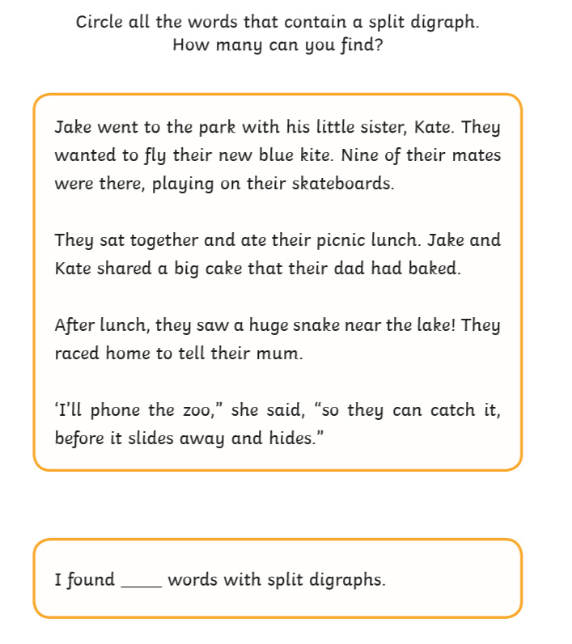
Spot the split digraph activity

Spot the split digraph answers
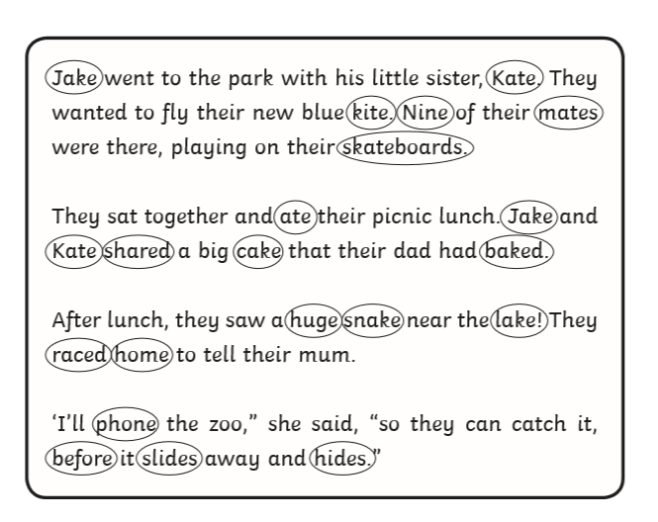

Split digraph colouring activity
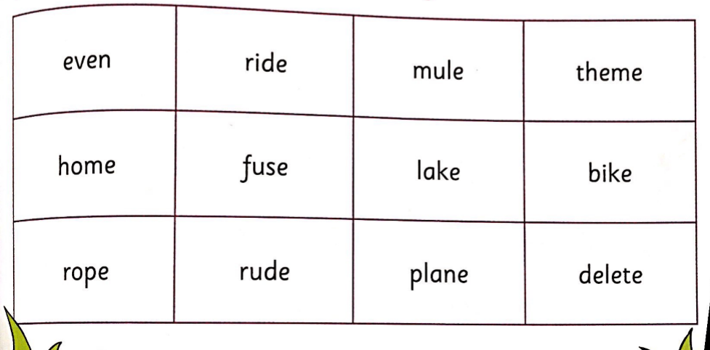
Colour words containing a_e, i_e, o_e and u_e in using different colours.

