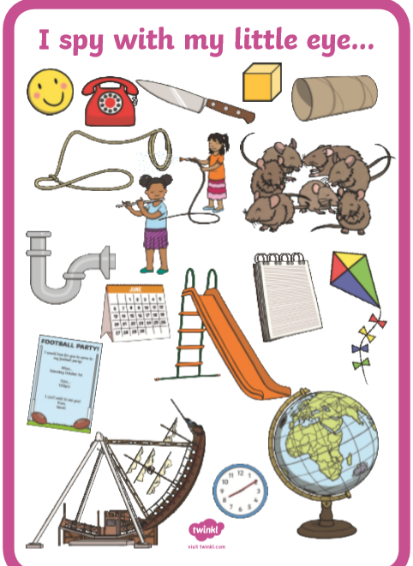

Using the picture above what words can you put in the table?
Can you then think of your own words which would go in each column?
 | i_e | o_e | u_e
Words from i-spy

Own words

