Dear parents,
I hope you are all well and enjoying the good weather. This week the maths tasks will continue on from last week and will be about numbers to 50; tens and ones and partitioning numbers. In English the tasks start working on punctuation with sentences before the children can then apply this to a couple of writing tasks. In reading there is a task about farmyards. There is a set of questions after the written text and there are also extension questions. Please don’t feel you have to do all the extension questions! I have also attached some PE tasks sent from the School games organiser.
As always I hope you have a good week. Email me if you have any questions or have things to share. I always enjoy seeing what the children have been up to – both linked to learning or not!
Missing you all,
Miss Branch

English tasks:
- Missing punctuation activity – read the ‘fruity sentences’. On the lines below, can you rewrite the sentences as they should be written.
- Rewriting sentences – read the words that are in the wrong order. Can you work out by reading the words what the sentence should say? Can you then rewrite it as it should be on the line below?
- Visit the link to see/hear a desert island - https://safeyoutube.net/w/Dxh6 Writing task: Could the children write a message imagining they are on the desert island – write a message in a bottle. Think about what they could hear, see, smell and touch? Or could they write a message to a friend they cannot see right now or a family member. Alternatively, get them to write me an email and I will respond to them.
- Writing activity linked to the desert island activity: Can they plan the perfect trip? Think of somewhere they would like to go – park, forest, beach etc. Get them to plan and then write about what they would need to bring with them; get them to draw and label what they would bring; what they would do at their chosen location; what games would they play when they are there; how long would they spend there etc.
- Brainstorm with the children all the different things they are grateful for or make them happy. Talk about if there are things which they have enjoyed doing over the last few weeks that have made them happy. Can they write a list of the things they are grateful for/ have made them happy or could they draw some pictures of them doing these things and then write a couple of sentences underneath about what it was and why it made them happy. See resource to help with this.

English Task 1
Hint: capital letters and full stops!
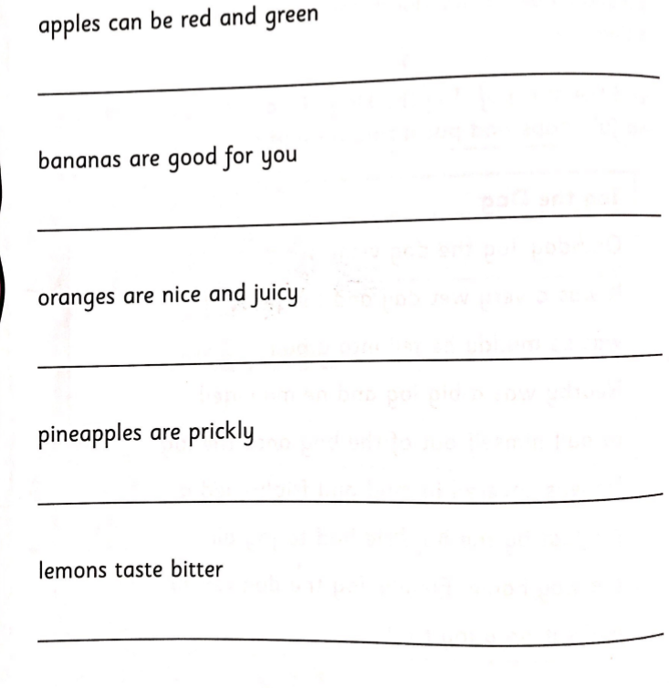

English Task 2
Hint: Remember, full stops at the end of the sentence and capital letters at the start!
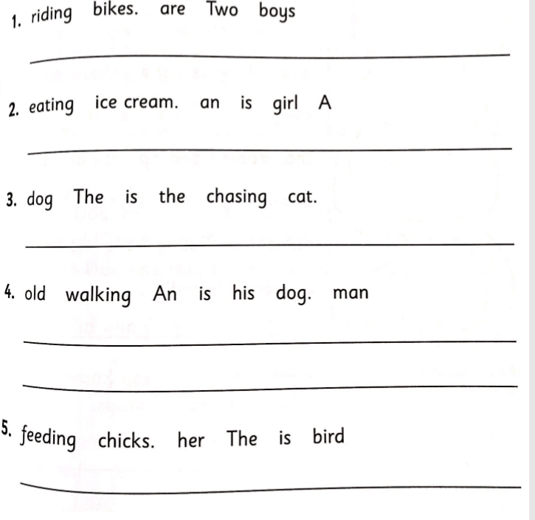
Answers:
- Two boys are riding bikes.
- A girl is eating an ice cream.
- The dog is chasing the cat.
- An old man is walking his dog.
- The bird is feeding her chicks.

Possible extension: Once they have written their sentences, could they underline all the nouns?
Could they then circle/highlight any adjectives?

English Task 5
What makes me happy

Sentence starters for Task 5:

Seeing _______________________ makes me happy because ______________________________.

Doing ________________________- makes me happy because ______________________________.

I enjoy _____________ because _____________________________________________________.

