Hi all,
I hope you are all well. It has been lovely to catch up with you all via email or phone. Please keep sending me pictures of what you have been up to as I love hearing your news.
This week’s activities are below. I have again put the maths into 4 tasks/ days along with the English and there are 3 graphemes to focus on this week for phonics as well as a couple of reading activities.
The English writing activities link to one of the reading tasks – all about Knights this week!
Any questions, please email me.
If your child is doing Nessy please continue with that daily along with spellings, reading and completing the 1-100 grid.
Thanks,
Miss Branch

English
For reading there is a reading activity called ‘Knights’ which then links to the writing tasks.
Writing/ creative tasks
- Which is your favourite knight from the pictures and why? Discuss this or write an answer.
- Design your own knight – draw them and label them. Think will your knight wear armour? Extension: Could you then write 3 or 4 sentences to tell me all about your knight including what their name is, where they live, what they are like etc.
- Design a shield that your knight would carry
- Create your own castle that your knight would live in – you could draw this, build it out of Lego or other materials at home. Could you then label it or do some writing explaining all about your castle?
- Extension: Could you write your own short story about a knight? Think about where they would live, who they would fight/rescue? You could write it, record yourself saying your story or draw a story map to tell the story.
- You could read about Saint George and the dragon see power point for the story.
Writing task to link with this: create a wanted poster for the dragon (either use the writing frame provided or create your own wanted poster)

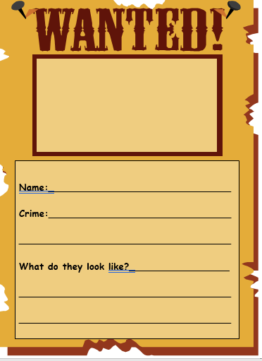
Designing your own knight
Red: adjectives
Blue: nouns
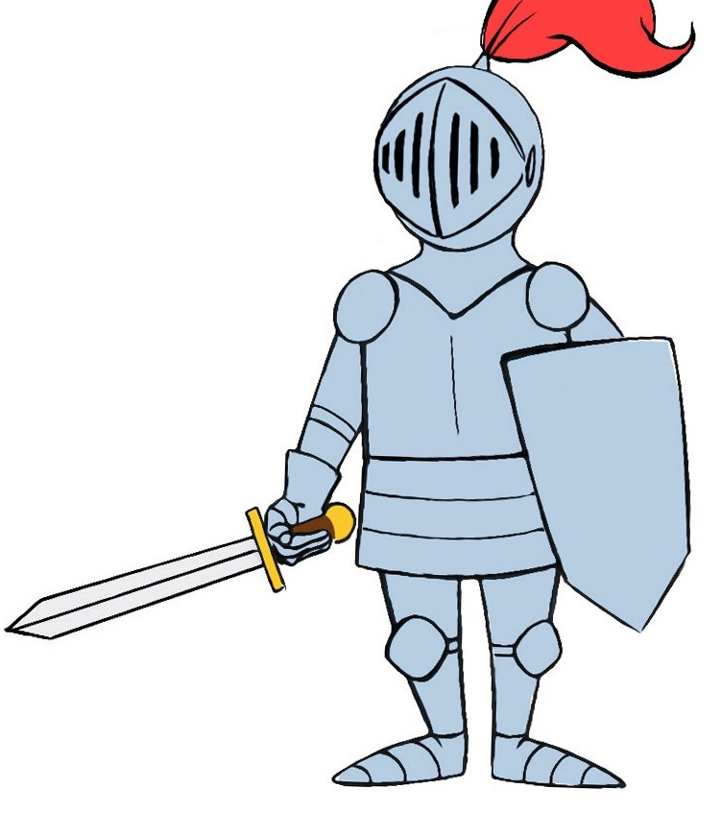
Strong shield

Sharp metal sword

Writing about your knight
Example:
My knight is called sir Charles. Sir Charles lives in a large, old castle with his family. He wears strong metal armour because he has to protect people. He has a sharp sword and a strong helmet. Sir Charles works hard and rides around on horses.
Sentence starters:
My knight is called___________________________________
He lives ________________________________________
He has _______________________________________________

