

**Year 5/6: Cricket catching skills**

Can you do the following activities as well as Heather Knight? Have a go!

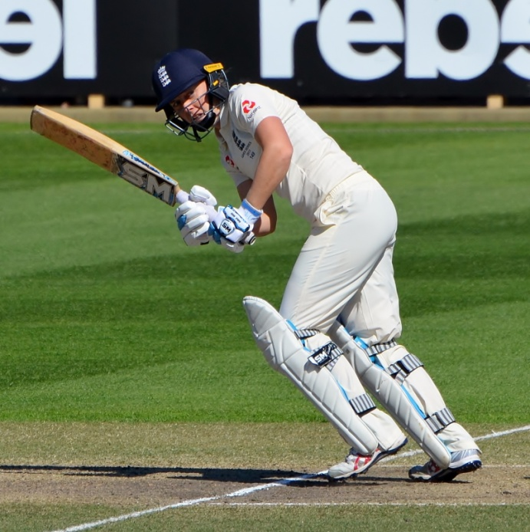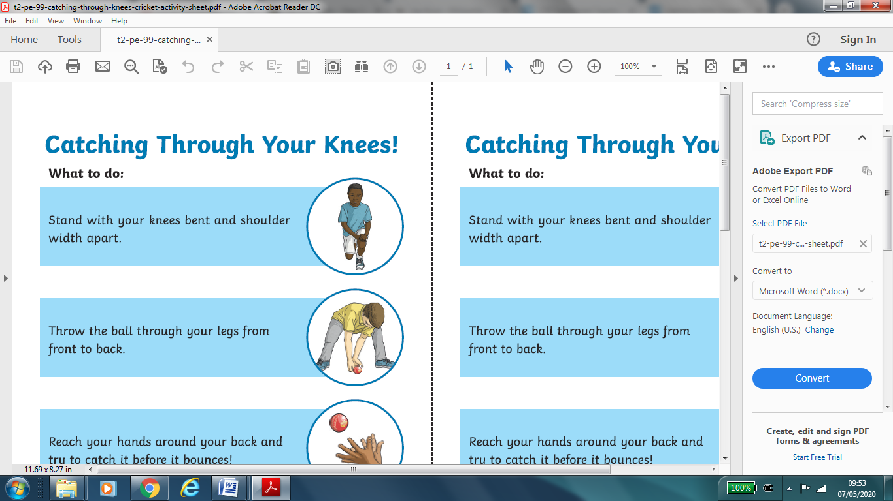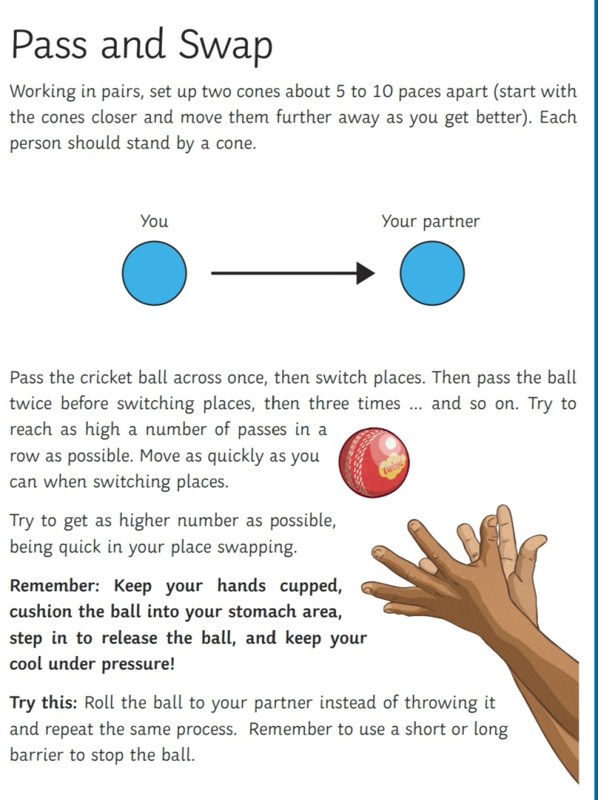

Can you catch with one hand?

Try a different size ball !

Heather is 29 years old. She has played cricket for England since 2010 and took over as captain in 2016. She was the first female cricketer to score a fifty and take five wickets in a One Day International innings.

Heather Knight – England Women’s Cricket Captain

1. Sit down
2. Throw the ball up in the air
3. Stand up
4. Try to catch the ball before it bounces!

Sit, throw, stand and catch

3. Reach your hand around your back and try to catch it before it bounces.

1. Stand with your knees bent, shoulder width apart

2. Throw the ball through your legs from front to back.

Catch through your knees

Pass and swap