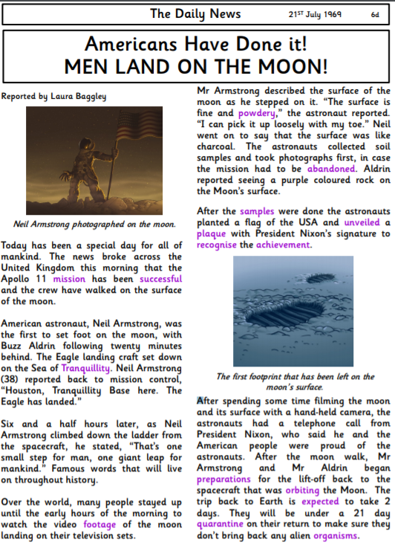

Questions
- On which date was the first moon landing?
- What is the name of the second man to walk on the moon?
- Which two adjectives did Mr Armstrong use to describe the surface of the moon?
- Why were the astronauts quarantined when they returned to Earth?
- Why do you think samples were taken from the moon?
- Would you like to walk on the moon? Explain your answer.

Extension questions
- Who would you like to meet from the text? Explain your answer.
- What was the most interesting part of the article?
- What does ‘the astronauts received a telephone call from President Nixon who said he and the American people were proud of the astronauts’ tell you about what President Nixon thought?

