Maths week beginning 4th May
Here are 4 different maths tasks and I will also include some extension work – see pyramid sums investigation.
Task 4 is a consolidation of shape work and is a separate resource.
Task 1
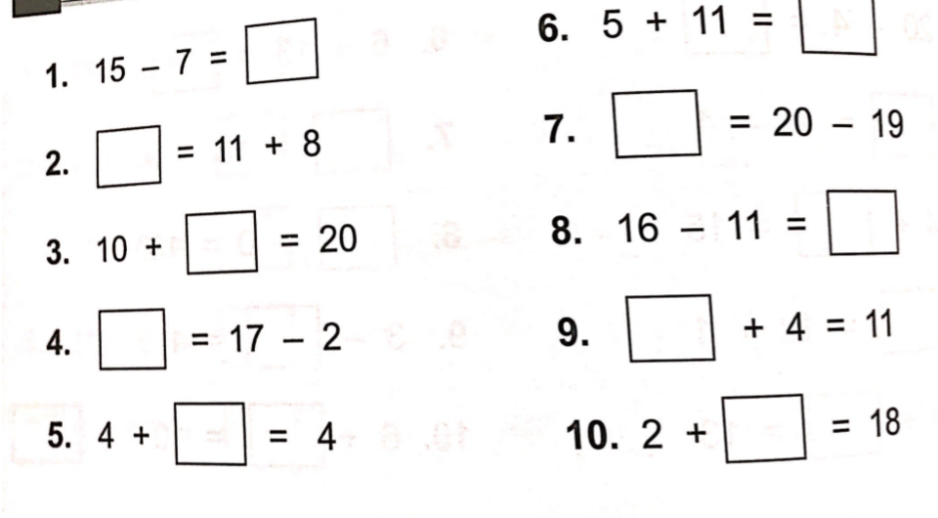
Answers:
- 8
- 19
- 10
- 15
- 0
- 16
- 1
- 5
- 7
- 16

Then pick one or two of the ‘Making a number activities to complete’. See separate sheet for this.

Task 2
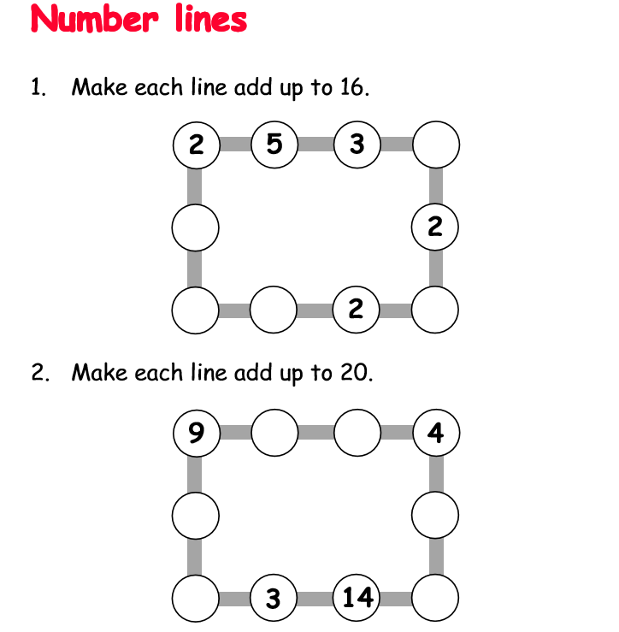
Extension: Could you make up your own puzzle like this for someone in your family to solve?
Answers:
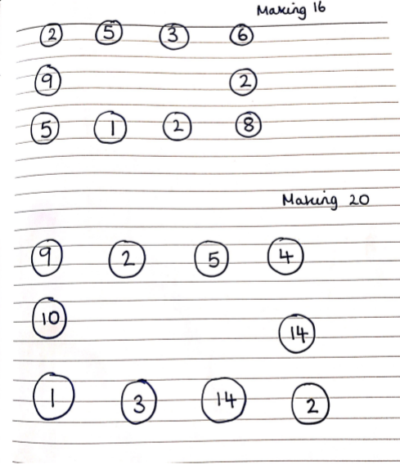

Task 3
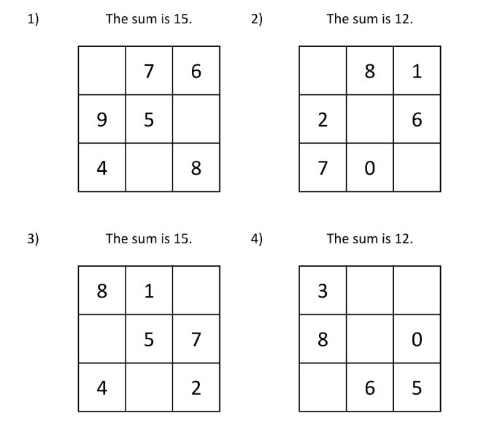
Magic squares – With magic squares each row, column and diagonal add up to the same total. Can you work out what numbers go in the different boxes?

Answers: 