Maths week beginning 18th May
Maths this week is all about representing numbers up to 50 and identifying how we partition numbers e.g. 18 is one ten and eight ones.
On Task 2 where it talks about base ten this is it:
Base ten is where tens are represented by this: and ones are represented by this:
The ten is just ten ones – the children have used this in class so will be familiar with this.
Task 1 – separate resource from classroom secrets looking at different ways of representing numbers using Numicon, diennes, whole-part whole models. There are a lot of questions you can either do them all or start with the first sheet and if your child is getting it then move on to the next one. It gets harder as you move through the three sheets.
Task 2 – see separate resource again practising identifying how many tens and ones there are in a given number.
Task 3 – using the part whole model page, can the children identify how many tens and ones there are in the different given numbers? Extension: Could they pick a number from their 1-100 grid and identify the tens and ones in that.
Task 4 – See below – discussion questions using diennes and whole-part models
Task 5 – See below – reasoning and problem solving questions related to representing numbers to 50.

There are also extension tasks which are below Task 5 as well as a resource entitled extra maths activity. These are two discussion based activities you can complete with your child to reinforce their ‘tens and ones’ understanding.

Task 3 – How would you represent these numbers using whole-part-whole models?
- 26
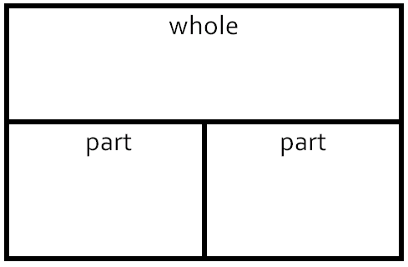
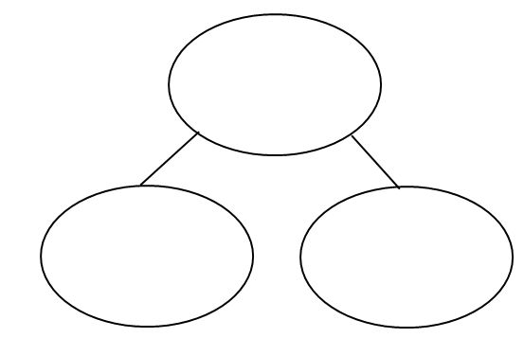

26 = _____________ tens and _________________ ones.

- 45

45 = _____________ tens and ___________________ ones.

- 52

52 = _____________ tens and ____________ ones.

- 7 tens and 6 ones

7 tens and 6 ones = _____________

Extension: Can you then create your own part-whole models using some numbers chosen from your 1-100 number square.

Answers
- 26 = whole. 1 part is 20; other part is 6. 26 = 2 tens and 6 ones
- 45 = whole. 1 part is 40; other part is 5. 45 = 4 tens and 5 ones
- 52 = whole. 1 part is 50; other part is 2. 52 = 5 tens and 2 ones.
- 7 tens and 6 ones = 76. 76 = whole. 1 part is 70; other part is 6.
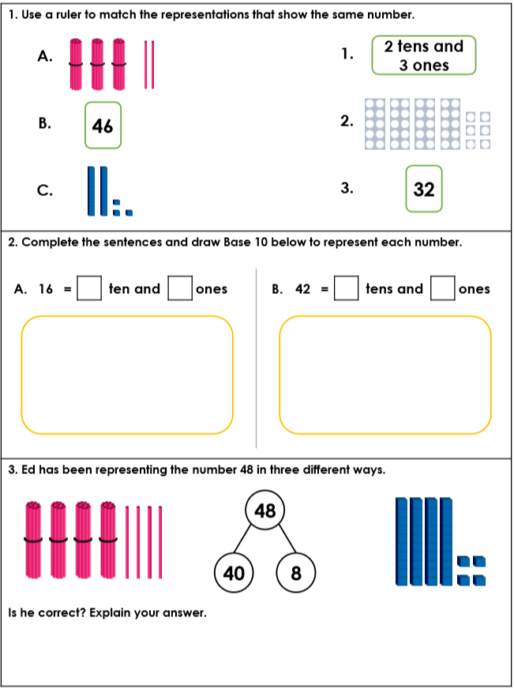
Task 4

Answers for Task 4
A pairs with 3
B pairs with 2
C pairs with 1

16 is 1 ten and 6 ones; 42 is 4 tens and 6 ones
Base ten is where tens are represented by this: and ones are represented by this:

With the Base ten/diennes he has represented 44 but when he did the part-whole model he has represented 48 so he has only represented 48 in one way.

Task 5
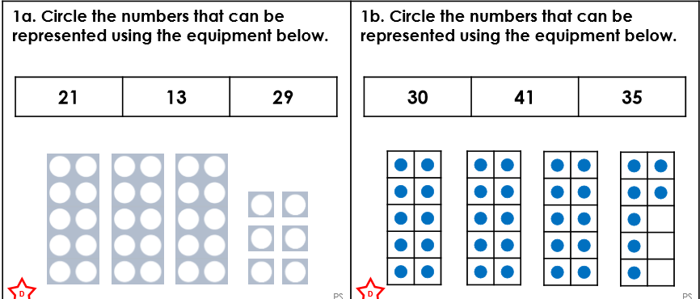

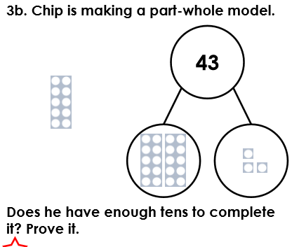

4.
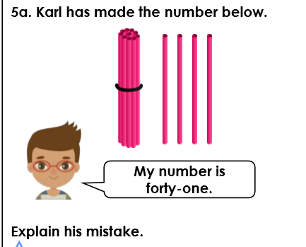
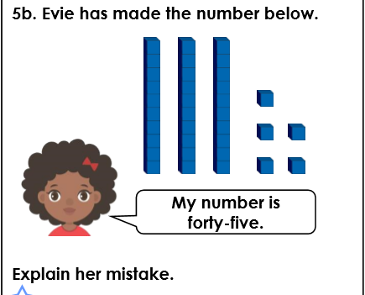
5.

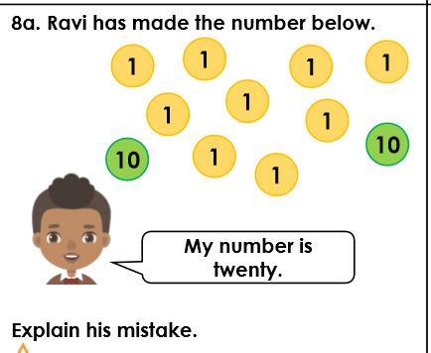
6.

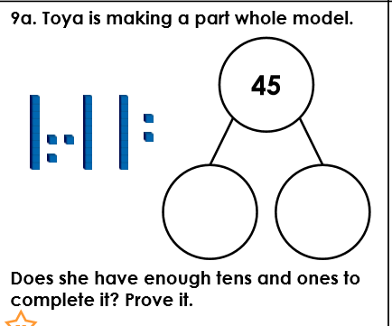
7.

Answers:
- 21; 13
- 30; 35
- No. He needs 4 tens to make 40 but he only has 3.
- Karl has counted 4 ones as 4 tens and 1 ten as ones. He only has 14.
- Evie has counted the number of tens and ones incorrectly. She only has 3 tens and 5 ones which is 35.
- Ravi has not counted the ones. He has two tens and nine ones which makes 29.
- No. She needs 4 tens and 5 ones but only has 3 tens and 5 ones so she can only make 35.
Extension task
