Maths week beginning 11th May
Maths is all about recapping length and height before moving on to work on numbers to 50. This builds on from place value work to 20 which we have done in class as well as using their knowledge of numbers up to 100 from the number squares.
Task 1: See resource about measuring using standard unit of measurement (cms)
Task 2: Length and height consolidation activity pack see separate resources
There are a series of questions and answers to work through.
Task 3: Page of questions about counting up to 50. Children can use their number squares if unsure how to write the numbers.
Task 4: Have a look at the questions below. All of them are to do with numbers up to 50.
Task 5: See separate resource for recognising and writing numbers to 50 – questions get tougher as you work your way through them. Answers are within the same resource.

Remember when completing these, if you use your number square and you go down one row that is the same as adding on ten.
Task 4
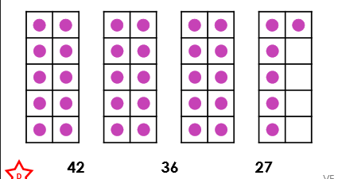
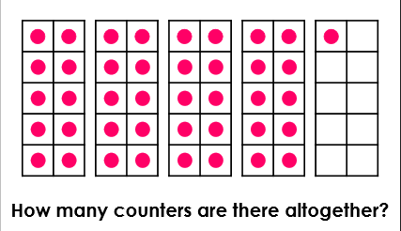
- 2.

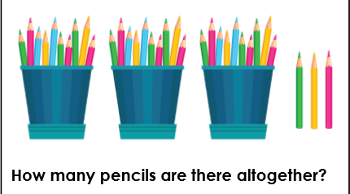
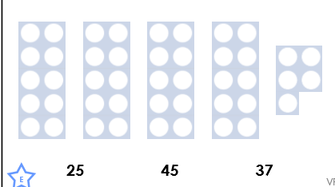
3.

Hint: Look at how many lots of ten
there are. Start at ten on your number
square and think how many rows down
you would need to go.
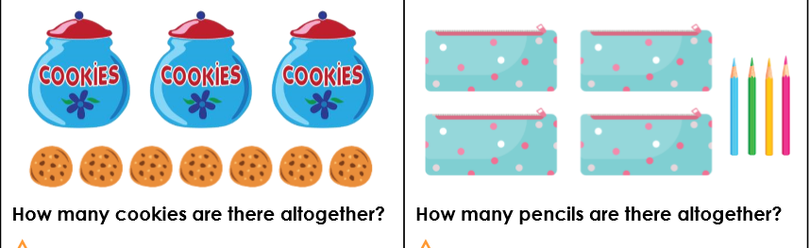
5.

6. 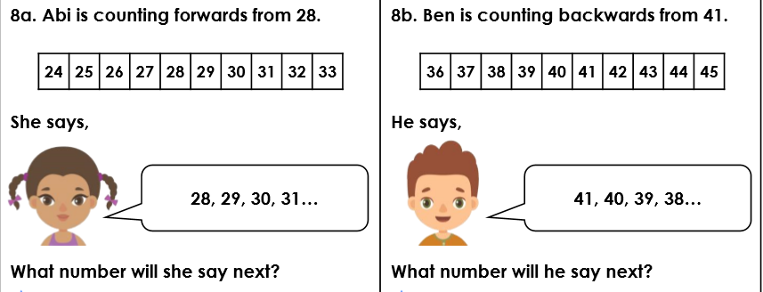

7. 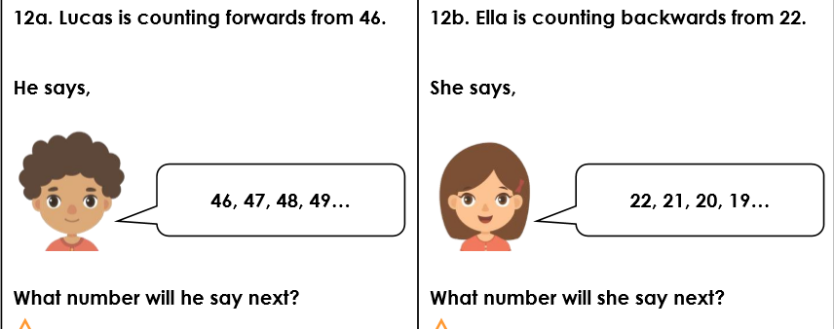

Reasoning and problem solving extension questions
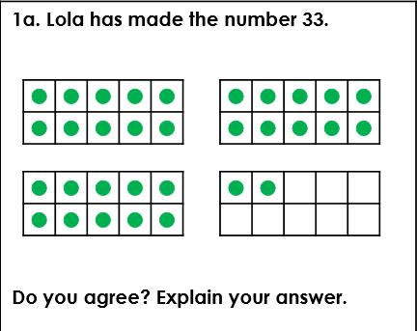

- Milly says she has made the number 22. Do you agree?
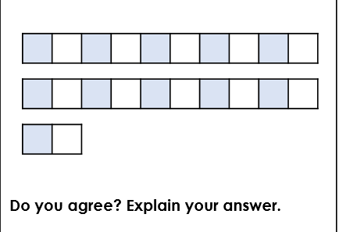

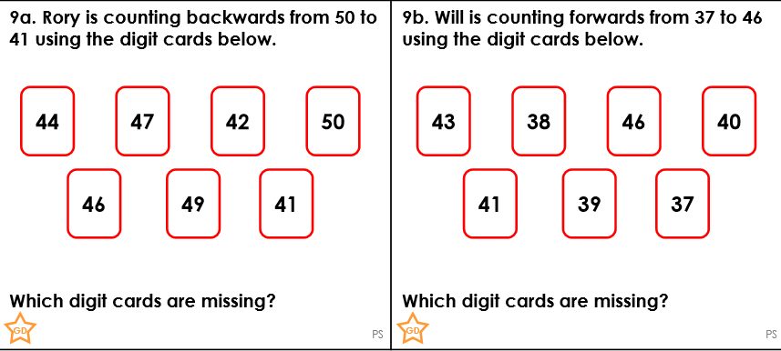

Answers for Task 4
- 41
- 36
- 45
- 33
- 37; 44
- 32; 37
- 50; 18

Reasoning and problem solving:
- No. Lola has made 32. She has 3 groups of 10 and 2 left over
- Yes. She has 2 groups of 10 and 2 left over
- 48, 45 and 43
- 42, 44 and 45.

