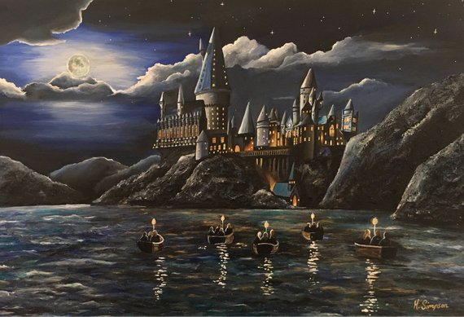
My castle is called The Haunted Castle. It is a huge castle that towers above you like a giant about to gobble you up! There are tall turrets all over the castle and each one has a scary gargoyle at the very top.
The Haunted Castle is made out of hard black stone which can’t be broken by anything except dragon fire. However, hundreds of little candles light up the windows of The Haunted Castle so it doesn’t look scary at all.
At The Haunted Castle you can hear swooping sounds like a gale because the happy witches and wizards who live there like to fly their racing brooms.
There is a huge lake just outside which sparkles in the sunlight and has a giant squid underneath the blue waves. There is also a wild forest which has gigantic trees.
Inside of The Haunted Castle there are over one thousand rooms! The scariest room is at the top of the highest tower because a monster lives there. Inside it is pitch black but you can hear strange growling. You can smell the blood of the monster’s victims and when you walk bones crunch underneath your feet! If you stay in there too long you’ll end up as the monster’s next meal!
The strangest room in The Haunted Castle is in the dungeons. Inside everything is backwards! The chairs are all on the ceiling and the lights are all on the floor. If you go inside all the chairs will try to sit on you so be careful. All the sounds are opposite too. If you whisper it sounds really loud and if you shout it will sound like you’re a tiny little mouse squeaking!
My favourite room is the food room. Everything is made out of food! When you go in there are sofas made out of chocolate and the cushions are made out of fluffy candyfloss that feel incredibly soft. There are also pens that are actually sizzling sausages, pieces of paper that are huge crisps and if you lick the wallpaper it tastes of your favourite food! You can also smell any food you like. All you have to do is close your eyes and think of the food you want to smell.
That is my castle, The Haunted Castle. Do you want to visit?

