While you are at home pick 1 or 2 activities a week to complete.
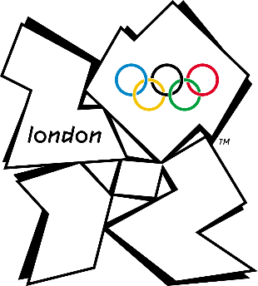  History  Interview someone who remembers the Olympics that were held in London in 2012.  What do they remember about it? Did they or someone they know go to an event? What was the atmosphere like? Present your findings in an interesting way. It could be a magazine article or record an interview with them if you can. | Art  Continuing the topic of the Olympics can you research mascots from past Olympics. Once you have found some ideas design your own one.  Think about colours and logos, how will they move, what do the represent? But most of all make them fun.  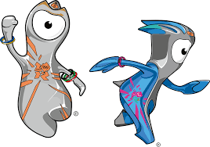 | RE  Think about how you celebrate special events in your family. Such as birthdays. Tell us what you do to make it special.  Can you find out about a special day for one, or more, religious group? How do they celebrate it?  Lots of religious groups have special food for celebrations. Can you find out what they eat? Maybe you could try making something yummy.
French  Explore the BBC Teach French video’s for KS2 at:  https://www.bbc.co.uk/teach/class-clips-video/french-ks2-virtually-there-france/zjby8xs  Watch some of the videos and try practicing some of the vocab.  This Photo by Unknown Author is licensed under CC BY-SA | Physical Education  Choose a sporting activity to improve on over several days.  For example you could bounce a ball against a wall and catch it, skip with a rope or do sit ups.  On day 1 set yourself a challenge for example how many times can you do it in a set time or before you drop the ball etc.  Each day practice and try to improve your score. At the end of the week test yourself again. Have you got better at it? | Geography  The Olympics will Japan next year.  Can you find out 10 facts about Japan. Some ideas of what you could include are:  Where is Japan?  What is the weather like?  What is the terrain like?  How many people live there?  See what you can discover about Japan, would you like to go there for a holiday?  