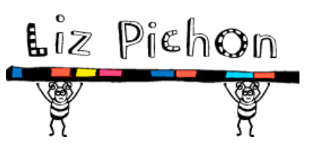
Author study
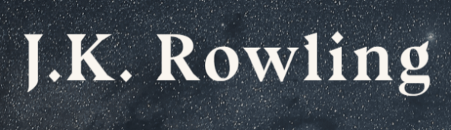

Do you have a favourite author? Roald Dahl? Enid Blyton? David Walliams? J.K. Rowling? Eric Carle? Liz Pichon? Julia Donaldson?
Maybe:
- It’s the author of a book you are currently reading
- A family favourite
- An author you enjoyed when you were younger
- You’ve read a collection of books by them
This list of writing opportunities is not exhaustive – maybe you have your own ideas for a writing task you could undertake? Don’t forget to celebrate your learning with me – email it across and I promise I will reply!

Complete a biography  Use the biography sheet. Find out about your chosen author’s life, and complete a fact file. | Practise your handwriting  Copy out an extract from a book by your favourite author | Ask an adult  Devise a set of interview questions you could ask a parent, or even a grandparent. Make a note of their answers too. | Make a comparison  Once you’ve completed your questionnaire, write a comparison between your favourite author, and that of you parent/grandparent.
Character profile  Write a character profile for your favourite character from your chosen author’s books. | Favourite Setting  Describe your favourite setting in your chosen author’s books. | Write a letter  Imagine you are able to write toy your favourite author. Explain to them why you particularly like their books. | Research online  Many authors have their own websites. Why not have a look and see some of the other games and activities you can complete? E.g.  https://www.worldofdavidwalliams.com/  https://www.wizardingworld.com/  http://lizpichon.com/
What ideas do you have for a new book by your favourite author?  Maybe you can present this as a story map, or a poster. Maybe you could even write the first paragraph! | Design a New Front Cover  You could do this on Purple Mash or, use Word Art, or show your real creative side using paints! | Look very carefully at the Year 3 / 4 Common Exception Word List.  Identify 8 spellings that you are still working on and focus on these this week. Think about some of the strategies we have learnt in class. How creative can you be in how you practise them?  I have set some of these on Purple Mash to complete, and also you can play the free games on Spelling Frame  https://spellingframe.co.uk/spelling-rule/45/27-Word-list-years-3-and-4---ci--to-ea-  https://spellingframe.co.uk/spelling-rule/50/32-Word-list-years-3-and-4---or--to-pre- | Spelling rule  Recap:  forgetting  forgotten  gardening  gardener  limiting  beginning  beginner  limitation  preferred  limitations

