English wb 1st June
There are two reading activities this week – A postcard for gran (see below) and then complete A surprise for mum activity (see below)
Reading Task 1
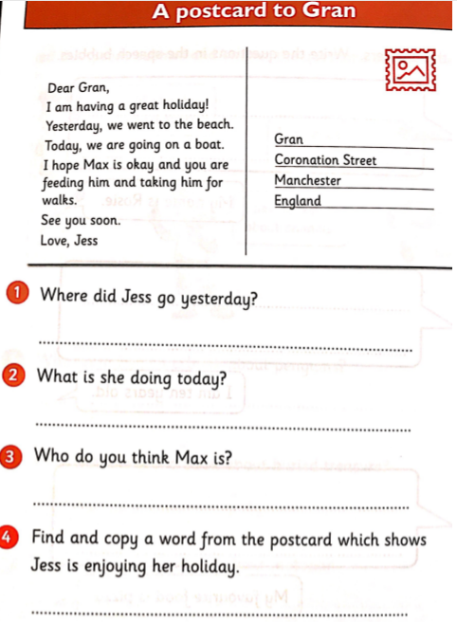
Answers:
- Jess went to the beach.
- Today they are going on a boat.
- I think Max is gran’s dog.
- Great

Reading Task 2
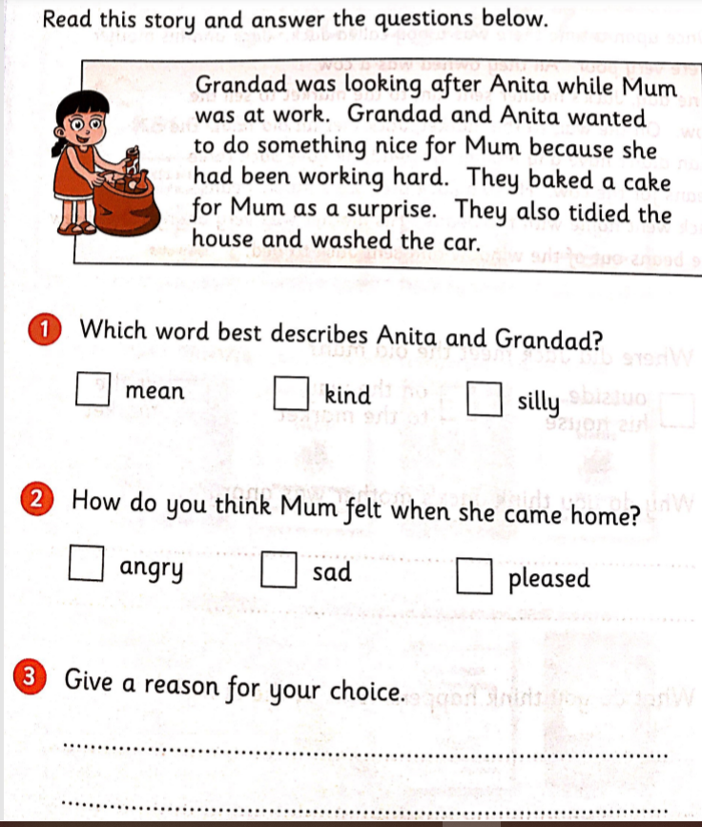
Answers:
- Kind
- Pleased
- I think she was pleased because Grandad and Anita had done lots of kind things while she was at work – washing the car and baking a cake.

Writing tasks
Task 1: Read the page on Sukey the cat. Add in capital letters at the start of a sentence and full stops at the end of a sentence (remember new idea = new sentence). Extension: Write out the paragraph as it should be written with full stops and capital letters
Task 2: Think about a favourite sporting person – again any sport. Imagine you were interviewing them, what questions would you ask? Think about who, what, where, when and how and don’t forget to write question marks at the end of your questions.
Task 3 ( 2 days worth of work) : Have you got a favourite sports teacher/ coach/ sporting star? It could be someone who teaches you PE out of school if you do football, dancing or another sporting activity, it could be someone who teaches you PE in school, it could be someone who teaches you PE as an after school club etc. Task – write an information page about them. See Task 3 below for a blank resource you could use.
Task 4: Can you create a poster all about team work and why team work is a good idea. This could be linked to team work in the family, the class in school or working together as a team when playing sport.

Task 1
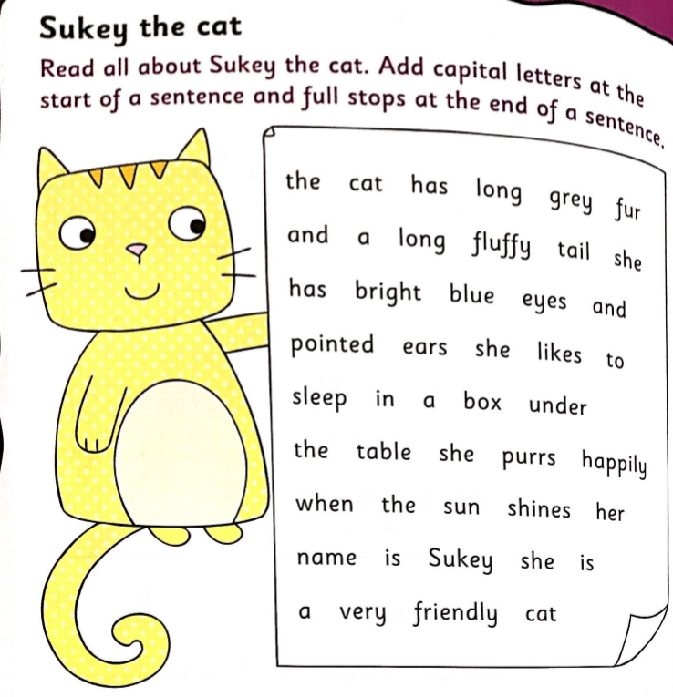

Answer:
The cat has long grey fur and a long fluffy tail. She has bright blue eyes and pointed ears. She likes to sleep in a box under the table. She purrs happily when the sun shines. Her name is Sukey. She is a very friendly cat.

Task 3
Name: | What does your favourite sporting coach/ star look like? – draw a picture and then describe them
Where do they live?

What are they famous for/ what do they teach you?

Why are they your favourite coach/ athlete? | How have they helped you? Or How have they inspired you?
Any other interesting facts about them

