Superheroes
THE earliest superheroes appeared in comic books in the 1930s. Some of them such as Captain Marvel are less well known today but others from that era, Superman for example, are still with us. They appear in feature films, cartoons, on television, as well as in comics and a new type of fiction called ‘graphic novels’. Such is their appeal that many of them – Batman, Superman and Wonder Woman, to name but three – are known throughout the world and their stories are told in many languages.
OF COURSE superheroes may be popular all over the world, but that does not mean that everybody likes them. Some people argue that their adventures are far-fetched and unrealistic. They are accused of having a harmful influence on children who put themselves in danger by copying their heroes’ impossible deeds. Others enjoy the stories for their excitement, suspense and escape from reality. Fans revel in knowing every detail about their superheroes: their individual powers, their intriguing costumes, their unique physical features – even their family backgrounds.
While fans may be interested in the detailed differences between these characters, there are certain features they have in common and which they have to possess in order to qualify as ‘superheroes’.
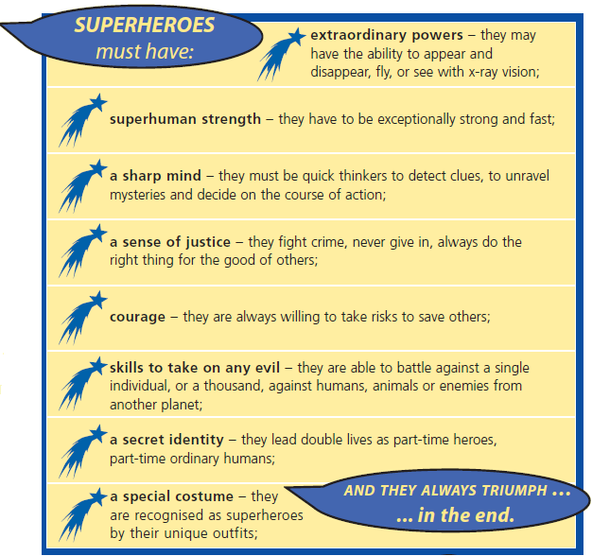

1. Where are the main places you can see superheroes now?

Tick three.
on television
in films
in museums
at the theatre
in graphic novels
1 mark
2. Look at page 1.
The writer has given reasons why some people like superhero adventures and others do not.
Write down one reason why people like them and another reason why they do not.
Like:
___________________________________________________________________
1 mark
Dislike:
___________________________________________________________________
1 mark
3. individual ... unique (page 1)
What do these words tell you about superheroes?
___________________________________________________________________
___________________________________________________________________
___________________________________________________________________
1 mark

4. Eight features of a superhero are described (page 2).
Draw lines to show which one would be most useful in each of the following challenges.
One has been done for you.
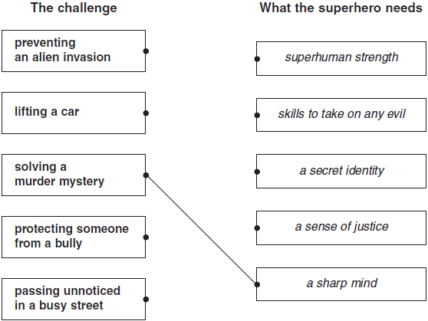
2 marks
5. Ordinary people sometimes perform heroic deeds.
Which three of the eight superhero features could an ordinary person have?
1. _________________________________________________________________
2. _________________________________________________________________
3. _________________________________________________________________
2 marks

6.
A huge meteor is sent hurtling out of control towards Earth by enemy aliens.  A superhero sets out to try to save the world.  Using the information you have read, explain which features the superhero will use to solve the problem and how they will be used. | 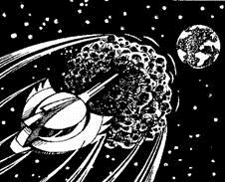
___________________________________________________________________
___________________________________________________________________
___________________________________________________________________
___________________________________________________________________
___________________________________________________________________
___________________________________________________________________
___________________________________________________________________
3 marks
7. Find and copy one word that describes how much fans enjoy finding out about their superheroes.
______________________________________
1 mark

Mark schemes
Q2.

1. Award 1 mark for three correctly ticked boxes.

on television
in films
in museums
at the theatre
in graphic novels
1 mark
2. Award 1 mark for each acceptable point from those listed below:
Like
• exciting, full of suspense;
• escape from reality;
• interesting details / differences, eg: costumes / powers.
1 mark
Dislike
• far-fetched / unrealistic;
• harmful influence on children.
1 mark
3. Award 1 mark for responses showing understanding of unique and/or individual, eg:
• they are special;
• they are all different;
• one of a kind.
Do not accept:
• individual or unique as the explanation;
• direct quotation from text without explanation.
1 mark
4. Award 2 marks for all pairs correctly matched.
Award 1 mark for two or three correctly matched pairs.
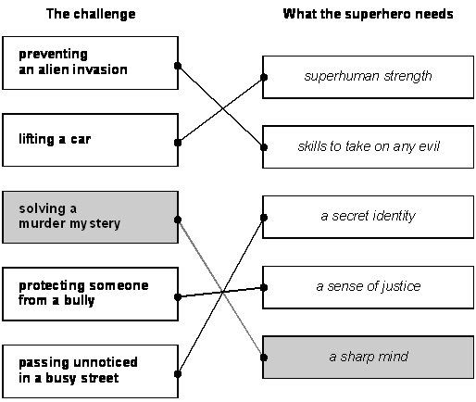
up to 2 marks
5. Award 2 marks for three correct answers:
Award 1 mark for two correct answers:
• sharp mind;
• sense of justice;
• courage.
up to 2 marks
6. Award 3 marks for working through the whole scenario, mentioning several of the characteristics listed or indicating more than one solution to the problem, eg:
• first, he would detect the danger by using his x-ray vision, then he would change into a superhero and fly into space. He would use his sharp mind to think of a plan and his superhuman strength to hold back the meteor and fight the alien enemy;
• first, the superhero will have to have courage to take on a meteor. A sharp mind to decide upon how he will attack the meteor. Then extraordinary powers to detect what the enemy is doing. Next, superhuman strength to use against the meteor, maybe by kicking it or something. Finally, skills to take on any evil or else it wouldn’t be able to attack the meteor.
Award 2 marks for identification of at least two superhero skills or characteristics and their application, which may be partly implicit, eg:
• he would use his ability to fly to get there and then use his superhuman strength to put the meteor off course and throw it back at the aliens;
• he needs a sharp mind to know what is going on and he needs to fly there and have superhuman strength.
Award 1 mark for application of one superhero skill or characteristic to the new situation, eg:
• he would use his ability to fly to get there and stop the meteor.
Do not credit answers which refer to powers / features not mentioned in the text, eg: magic fist.
up to 3 marks
7. Award 1 mark for:
Revel.
1 mark

