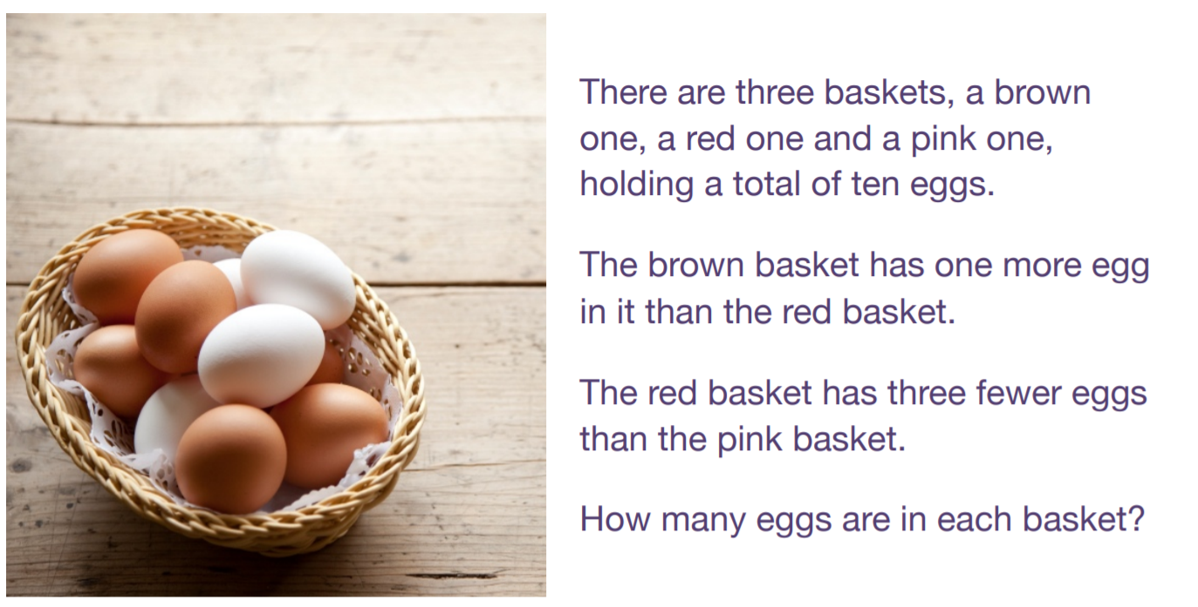

Answer:
Brown = 3
Red = 2
Pink = 5

