

**KS1 Cricket**

**catching challenge**

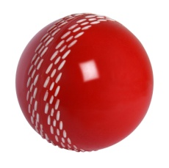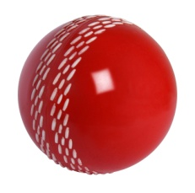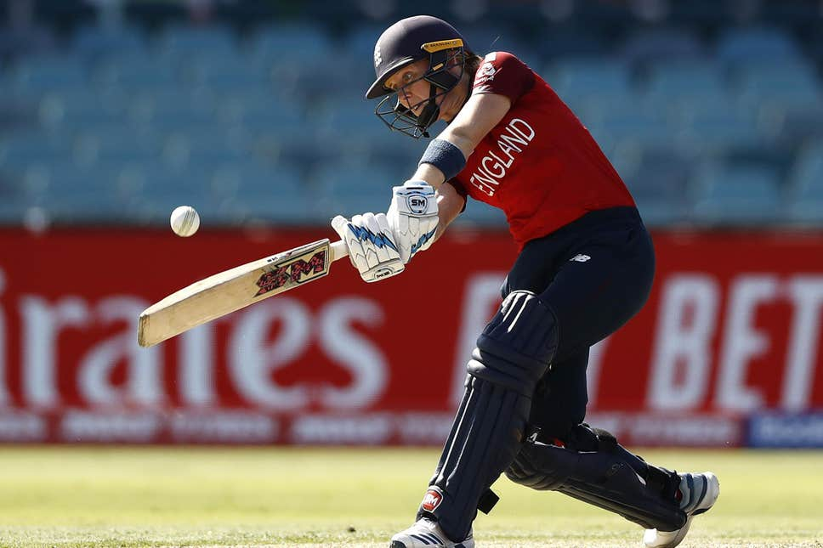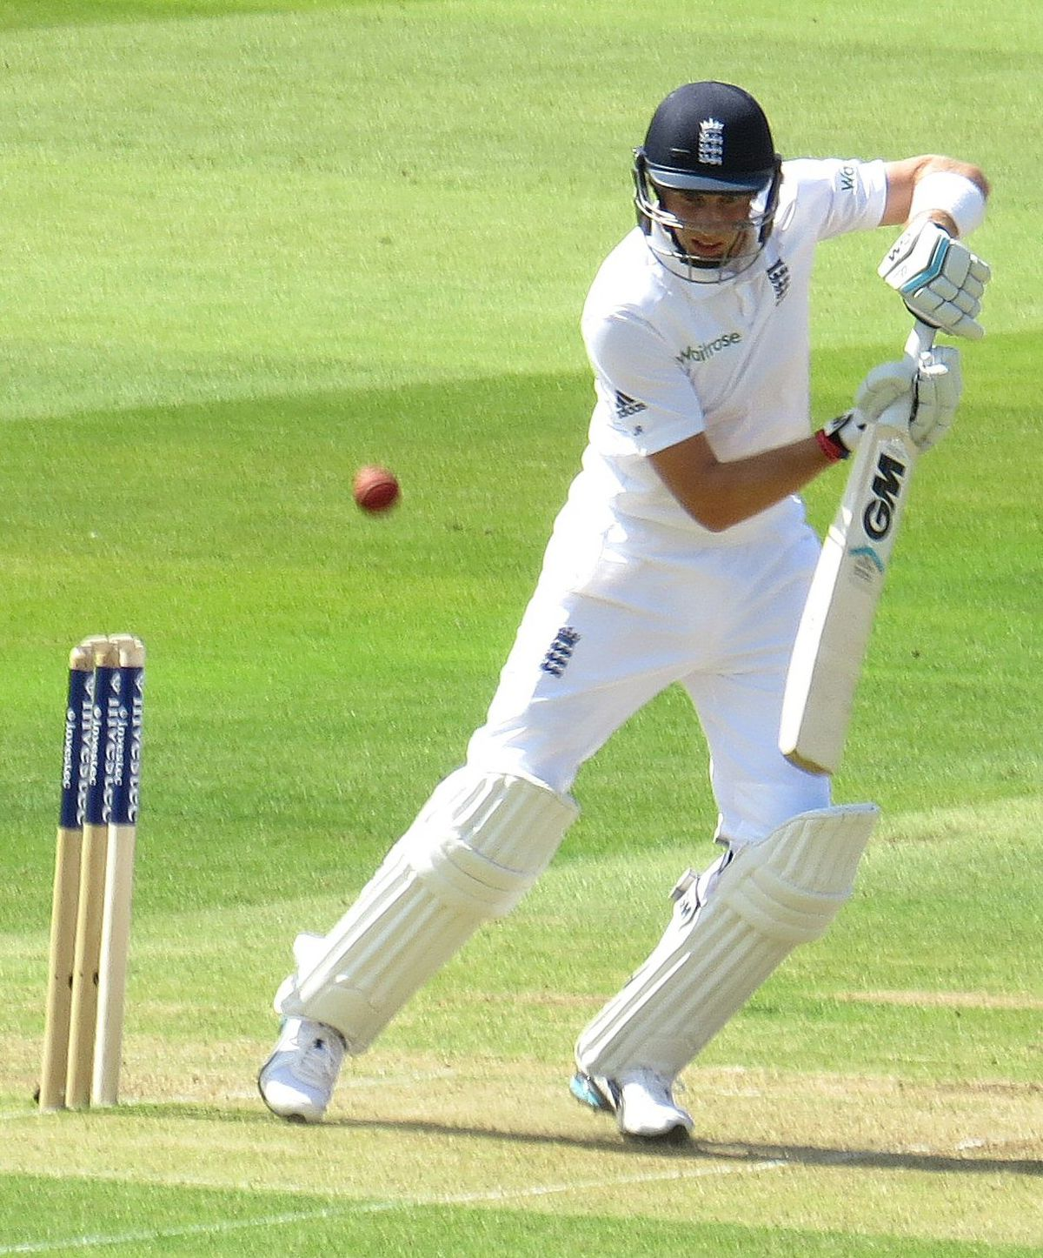

Complete each challenge in order from 7 to 1, without dropping the ball. If you make a mistake, start at number 7 again!

*Can you do these skills as well as Heather Knight and Joe Root?*

Can you catch with one hand ?

**5**

**6**

**1**

**3**

Bounce the ball on the floor three times and catch it. Do this 5 times.

**4**

Throw the ball up in the air, spin all the way round, let the ball bounce once and catch it. Do this twice.

**2**

Throw the ball under one leg, up in the air and catch it. Do this 3 times.

Throw the ball up in the air, clap once and catch it. Do this 4 times.

Throw the ball up in the air, spin all the way round and catch it (without a bounce). Do this once.

Throw the ball up in the air and catch it, without a bounce. Do this 6 times.

**7.**

Throw the ball up in the air, let it bounce once and catch it. Do this 7 times.

Try a different size ball !

Joe Root – England Men’s Test Cricket Captain

Heather Knight – England Women’s Cricket Captain