Start here!
Suggested daily schedule
30 to 45 mins | 15 to 30 mins | 30 to 45 mins | 15 to 30 mins | 30 to 45 mins
Maths | comprehension | English task | Purple Mash | Art and design task and  History task

Hi all! I’ve packed a lot more into this week for you. Aren’t I kind?! Enjoy, you lovely people x
Maths

This week you have 5 maths activities of varying difficulty plus 1 optional extension. All the answers are provided at the end of each document. If you find it difficult to get the answer, or if you find that your answer is wrong, ALWAYS look at the correct answer and try to work out why it is that answer. This will really help your maths learning!

As always you DO NOT need to complete all the work: just do 30 to 45 minutes a day, to keep your brain active.

Deadline Friday 22nd I do not need to see your work.

English

No grammar this week! Yay! However, let’s do one more reading comprehension! Yay x 2!! Remember – self mark.

Deadline Friday 22nd May. I do not need to see your work.

I would like you to design and produce a meal for your family (you can get help with this, if you like!).

- Write a list of ingredients
- Write out a step by step guide of to how to make the meal
- Take photos of the process to illustrate each step
- Take photos of the finished product
- Ask your family to review the meal and then record (write) what they say.
- Send me what you have done in any format you like.
Deadline 22nd May
Purple Mash
I have set 2 spelling tasks; 2 science activities; the usual maths bubbles and times tables apps and an additional factors game (which I was rubbish at!!).

A bit of History
I would like you to give me a detailed timeline of the history of men’s football world cup finals tournament. Think about where, when, winners, losers, stand-out players etc. You can do this on your computer or on paper – your choice.
Now do exactly the same for the women’s football world cup finals tournament. Spot the difference . Let me know why you think there is a difference and what your opinion of it is.
Deadline 22nd May

A bit of Art & Design

I would like you to design your ideal bedroom. Below you can see a couple of ways you could present your work. I suggest you use a Power Point slide to draw your ideas, insert images, shapes and suggested fabric choices etc. Let your imagination run riot. Maybe you’d like a slide or a mini cinema/stage or a wonderful sound system or a balcony with floor to ceiling windows and a slide down to a swimming pool in the garden.

I would like you to use your computer to do this, if possible, so that you can practise a variety of different skills. If this is not possible, you could draw it. Please let me see it, though!

Deadline: 22nd May

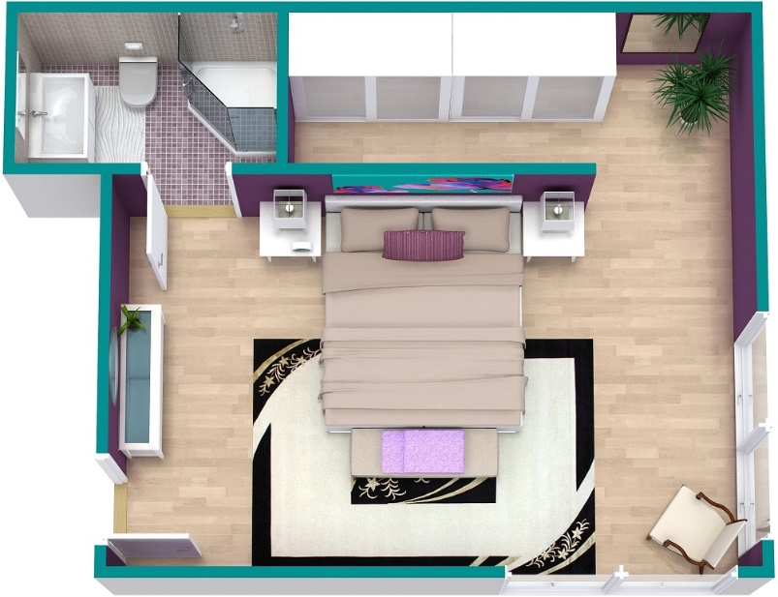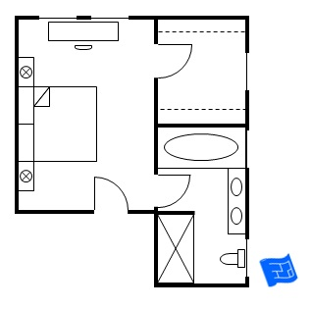

PE
Have a go at being a Disney character and doing some exercise at the same time.
https://www.youtube.com/watch?v=hsfheb5UwdE&feature=youtu.be
Have a wonderful week and lots of love as ever xx

