Q1.
Tree
(a) Ella is looking at some leaves.
The key below identifies which tree each leaf comes from. | 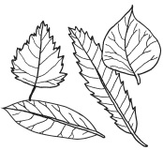
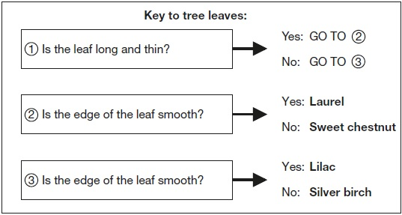

Look at this picture of a leaf from one of the trees. | 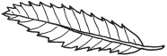
(i) Use the key above to identify the tree it comes from.
The leaf is from a ___________________________________________ tree.
1 mark
(ii) Tick ONE box to show why it is useful to identify plants and put them into groups.
 | so we know where to find a plant |  | because there is a large variety of plants
 | in case the plants become extinct |  | so we can observe the plants in their habitats
1 mark
(b) Complete the sentences below to show the function of the leaves and roots.
(i) The tree uses its leaves to ________________________________________.
1 mark
(ii) The tree has roots to ____________________________________________.
1 mark
(c) Ella finds a seed.
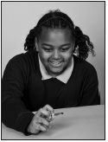
Why does the tree need to produce seeds?
___________________________________________________________________
1 mark
(d) Squirrels live in trees.
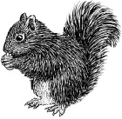
Give ONE feature of the squirrel from the picture.
Describe how this feature helps the squirrel to live in a tree.
Feature of the squirrel that helps it live in a tree: ____________________________
How the feature helps: ________________________________________________
___________________________________________________________________
1 mark

Q2.
Plants on the school field
(a) Some children are finding out about plants. They get three buttercup plants. They put each plant in a place with different conditions.
After two weeks, the buttercup plants look like this:
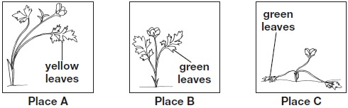
Write A, B, and C in the table below to match each place to the conditions found there.
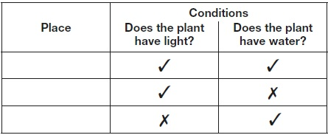
1 mark
(b) There are differences between plants.
These differences help people sort plants into groups.
Write true or false next to each reason that explains why plants need to be sorted into groups.

 | Plants need to be sorted into groups... | True or False?
 | to stop plants becoming extinct. | ____________
 | to help people identify plants | ____________
 | to help plants reproduce. | ____________
1 mark
(c) The children look at different plants on the school field.
They record the number of common plantain and buttercup plants in 1m² in different places. | 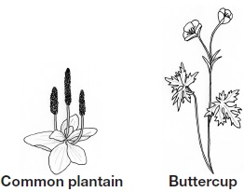
The children think they see a pattern in the place that the plants grow.
The table shows their results.
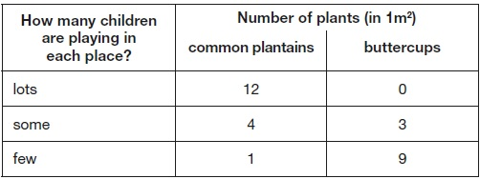
Describe the relationship between how many children are playing in a place and the number of common plantains found there.
___________________________________________________________________
___________________________________________________________________
1 mark
(d) The buttercup plant has a long thin stem.
The long thin stem of the buttercup plant stops it surviving in places where lots of children play. Explain why.
___________________________________________________________________
___________________________________________________________________
1 mark

Q3.
Sea creature
(a) The picture shows the fossil of a pliosaur.
These animals lived in the sea a long time ago.
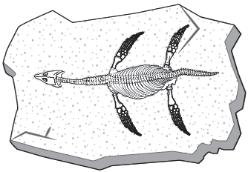
What material are fossils made of?
........................................................................................................................
1 mark
(b) How did the fossil of the pliosaur form? Match each stage to order what happens.
Stage What happens

1st |  | Soft parts decayed away.
2nd |  | Hard parts were turned into fossils over many years.
3rd |  | Hard parts were buried by many layers of sand.
4th |  | The pliosaur died and sank to the sea bed.
1 mark
(c) Very few animals become fossils after they die.
Explain why very few animals become fossils after they die.
1. ...................................................................................................................
2. ....................................................................................................................
1 mark
(d) Fossils can give a lot of information about animals that lived in the past.
Write true or false for each statement about the pliosaur fossil.
The pliosaur’s fossil could give
us information about...
True or false?
how long ago the animal lived. ......................................
what the animal ate. ......................................
what the animal smelt like. ......................................
what colour the animal’s eyes were. ......................................
how large the animal was. ......................................
2 marks

Q4.
Penguins
(a) The key below can be used to identify penguins. 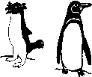
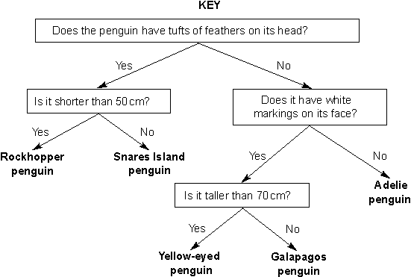
Use the key to identify the penguin below.
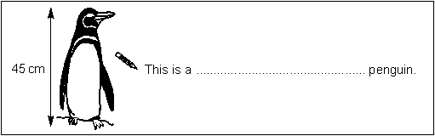
1 mark
(b) Tick ONE box to show the best reason for identifying animals.
so you can find out what  scientific group they are in |  | so you can compare  them with plants
so you can learn about  the country they live in |  | so you can measure  how tall they are
1 mark
(c) Look at the part of the penguins’ food chain below.
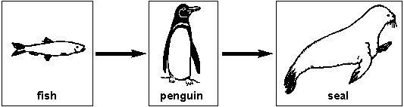
(i) Tick ONE box to show which life process the food chain shows.
movement |  | nutrition
growth |  | reproduction
1 mark
(ii) A fish is not a producer.
Explain why a fish cannot be a producer.
..............................................................................................................
..............................................................................................................
1 mark
(d) Give ONE feature of a penguin and describe how it helps a penguin to live in its environment.
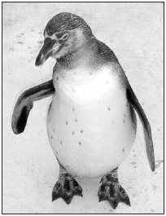
Feature: ...................................................
How the feature helps: ...................................................................................
1 mark
Q5.
Brine shrimps and flamingoes
(a) A brine shrimp is a tiny living thing. It lives in lakes and eats algae (green plants).
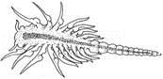
Brine shrimp
Flamingoes eat brine shrimps. They filter the shrimps from the water.
Look at the picture of the flamingo.
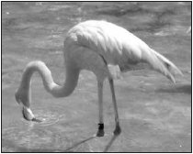
Describe one feature of the flamingo’s neck that helps the flamingo to feed.
.....................................................................................................................
1 mark
(b) Write the food chain for the three living things described above.
1 mark
(c) The lakes dry up in hot weather and fill up again when it rains.
When the lake is dry the adult brine shrimps die, but the eggs do not.
Explain why it is important to the life cycle of brine shrimps that the eggs do not die when the lake dries up.
.....................................................................................................................
.....................................................................................................................
1 mark

Mark schemes
Q1.
(a) (i) Award ONE mark for:
• (Sweet) chestnut
1
(ii) Award ONE mark for:
Do not give credit if more than one box has been ticked.
1
(b) (i) Award ONE mark for a response stating that the leaves make new materials for growth or take in light, for example:
The tree uses its leaves to…
• produce sugar/food (for growth)
• absorb light
♦ Award ONE mark for a correct response that goes beyond the key stage 2 programme of study, for example:
• take in/release CO₂ / O₂
• release water
• create/produce O₂
• store food/waste
• respire/photosynthesise
• absorb energy from the sun(light)
• produce chlorophyll
ONE mark may be awarded for:
• make/give it food
ONE mark may be awarded for:
• collect/gather/catch (sun)light
Do not give credit for a response that includes incorrect science:
The tree uses its leaves to...
• make energy
• feed
• get/take in food (from the Sun)
• breathe in carbon dioxide/oxygen
Do not give credit for an insufficient response, for example:
• produce/make/get nutrients
1
(ii) Award ONE mark for a response stating that the roots are used to anchor the plant in the soil or absorb water/minerals from the soil:
The tree has roots to…
• absorb/take up/soak up water/moisture/minerals
ONE mark may be awarded for:
The tree has roots to…
• stabilise the plant (keep it steady)
• take in/get water/nutrients
• draw/drain water (from the soil)
• gather/collect water/nutrients
• carry water
ONE mark may be awarded for a response indicating a supporting function of the roots which may work in conjunction with the stem, for example: The tree has roots to…
• support (the plant)
• hold it up
• make it stand straight/up
ONE mark may be awarded for a response indicating that the roots can store water.
Do not give credit for a response that includes incorrect science indicating that water is taken up by ‘drinking’ or ‘sucking’.
Do not give credit for a response that includes incorrect science indicating that the root gives the plant food:
• take/send up/bring/gather/absorb food
• feed it
• for nutrients/moisture [not clear they are taken in]
Do not give credit for an insufficient response, for example:
• the roots keep the plant balanced
• hold it in
Do not give credit for a response that includes incorrect science indicating that roots produce nutrients.
Do not give credit for an insufficient response where ‘goodness’ is used in place of ‘nutrients’, ‘water’ or ‘minerals’.
1
(c) Award ONE mark for a response indicating seeds are produced so the tree can reproduce, for example:
• for reproduction/to reproduce
ONE mark may be awarded for a response describing or implying reproduction, for example:
• to grow/make more/new plants/trees
ONE mark may be awarded for a response explaining the tree will not become extinct, for example:
• so the species survives
Do not give credit for an insufficient response, for example:
• so they can be dispersed
• to produce the flowers
• because trees grow from seeds [does not imply more/new trees]
• to continue the cycle
• so the tree survives
1
(d) Award ONE mark for a response identifying a feature and describing how it helps the squirrel to live in a tree, for example:
• (bushy) tail; it helps to keep balance
• claws/long fingers and toes; to grip onto the branches/climb trees
• (sharp) teeth; to eat nuts/seeds/fruits growing on trees
ONE mark may be awarded if the feature is given within the description, for example:
• feet; clawing feet grasp the tree for climbing
Do not give credit for an insufficient response indicating hands or feet grip the tree, for example:
• hands/feet; grip tree/branches
Do not give credit for an insufficient response, for example:
• fur; keeps them warm in winter [this is not specifically needed for tree living]
• brown fur; for camouflage
• good climber; helps it escape from predators/eat nuts
• eat nuts/seeds; these grow in trees
• hands/feet; climb/hold nuts
• claws; for keeping balance
1
Q2.
(a) Award ONE mark for:
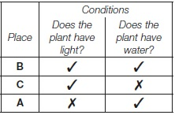
1
(b) Award ONE mark for:

to stop plants becoming extinct. | false
to help people identify plants. | true
to help plants reproduce. | false
1
(c) Award ONE mark for a general comparison describing the relationship between the number of children playing in an area and the number of common plantains found there, for example:
• the fewer children playing in a place, the lower the number of common plantains found there
• the more children (playing in a place), the more common plantains (found there)
• the bigger the number of common plantains found, the more children play there
ONE mark may be awarded for two specific comparisons describing the relationship, for example:
• there are most common plantains where most children play and least common plantains where fewest children play
Do not give credit for an insufficient response giving a single comparison of the variables, for example:
• many common plantains grow where lots of children play
Do not give credit for a response that changes one or both variables, for example:
• the more plantains, the fewer buttercups
1
(d) Award ONE mark for an indication that the stem of the buttercup will break easily, for example:
• the stem (is thin so it) breaks easily
• the buttercup’s stem could break
ONE mark may be awarded for:
• it is less strong
Do not give credit for an insufficient response which does not describe what may happen to the buttercup stem specifically:
• it could get trodden on
Do not give credit for an insufficient response:
• it gets squashed [smaller plants also get squashed but survive]
1
Q3.
(a) Award ONE mark for correctly naming a material, eg:
• minerals
• stone/rock (for fossil casts).
Give credit for responses that go beyond key stage 2 naming a
sedimentary rock that may contain fossils, eg:
• sandstone
• mudstone.
Do not give credit for an insufficient response that does not indicate an animal has undergone fossilisation, eg:
• bone
• teeth.
1
(b) Award ONE mark for correctly matching each stage to what happens during the formation of a fossil of the pliosaur:
Stage What happens
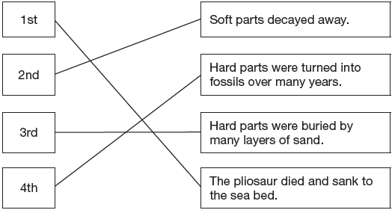
1
(c) Award ONE mark for an explanation that identifies that most dead animals will decay before they have a chance to be buried or that many animals do not have skeletons or hard parts that can be fossilised:
• lots of animals decay before they are buried (and so cannot become preserved/fossilised)
• many animals do not die in places/environments where they could be buried and fossilised (eg in lakes, shallow seas, sandy deserts)
• many organisms do not possess hard parts (that are easily fossilised).
ONE mark may be awarded for:
• dead animals may not get buried deep enough (to become surrounded in rock).
1
(d) Award TWO marks for correctly classifying all five statements:
• how long ago the animal lived. True
• what the animal ate. True
• what the animal smelt like. False
• what colour the animal’s eyes were. False
• how large the animal was. True
2
or
If you are unable to award two marks, award ONE mark for correctly classifying four of the five statements.
1
Q4.
(a) Award ONE mark for identifying the penguin correctly:
• Galapagos penguin.
1(L4)
(b) Award ONE mark for:

• so you can find out what
scientific group they are in
1(L5)
(c) (i) Award ONE mark for:

• |  | nutrition
1(L4)
(ii) Award ONE mark for an explanation that fish cannot make
their own food:
• a fish eats other things (to live)
• a fish cannot make its own food
• a producer is a plant
• a fish is not a plant
• a fish is an animal
• it is a consumer/predator.
♦ Give credit for a correct response that goes beyond the
key stage 2 programme of study:
• the fish/it cannot photosynthesise.
Do not give credit for an insufficient response that describes the position of the fish in the food chain:
• it is not the first thing in the food chain.
Do not give credit for an insufficient response:
• the fish cannot be a producer [given]
• it is not green.
1(L4)
(d) Award ONE mark for a feature of a penguin and a description of
how it helps a penguin to live in its environment:
• (thick) feathers
it keeps them warm
• webbed feet
to allow them to swim/to walk on snow
• streamlined shape
for swimming
• layer of fat/blubber
it insulates them
• a rounded body
reduces heat loss /allows it to slide on ice
• white tummies/a black back
animals swimming underneath/above them cannot see them easily
• flippers
they can pull themselves through the water
• beak
to eat /catch fish.
ONE mark may be awarded for a feature of a penguin’s behaviour rather than its body which accurately describes how it may help the penguin to live:
• huddling together keeps them warm.
ONE mark may be awarded for a response confusing the penguins’ feathers with fur [specific knowledge of penguins’ anatomy is not required]:
• fur/hair/thick coat to help keep them warm.
Do not give credit for an insufficient response that identifies a feature of a penguin but omits or gives an insufficient explanation of how that feature helps the penguin live in its environment:
• flippers in the water
[does not describe how flippers help in water].
Do not give credit for an insufficient response giving a generalised feature of many animals even when an appropriate explanation is given:
• feet it helps them walk/balance
• coat helps to keep it warm
• arms to help swim.
1(L4)
[5]
Q5.
(a) Award ONE mark for an indication that the neck is long and/or flexible:
• it is (long and) bendy;
• it is flexible;
• it is long;
• it can reach out (to find food).
ONE mark may be awarded for:
• the length (of the neck);
• (it bends) to allow the beak to get in
the correct position to feed;
• it can stretch;
• it is curly/bent.
ONE mark may be awarded for a response that indicates that food passes from the mouth to the stomach, via the neck.
Do not give credit for an insufficient response which does not describe a property of the neck:
• they do not have to bend over;
• it is easier to feed;
• they can put their head in the water.
1(L3)
(b) Award ONE mark for all three organisms in the correct order:
algae |  | brine  shrimp |  | flamingo
ONE mark may be awarded for a food chain in which ‘green plants’ replace ‘algae’.
Do not give credit for an insufficient response naming ‘bird’ in place of ‘flamingo’.
Do not give credit for an insufficient response naming an organism from a different habitat.
1(L4)
(c) Award ONE mark for an understanding of the role of the eggs in the life
cycle of the brine shrimp or a response relating to the survival of the
population, rather than of the individual:
• (if the eggs do not die), they can still hatch (when the lake fills with water);
• (new) brine shrimps can still develop from the eggs (when the lake fills up);
• it might prevent the species dying out/becoming extinct;
• the brine shrimp population/species will survive;
• if the eggs die, there will not be any brine shrimps (to reproduce).
ONE mark may be awarded for:
• it will not die out [‘die out’ implies extinction of the
population];
• to carry on the life cycle;
• more brine shrimps will grow (if the water dries up);
• more brine shrimps will be produced/ can be born;
• they can reproduce.
Do not give credit for an insufficient response implying the adult brine shrimp, rather than the population, continues to live or reproduce:
• it helps the brine shrimps to live longer;
• it can stay alive and live for a long time.
Do not give credit for an insufficient response which describes, without qualification, what happens if the eggs do die:
• the brine shrimp will become extinct.
Do not give credit for an insufficient response that repeats given information without further explanation:
• the adult dies but the eggs do not;
• because the shrimp eggs can live in dried up water/on land;
• because the lake will fill up again;
• brine shrimp eggs do not dry up.
1(L5)
[3]
[5]

