Q1 Country walk
(a) Maryam goes for a walk.
Maryam takes photos of some of the things she sees.
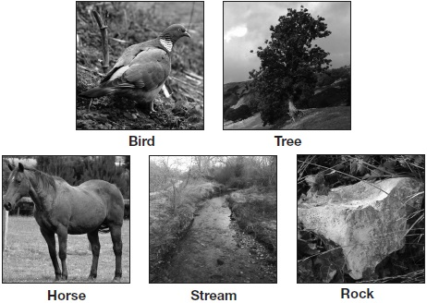
Complete the key to show how Maryam can sort each of the things she has photographed. Fill in all the boxes.
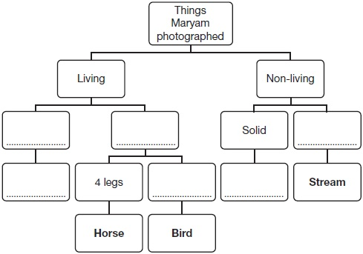
2 marks

(b) Write yes or no for each reason below to show why we use keys.
Reason | Yes or no?
to sort things into groups
to show feeding relationships
to help identify things
1 mark
(c) Maryam saw an animal skull on her walk.
She knows that the teeth of an animal can be used to find out what the animal eats.
Draw THREE lines to match each animal skull to what the animal eats.
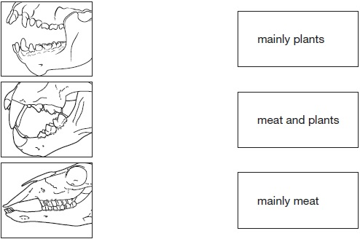
1 mark
(d) Write the name of this type of tooth on the line below.

......................................................... | 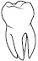
1 mark

Q2 Duck pond
(a) Peter goes to the duck pond with his grandad and his dog.
Tick TWO boxes to show two things that are true about a dog and a duck.
They both have fur. |  | They both move.
They both lay eggs. |  | They both breathe.
1 mark
(b) Two of the ducks come out of the pond.
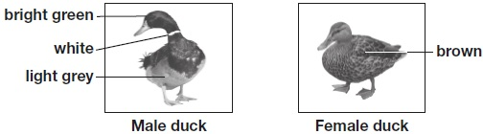
(i) Describe how a duck’s feet are adapted for swimming.
______________________________________________________________
1 mark
(ii)
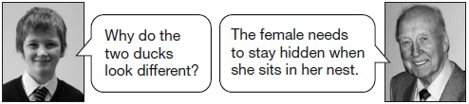
Why would the female duck be hard to see in a nest?
______________________________________________________________
1 mark
(iii) Explain why the female duck needs to stay hidden when she is in her nest.
______________________________________________________________
1 mark
(c) Peter sees some piles of soil on the grass near the pond.
Grandad tells him that the piles of soil are made by animals called moles.
Look at the picture of a mole.
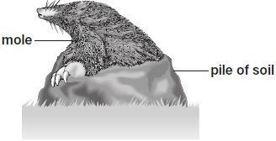
(i) Describe how a feature of the mole helps the mole to live underground.
Feature: _______________________________________________________
How it helps: ___________________________________________________
1 mark
(ii)
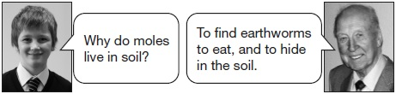
Which word cannot be used to describe a mole?
Tick ONE box.
prey producer predator consumer
1 mark

Q3. Butterflies
(a) Some children visit a butterfly park.
They use the pictures below to identify the butterflies they see.

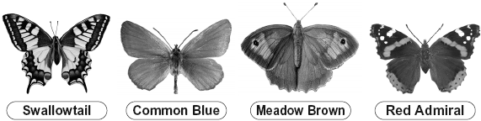
Swallowtail image © Fingerprint design 2010

Sally makes some notes about one butterfly she sees.  Oliver tries to use Sally’s notes to identify the butterfly.  Explain why Oliver cannot use Sally’s notes to identify the butterfly. | 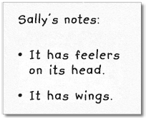
........................................................................................................................
1 mark

(b) Ahmed drew a butterfly.  It is not a Common Blue.  Tick ONE feature of Ahmed’s butterfly and describe how it is different from a Common Blue. | 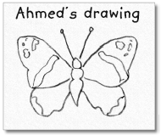
Feature: body wings
This feature of Ahmed’s butterfly is different because ..................................
........................................................................................................................
1 mark
(c) The children write conclusions about the butterflies.
Look at the butterflies and decide whether each conclusion is true, false or you cannot tell. Tick ONE box for each conclusion.

 | All of these butterflies... | True | False | Cannot  tell
 | have spots on their wings.
are eaten by the same
predators.
 | are the same age.
have antennae which are
longer than their bodies.
2 marks
(d) The number of butterflies in Britain is gradually getting smaller.
Tick TWO boxes to show what is likely to cause the number of butterflies to get smaller.
There are fewer butterflies because there are...
more houses being built on woodland or grassland.
more schools with wildlife areas.
fewer predators eating caterpillars and butterflies.
fewer plants which butterflies feed on being grown in gardens.
fewer diseases among the butterflies.
2 marks
Q4. Yeast
(a) Yeast is a type of micro-organism.
Class 6G know that bread needs yeast to rise.
The yeast must be mixed with water and sugar.
They want to find out if the temperature of the water affects the yeast.
They put sugar in a bottle and add water at a temperature of 20°C.
Name the scientific word that describes what happen to the sugar when it is mixed with water.
.................................................
1 mark
(b) The class then add yeast to the sugar and water in the bottle.
They put a balloon over They time how long it takes
the top of the bottle. for the balloon to stand up.
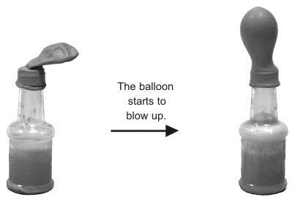
Write true or false next to each statement about the investigation.
True or false?
A gas is produced by the yeast. ..........................
A reversible change has happened. ..........................
The balloon is flexible. ..........................
1 mark
(c) The class repeat the test using water at different temperatures.
The teacher adds the same amount of yeast, sugar and water each time.
The table below shows their results.

Temperature of water  (ºC) | 3 | 20 | 30 | 50
Time taken for balloon to stand up (mins) | 52 | 18 | 16 | 4
Describe how the temperature of the water affects the time taken for the balloon to stand up.
.......................................................................................................................
.......................................................................................................................
2 marks
(d) A cook book says that yeast works most quickly with water at a temperature of 20ºC to 30ºC.
(i) Tick ONE box to show if the results in the table support the information in the cook book.
yes no
(ii) Use examples from the results table to help you explain your answer.
..............................................................................................................
..............................................................................................................
1 mark

Q5 Space station
(a) Class 6F has been watching a programme about the International Space Station.
Astronauts live in the space station for many months. Each day they spend two hours on exercise machines.
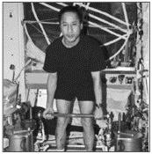
(This photograph has been reproduced by kind permission of NASA.)
Why do astronauts need to exercise while they are in the space station?
..............................................................................................................
1 mark
(b) The astronauts are not allowed to eat bread or crackers because the crumbs float around the space station.
On Earth, crumbs fall down.
Why do crumbs fall down to the ground on Earth?
Write about a force in your answer.
..............................................................................................................
..............................................................................................................
1 mark
(c) Food that astronauts take into space has been dried to remove air and
water. This stops micro-organisms growing on the food.
Write true or false next to each statement about their food.
Dried food is better than fresh food to take into space
because it... True or false?
weighs more. ......................
decays more slowly. ......................
1 mark
(d) The astronauts investigate plants in the space station.
The plants grow in a special jelly instead of soil.
The jelly contains the things plants need to grow.
What things from the jelly do the plants need to take in through the roots?
Tick ONE box.
water and light |  | nutrient and air
water and nutrients |  | air and water
1 mark
(e) The roots of plants take in some things the plants need to grow.
Describe another function of the roots.
..............................................................................................................
1 mark

Answers
Q1.
(a) Award TWO marks for correctly completing the key, e.g.
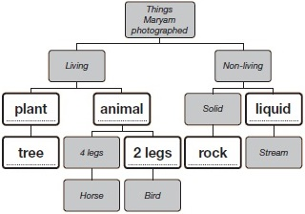
2
or
If you are unable to award TWO marks, award ONE mark for correctly completing any four or five boxes in the key.
Credit may be awarded for any acceptable groupings for the Living and Non-living things, e.g.
• Living: producer and consumer
• Non-living: (solid and) not a solid
• Non-living: (solid and) wet/runny.
Credit may be awarded for naming a specific type of tree/plant, e.g.
• oak.
Credit may be awarded for ‘stone’ used instead of ‘rock’.
Credit may be awarded for a specific type of rock, e.g.
• limestone.
Do not give credit for an insufficient answer, e.g.
• Non-living: (solid and) flowing [could also refer to gases]
• Non-living: (solid and) water.
1
(b) Award ONE mark for correctly classifying each reason in the table:

Reason | Yes or No?
to sort things into groups | yes
to show feeding relationships | no
to help identify things | yes
1
(c) Award ONE mark for correctly matching each animal skull to what the animal eats:
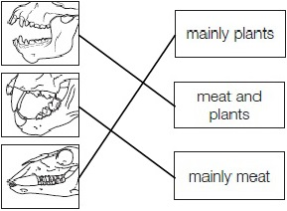
1
(d) Award ONE mark for:
• molar.
ONE mark may be awarded for:
• pre-molar.
Do not give credit for naming an incorrect tooth type, e.g.
• incisor/canine.
1
Q2.
(a) Award ONE mark for:
1
(b) (i) Award ONE mark for:
• webbed
• they are like paddles/flippers
ONE mark may be awarded for:
• they are wide (to push back the water)
Do not give credit for an insufficient response, for example:
• it helps them swim
• they are large/larger
• the feet are spread out
1
(ii) Award ONE mark for recognising the female duck’s colouration will mean it is camouflaged, for example:
• it is brown so the same colour as the nest
• brown so well camouflaged
• duller colours than male so better camouflaged
ONE mark may be awarded for:
• it is camouflaged
• she is the same colour as the nest
• she is not colourful so would blend in / not stand out
Do not give credit for an insufficient response, for example:
• the duck is brown
• it is hidden because it is brown [given that the duck is hidden and brown]
1
(iii) Award ONE mark for identifying that the duck needs to stay hidden so she or her eggs/ducklings are safe from predators, for example:
• to protect her eggs/ducklings/babies/young (allow chicks) from predators
• so she cannot be seen by predators/hunters
ONE mark may be awarded for:
• so her eggs/young don’t get eaten
• so she isn’t eaten/shot
• to protect her eggs/young
Do not give credit for an insufficient response, for example:
• she stays hidden [given]
• so she cannot be seen [unqualified]
1
(c) (i) Award ONE mark for one feature identified and a description of how it helps the mole to live underground:
• broad/wide legs; strong for digging
• front legs; look strong/have large muscles
• feet; are large and wide to push back soil
• (front) claws; for breaking up the soil/dirt
• sharp/long claws; for digging
• whiskers; for sensing prey/where they are going when underground
ONE mark may be awarded for:
• head/nose; it is pointed to move through the soil
• fur; smooth to move through the soil
• claws; for digging
ONE mark may be awarded for a feature of a mole that is not clearly observable from the picture and a description of how that feature helps the mole to live underground:
• tiny/invisible eyes; so dirt does not get in
• small hind limbs; so do not get in the way to move easily through the soil
Do not give credit for an insufficient response:
• claws; to live underground [given]
1
(ii) Award ONE mark for:
Do not give credit if more than one box is ticked.
1
Q3.
(a) Award ONE mark for a recognition that the features given
are insufficient to enable the butterfly to be identified or for
a suggestion of how the features should be used to identify
the butterflies:
• they all have feelers/antennae
• all butterflies have wings
• she has not said what shape the wings are.
ONE mark may be awarded for:
• they all have what she describes.
Do not give credit for an insufficient response that does not state why listing these features is not enough to identify the butterfly:
• it only tells about the feelers and wings.
Do not give credit for an insufficient response stating additional information is needed:
• she needs to describe it more.
1 (L3)
(b) Award ONE mark for a description of how the chosen feature
is different from that of a Common Blue:
• body
AND FOR BODY
This feature of Ahmed’s butterfly is different because...
• it is not long and thin/it is broad
• the body ends in a point
• the body is a different shape.
or
• wings
AND FOR WINGS
This feature of Ahmed’s butterfly is different because...
• it has patterns/spots
• the wings have a different pattern
• the wings are a different shape/its shape is different
• the Common Blue does not have spots.
ONE mark may be awarded for:
• body
AND FOR BODY
This feature of Ahmed’s butterfly is different because...
• it has not got a long tail.
ONE mark may be awarded where the body box is ticked, followed by a description of a feature of the wings, provided it is clearly stated that it is the wings being described:
This feature of Ahmed’s butterfly is different because...
• the wings have patterns.
ONE mark may be awarded where the wings box is ticked, followed by a description of a feature of the body, provided it is clearly stated that it is the body being described.
ONE mark may be awarded if neither box is ticked but the creditworthy response clearly states if either a feature of the body or the wings is being described.
Do not give credit for an insufficient response:
• it does (not) have a tail
• the body and wings are different.
Do not give credit for an insufficient response referring to the number of body segments:
• it is/is not in three parts.
Do not give credit for an insufficient response giving a feature of the body/wings of the Common Blue butterfly [unless it is made clear that the feature relates to the Common Blue]:
• the body is (long and) thin
• the wings do not have patterns.
Do not give credit for an insufficient response where body has been ticked followed by a response where a feature of the wings is described but ‘wings’ are not referred to explicitly in the answer:
• it has/they have different patterns.
1 (L4)
(c) Award TWO marks for correctly classifying all four conclusions:
All of these butterflies... | True | False | Cannot  tell
have spots on their wings.
are eaten by the same
predators.
are the same age.
have antennae which are
longer than their bodies.
2 (L4)
or If you are unable to award two marks, award ONE mark for
correctly classifying any three conclusions.
1
(d) Award TWO marks for both correct statements identified:
There are fewer butterflies because there are...
• | more houses being built on woodland or grassland.
• | fewer plants which butterflies feed on being grown in gardens.
2 (L4)
or If you are unable to award two marks, award ONE mark for
any one correct statement identified.
1
[6]
Q4.
(a) Award ONE mark for:
• dissolving
• dissolves.
• Give credit for a correct response that goes
beyond the key stage 2 programme of study:
• a solution
• it is a solute.
Do not give credit for an insufficient response:
• it sinks to the bottom
• mixing [given].
1(L3)
(b) Award ONE mark for classifying all three statements correctly:
A gas is produced by the yeast. True
A reversible change has happened. False
The balloon is flexible. True
1(L4)
(c) Award TWO marks for a general comparison describing the relationship
between the temperature of the water and the time taken for the balloon
to stand up:
• the higher the temperature, the less time it takes for the balloon to rise
• the lower the temperature, the longer it takes for the balloon to stand up.
2(L5)
or
If you are unable to award two marks, award ONE mark for two specific
comparisons describing the relationship:
• a high temperature took a short time and a low temperature took a long
time for the balloon to stand.
Award ONE mark for a single comparison of the variables:
• a hot temperature made the balloon stand up in a short time
• the balloon took a long time to stand up when the temperature was low.
Marks may be awarded for responses giving the relationship between the temperature of the water and the effect on the time taken for the balloon to stand up:
• the warmer the water, the quicker the balloon rises
• the hotter the water, the quicker gas was produced.
Do not give credit for a response that includes incorrect science suggesting that the yeast rises:
• the hotter the water the quicker the yeast rises.
Do not give credit for a response that includes incorrect science, changing one or both variables:
• the hotter the water, the smaller the balloon
• the hotter the water, the shorter time the balloon stays up for.
Award ONE mark for a single comparison of the variables:
• a hot temperature made the balloon stand up in a short time
• the balloon took a long time to stand up when the temperature was low
Do not give credit for an insufficient response that does not interpret the results:
• at 3°C it took 52 minutes, and at 50°C it took 4 minutes.
1
(d) Award ONE mark for:
• no
AND
a response explaining that the mixtures at 20ºC and 30ºC
did not cause the balloon to stand up most quickly:
• the balloon blew up more quickly at 50ºC
• the balloon blew up faster at a higher temperature than 20ºC or 30ºC
• it took longer for gas to be produced at 20ºC and 30ºC than at 50ºC.
Award ONE mark for:
• no
AND
a response indicating that the yeast works quickest at 50ºC or at a higher temperature than 20ºC or 30ºC:
• it works quickest at 50ºC
• at 30ºC it took 16 minutes but it only took 4 minutes at 50ºC.
ONE mark may be awarded if neither box is ticked but a creditworthy explanation indicates that the pupil believes the information from the cook book is not supported by the results of the investigation.
Do not give credit if the ‘yes’ box is ticked.
Do not give credit for an insufficient response that gives a continuous variable relationship between the time to stand up and the temperature of the water:
• the hotter the water, the quicker it takes to stand
[does not give examples from the results].
Do not give credit for an insufficient response that only restates the results in the table:
• I know this because it was 4 mins at 50°C,
18 mins at 20°C and 16 mins at 30°C.
Do not give credit for an insufficient response:
• it is easier at higher temperatures
[it is ambiguous as to what easier refers to]
• it is best at 50°C [best must be defined].
1(L5)
[5]
Q5.
(a) Award ONE mark for an indication that exercise improves/maintains
the fitness and/or the health of the astronauts:
• to exercise their muscles
• to keep them healthy/fit.
• Give credit for a correct response that goes beyond the key stage 2
programme of study:
• to maintain bone density/thickness
• to stop their bones going weak
• to stop them getting blood clots
• to improve their circulation/heart.
ONE mark may be awarded for:
• to keep/make their legs strong
• so they do not gain much weight/ fat
• so they do not become weak.
Do not give credit for an insufficient response:
• they are weightless
• there is no gravity (in space) [technically there is gravity in space and these responses do not explain why astronauts need to exercise]
• so they are ready to go into space
• so they are thin/they need to be thin
1(L4)
(b) Award ONE mark for an indication that gravitational attraction/
weight pulls the crumbs to the ground:
• gravity pulls the crumbs to the ground (on Earth)
• the pull of gravity is stronger than in space
• because the crumbs weigh more on Earth.
ONE mark may be awarded for:
• (because of) gravity/weight
• crumbs are pulled to the ground/Earth.
Do not give credit for a response that includes incorrect science:
• gravity pushes down on Earth.
Do not give credit for an insufficient response which is technically wrong:
• there is no gravity in space.
1(L4)
(c) Award ONE mark for both statements correctly classified:
Dried food is better than fresh food to take into space because it...
weighs more. False
decays more slowly. True
1(L5)
(d) Award ONE mark for:

• water and nutrients
1(L4)
(e) Award ONE mark for a response indicating that the root anchors
the plant in the soil:
• the roots anchor the plant
• they hold it in place.
ONE mark may be awarded for a response indicating a supporting function of the roots which may work in conjunction with the stem:
• they support/stabilise the plant
• they hold/keep the plant down/in place
• they make the plant stand straight/upright.
ONE mark may be awarded for a response indicating that the roots could store water:
• the roots can hold water for the plant when it is dry.
Do not give credit for a response that includes incorrect science:
• the roots take up food.
Do not give credit for an insufficient response indicating that roots absorb water/nutrients from the soil.
1(L4)

