Pamela Gillian wrote this poem about long distance swimming in a different kind of pool - a ‘sea-pool’. There are not very many of these around the country. They are ‘tidal’ pools which fill up with seawater at every high tide. When the tide goes down, the sun heats the water and makes an ideal swimming pool, without the dangers of waves or unexpected currents.
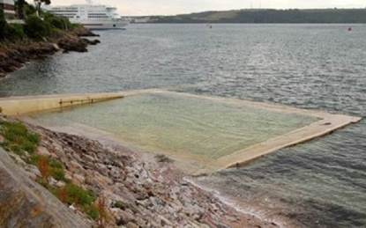
The half-mile
I was twelve when I swam the half-mile,
up and down the tide-fed cold concrete
pool, with a slow steady side-stroke.
My father counted the lengths,
at first from the deep-end board
and then, as I moved more laboriously,
pacing alongside, urging me on.
The race was only against myself
and distance. The grainy salt water,
though not translucent like the chlorinated
blue lidos of town, buoyed me helpfully,
lapped softly against the bath’s grey sides
variegated with embedded hardcore pebbles.
I swam from goal to alternate goal; he counted.
When he called enough I scrambled
over the sharp shutter-cast lip,
shuddered into a dry towel, drank
the words of praise. The planks
of the changing-room walls
were warm to touch. It had seemed to be
a great deal of swimming; still does.

1. Pamela Gillian describes the half-mile swim as being both a positive and a negative experience.
Identify and explain one positive and one negative phrase from the poem in the table below.

Positive experience | Negative experience
Phrase  ____________________________  ____________________________  Explanation  ____________________________  ____________________________  ____________________________  ____________________________  ____________________________ | Phrase  ____________________________  ____________________________  Explanation  ____________________________  ____________________________  ____________________________  ____________________________  ____________________________
2 marks
2. Find and copy one phrase in the poem which suggests that Pamela Gillian followed a rhythm when swimming.
______________________________________________________________
______________________________________________________________
1 mark
3. What do you find out about the father’s character from the poem?
Explain your answer, using evidence from the text.
______________________________________________________________
______________________________________________________________
______________________________________________________________
______________________________________________________________
______________________________________________________________
______________________________________________________________
______________________________________________________________
3 marks
4. Look at verse 2.
The grainy salt water,
though not translucent...
Give the meaning of the word translucent in this sentence.
______________________________________________________________
1 mark

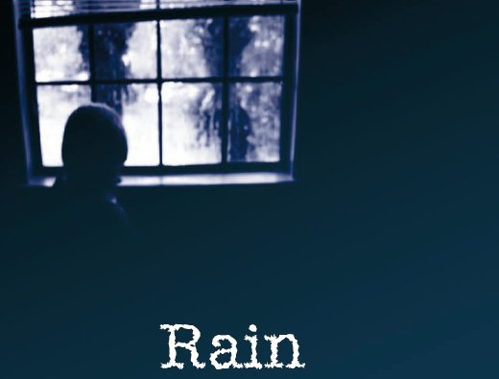
The lights are all on, though it’s past midday.
There are no more indoor games we can play.
No one can think of anything to say,
It rained all yesterday, it’s raining today.
It’s grey outside, inside me it’s grey.
I stare out of the window, fist under my chin,
The gutter leaks drips on the lid of the dustbin,
When they say ‘cheer up’, I manage a grin,
I draw a fish on the glass with a sail-sized fin,
It’s sodden outside, and I’m damp within.
Matches, bubbles and papers pour into the drains,
Clouds smother the sad laments from the trains,
Grandad says it brings on his rheumatic pains,
The moisture’s got right inside of my brains,
It’s raining outside, inside me it rains.
by Brian Lee
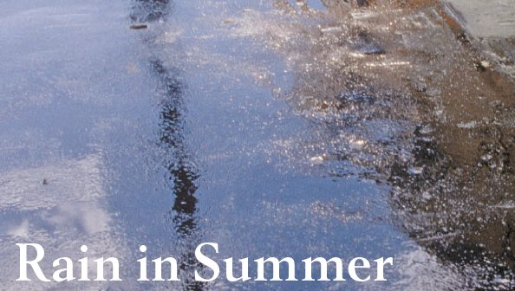
How beautiful is the rain!
After the dust and heat,
In the broad and fiery street,
In the narrow lane,
How beautiful is the rain!
How it clatters along the roofs,
Like the tramp of hoofs!
How it gushes and struggles out
From the throat of the overﬂowing spout!
Across the window pane
It pours and pours;
And swift and wide,
With a muddy tide,
Like a river down the gutter it roars
The rain, the welcome rain!
by Henry Wadsworth Longfellow

1. Tick two bad effects of the rain in the first poem.

Tick two.
keeps you indoors
water falls on the dustbin
dulls your imagination
your hair gets wet
the air cools down
1 mark
2. What did the poet do while it was raining?
Write down two things.
1. ______________________________________________
2. ______________________________________________
2 marks
These questions are about the poem Rain in Summer.
3. Why is the rain described as beautiful?
___________________________________________________________________
___________________________________________________________________
1 mark
4. What do the words clatters and tramp of hoofs tell you about the rain?
___________________________________________________________________
___________________________________________________________________
1 mark

5. What is the main purpose of the second verse of the poem?

Tick one.
to create a picture of the way rain moves
to show how rain can work with heat
to make the reader feel miserable
to show the effect of rain on people’s lives
1 mark

Mark schemes
Poem 1

1.
Positive experience | Negative experience
Phrase - Acceptable points:  1. (with a slow) steady (side stroke)  2. urging me on  3. (the race was) only against myself  (and the distance)  4. (the grainy salt water) buoyed me  (helpfully)  5. lapped softly  6. (I swam from) goal to alternate goal  7. (shuddered) into a dry towel  8. (drank the words of) praise  9. (changing-room walls were) warm  (to touch)  10. (It had seemed to be) a great deal  of swimming(; still does). | Phrase - Acceptable points:  11. up and down  12. (the tide-fed) cold / concrete (pool)  13. (as I moved more) laboriously  14. urging me on  15. (the race was) only against myself  (and distance)  16. not translucent  17. (I swam from) goal to alternate goal  18. scrambled  19. (the) sharp (shutter-cast lip)  20. shuddered (into a dry towel)  21. (It had seemed to be) a great deal of  swimming(; still does).
Explanation  Accept any reasonable explanation of the phrase given, eg:  • shows she is calm [B1]  • her dad helped her to keep up the good  work and not to stop [B2]  • because she had it all to herself and not  racing other people and not distracted  by other people [B3]  • helped her float which was handy for  swimming [B4]  • there weren’t too many waves and it was  nice to swim in that [B5]  • she’s proud of herself for doing a lot of  laps and it’s an achievement [B6]  • it shows it was nice to get a dry towel  because she had been cold and wet [B7]  • she was happy that her father praised  her and she remembered them [B8]  • it was a pleasant contrast from the very  cold water [B9]  • that even though it was a lot she  remembers it and is proud that she did  it [B10]. | Explanation  Accept any reasonable explanation of the phrase given, eg:  • it’s boring and repetitive [B11]  • as it was cold it would be hard to get  used to and it would take your breath  away for a bit due to how cold it was [B12]  • she was tired and had to move slower  because it drained her [B13]  • her father was making her carry on  swimming [B14]  • she had to fight against herself which is  mostly quite hard; and you want to stop  but you know you shouldn’t [B15]  • suggests that the water is dirty, salty,  murky and not pleasant to swim in than  a swimming pool [B16]  • it seemed to go on and on and on [B17]  • glad to be out and really not wanting to  do it again, quickly getting over and in a  big rush to get out [B18]  • it will be sharp and it may cut you [B19]  • she got badly cold and shivering [B20]  • it must have been very hard to swim that  much [B21].
Award 2 marks for identifying and explaining both a positive and a negative phrase.
Award 1 mark for identifying and explaining a positive or a negative phrase.
Do not accept:
• explanations using general words that paraphrase positive / negative in the question
(eg nice / horrible) without further development.
Up to 2 marks
2. Award 1 mark for either of the following:
1. (with a slow) steady side-stroke
2. (I swam from) goal to alternate goal.
Accept quotations that add ‘and’ before ‘steady’.
1 mark
3. Acceptable points:
1. supportive / helpful
2. encouraging
3. proud
4. patient
5. committed
6. pushy / determined for her to win
7. unsympathetic.
Award 3 marks for reference to three of the acceptable points together with evidence from the text to support each point, eg:
• I think he was quite helpful, as it says ‘my father counted the lengths’. I think he’s determined for his child to win because ‘he was pacing along the side, urging me on’. I think he was encouraging because it says; drank words of praise’ which shows he congratulates her. [B1 + B6 + B2 with evidence for each]
Award 2 marks for reference to two of the acceptable points together with evidence from the text to support each point, eg:
• you find out that he was a very supportive dad as he was counting all of the lengths, first from the deep-end board and then he was pacing along side her, urging her on. From the text you could also hear he was proud of her as she said ‘As I drank the words of praise’. [B1 and B3 with evidence for both]
Award 1 mark for reference to one of the acceptable points together with evidence from the text, eg:
• the father seems to be very competitive because ‘he was pacing alongside, urging me on’. He wants his child to do well at all costs. [B6 + evidence].
Also award 1 mark for simple reference to more than one of the acceptable points without evidence from the text, eg:
• you find out the father is a very encouraging person and has all the confidence in his daughter. He believes in her and is very proud of her. [B2 + B3, no evidence]
Accept the same evidence for more than one acceptable point, if appropriate.
Up to 3 marks
4. Award 1 mark for answers that recognise it as allowing light to pass through but not clearly defined objects eg:
• you can see through it but a but blurred
• semi-transparent
1 mark

Poem 2

1. Award 1 mark if both correct answers are ticked.

keeps you indoors
water falls on the dustbin
dulls your imagination
your hair gets wet
the air cools down
1 mark
2. Award 1 mark each for any two activities taken from the poem, up to a maximum of 2 marks:
• plays games
• draws a fish
• looks out of window / watches the rain (with his fist under his chin)
• just sits there
• stays inside
• talks to grandad
• manages a grin / puts fist under chin.
Do not accept:
• he wrote a poem.
up to 2 marks
3. Award 1 mark for an understanding that the rain is a relief, eg:
• it has been hot / dusty
• it cools everything down
• it’s refreshing
• there has been no rain for such a long time.
1 mark
4. Award 1 mark for answers which refer to the force or volume of the rain, eg:
• the rain is loud / heavy / hard
• it’s hitting the roofs.
1 mark
5. Award 1 mark if the correct answer is ticked.

to create a picture of the way rain moves
to show how rain can work with heat
to make the reader feel miserable
to show the effect of rain on people’s lives
1 mark

