Year 3 Homework w/c 27th April
Hi everyone,
I hope you are all doing well and have managed to get back into the swing of home learning. It was lovely to speak to some of the parents over the phone last week. I will be contacting the rest of you this week! As always, if you have any questions at all, please don’t hesitate to contact me.
Numeracy
Monday
Please start off with a recap activity on Purple Mash – Time Conversions. Today, you are going to be focused on converting times from 12-hour to 24-hour clock and visa versa. An easy way to remember this to add/subtract 12 from the hour digit.
This video is a recap on AM and PM.
https://www.youtube.com/watch?v=xrwQIYmoYhs
Move onto ‘Monday resources’ with some fluency, reasoning and problem solving.
Tuesday
You are going to be using your Time knowledge to answer some ‘Time Problems’ using the relevant 2Do. Throughout the week, please continue practising telling the time to the nearest minute, if you can. If you are finding this a bit tricky, first work on o’clock, then move onto half past, quarter past and quarter to. Then start reading the time to the nearest 5 minutes. Some of you may want to do some extra practise of your 5 times tables to help you do this.
Wednesday
Today I would like you to work on your times tables. Please complete your daddy grid then show your parents after. You do not need to be timed today – have as long as you need to complete it. Once your parents have seen your scores, they will be able to tell you which times tables you should be focusing on for your daily times table practice. If you have achieved a score of 144, feel free to move up to your 13, 14 and 15 times tables!
Based on your previous daddy grid scores, I have set some multiplication activities on PurpleMash for you to do. After you have completed them, please complete some ‘Monster Multiplication’.

Thursday
We are going to be recapping some place value activities. Place value is one of the most important maths topics, as it helps you in many other topics, for example addition and subtraction. Please complete the 2Dos assigned to you.

Friday
Complete the Odd and Even 2Do assigned to you to refresh your memory of odd and even numbers. Then complete the Place Value 2Dos on comparing and ordering numbers.
Literacy
This week, you will be conducting some research on a famous scientist and presenting this using a non-chronological report. We have already written a non-chronological report in school on different sea creatures so you should be familiar with the structure and features. As a recap, you will start off by using a non-chronological report on Australian Animals to help you with the Monday and Tuesday activities.
Monday
Please complete the reading comprehension on the non-chronological report ‘Australian Animals’. There is an extension sheet on using a dictionary to look up the definition of words – complete this is you can/want to!
Tuesday
Today you are going to be using the Australian Animals text to decipher the definitions of some tricky vocabulary using the Tuesday resources sheet. Read through Monday’s text to help you with this task.

Wednesday
Today you are going to start researching the famous scientist Mary Anning. This video is brilliant and would be a good starting point.
https://www.bbc.co.uk/teach/class-clips-video/true-stories-mary-anning/zn7gd6f
Remember, to make sure you are using the internet safely. You should use https://www.alarms.org/kidrex/ website to complete your child-friendly searches. Here are some good websites:
- https://www.natgeokids.com/uk/discover/history/general-history/mary-anning-facts/
- https://www.bbc.co.uk/bitesize/topics/zd8fv9q/articles/zf6vb82
When researching, think about what you want your subheadings and therefore paragraphs to be about. Some ideas for sub-headings could be:
- Mary Anning’s Childhood
- Amazing Discoveries
- Fun Fact/Did you know?
- Pterosaur (or another dinosaur that she found the fossil of)
- Mary Anning’s shop
Thursday & Friday
Over the next two days you will be creating your non-chronological report. Don’t forget to include all key features (see below).
Please take a photograph of it (if completed on paper) and email it across to me. I can’t wait to see it! If you need any help at all when completing this, please pop me an email.
Non-chronological report features
- Title
- The information is structured in relevant paragraphs
- Sub-headings
- Photo/Picture
- Caption
- Written in the third person (using pronouns such as she/her/their)
- Technical language (you can include a glossary as a challenge!)
Here is a word mat you could use. Make you vocabulary as interesting as possible!
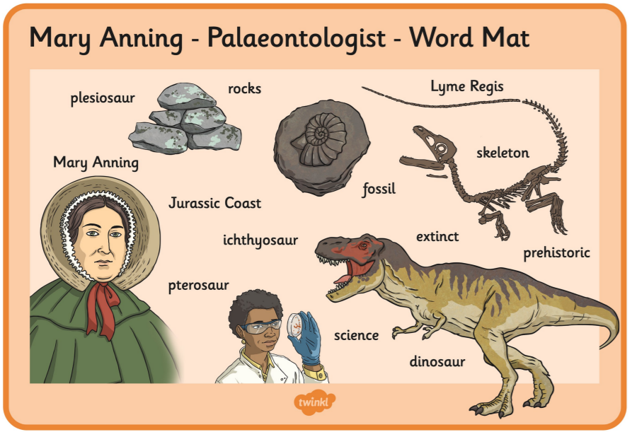

Science and Foundation Subjects
For your additional projects this week, please look at the resource ‘Science and foundation subject activities’. Please choose 2 activities to complete this week. You will be choosing another 2 activities from this sheet for next week too!

Spelling
Mrs Richardson and Mrs Parnell have been busy making some extra resources for their spelling groups. Please find these attached. If you are unsure of what group you are in, please make sure you email me. (Mrs Parnell’s special spellers are the children who work on their common exception words every morning on a normal school day).

As always, if you have any questions/concerns at all, please give me an email on:
g.brennan@henhamugley.essex.sch.uk

