Year 3 Homework w/c 20th April

Hi parents and children!
I hope you all had a fantastic Easter holiday and enjoyed the glorious sunshine! We are back to home schooling again this week so here is your planning. Just to be clear on the expectations for home learning. I am providing daily literacy and numeracy lessons, which I check have been completed. If they are not, I reset the 2Dos on Purple Mash. There will also be an additional project to complete throughout the week – this week is creating your own life timeline! Alongside this, please continue with your daily reading, spelling and times table practice as well as completing the science activity.
Feel free to email me your work if you would like any feedback or if you have any requests or questions. I hope to see you all soon – miss you lots!
Numeracy
This week, we are going to start on the topic ‘Time’. This is a great topic to be learning at home as you can ask lots of different questions throughout the day! For example:
- What is the time now?
- What will the time be in 30minutes/1 hour etc?
- If dinner is at 7pm – how long do we have to wait until then?
- If you start playing on your iPad at 3.30 for 45 minutes – what time do you need to stop?
Looking for an extra challenge? I have uploaded some Time Mastery Challenges for you to have a go at!
Monday – using a calendar
Look at the calendar (1 2020 calendar on resources) – print it off if you can! Then answer the questions using the Monday resources. There are some Fluency questions and for an extra challenge complete the Problem Solving and Reasoning questions.
Tuesday
Begin by playing the calendar game on: https://mathsframe.co.uk/en/resources/resource/261/using-a-calendar
Select level 1. Locate information on a calendar, then dd/mm/yyyy.
Then complete the Purple Mash activities assign to you:
- Years and Months
- AM & PM

Wednesday
Begin by playing a different calendar game using: https://mathsframe.co.uk/en/resources/resource/261/using-a-calendar
Select level 2. Use a calendar to calculate time intervals (this month), then dd/mm/yyyy. For some trickier questions – have a go at level 3!
You will be creating a daily timetable. Please include at least 6 different activities, including your start and end times (where necessary). For example:
Activity | Start time (am/pm) | End time | Duration
Wake up | 7.30 am | - | -
Eat breakfast | 8.00am | 8.30am | 30 mins
School work | 9.00am | 11.30am | 1 hour 30 mins
Watch TV | 11.30am | 12.00pm | 30 mins
Eat lunch | 12.00pm | 12.45pm | 45 mins
Exercise | 12.45pm | 1.30pm | 45 mins
Reading | 1.30pm | 1.50pm | 20 mins

You could present this as a table (as above), through drawings of you completing your activities (with timings) or using the Purple Mash program.

Thursday
Today you are going to be making your own clock! I understand that resources may be limited at home so this is your time to get creative! You could use an old cereal box or a paper plate. Don’t forget to include the numbers 1-12 and the minutes (0-55) and to ensure that the minute and hour hands are different sizes. You could also add in the 24 hour numbers (13-00). Ask an adult at home to test you reading and making different times.
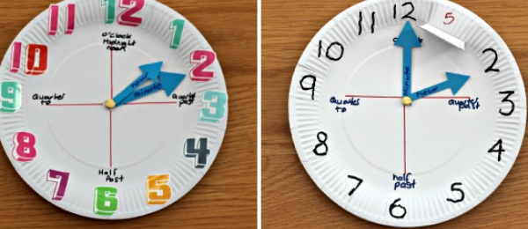
Friday – Telling the time
By the end of Year 3, you are expected to be able to tell the time to the nearest minute i.e. 22 past 4, 25 to 7. Please complete the 3 Purple Mash activities assigned to you.

Literacy
This week you will be using a book of your choice to complete your writing tasks. You can either use a book from home, a school book or an online book. This website gives you access to some free online books:
https://www.oxfordowl.co.uk/for-home/find-a-book/library-page/#
If you are on a reading band, then you have taken 2 or 3 school books home with you. You need to select a book that you know well, have recently read, or one that you can read this week.

Monday
You are going to start by playing a game to help you recap some of the different word classes and grammar rules we have learned so far in Year 3. Please follow this link then click on the first game, ‘Grammar Word Types’.
http://www.crickweb.co.uk/ks2literacy.html
Next, complete the Purple Mash activity - Word Classes. Please select the Monster Munch level and make a list of at least 5 nouns, verbs, adjectives and adverbs from your own reading book.
Tuesday
You are going to be going on a grammar hunt using your reading book! Start off by watching the short videos on fronted adverbials, then complete the short quiz below on the same page:
https://www.bbc.co.uk/bitesize/topics/zwwp8mn/articles/zp937p3
Complete the same for a recap on expanded noun phrases:
https://www.bbc.co.uk/bitesize/topics/zwwp8mn/articles/z3nfw6f
Then, please complete the Purple Mash activity – Book Review: Grammar Analysis. Please fill in the table using your reading book. Can you find:
- Fronted adverbials for a place/time? For example: Afterwards, Later, Outside, In the wooden box,
- Expanded noun phrases?
- Powerful verbs? i.e. not a boring one (said, walk, run)
- ‘How’ fronted adverbials in the sentence? For example: Carefully, Happily, Quickly,
- Direct speech?
When you have found all of these things (3 examples of each), please copy them into the Purple Mash document so that I can see them.
Wednesday
Today, you are going to be creating a comic strip retelling your book! Remember to add in all of the key events. In each section, you are able to either draw your scene or use this button 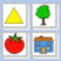 to add in pictures. You will be retelling the story through speech, using speech bubbles. You do not need to use speech punctuation for this.

Thursday
Now that you have a great understanding of the book, you are going to be using your inference skills to get into character! Choose your favourite character from the book and imagine that you are interviewing them. What would you ask them? What do you think they would reply? Remember to link this to the story. For example:
Question: Thor, how did you feel you found out that the giant had used magic to trick you?
Thor: I feel appalled! He only did it because he was fearful of my strength! I can’t wait to get the chance to defeat him properly.

Friday
To finish off the week, you are going to be writing a book review on your book. You need to write a brief summary of the story but remember to not give the ending away! In the section ‘My Thoughts About The Story’, think about:
- What type of book it is – fiction/non-fiction/adventure/mystery.
- Did you like the characters? Who was your favourite?
- What you like/dislike about the story.
- Who you would recommend the story to? Why?

Project
As part of the history curriculum in Year 3, children are expected to ‘describe memories of key events in his/her life’. Therefore, the children are going to create a timeline of their own lives. This is a great opportunity to get creative, have a look through family photos and have interesting discussions with your family! I have attached a copy of the timeline that I created for my life (Mrs B’s timeline) as an example. I have attached an empty template for you to use if you so wish – but please feel free to use something different as the template is a bit fiddly. I can’t wait to see what you produce!

Spellings
I hope you are still managing to work through your ‘Year 3 & 4 Common Exception words’ list. Here are some more spellings rules for you to focus on. Please do 10-15 minutes of spelling every day. If you are unsure of what group you are in, please feel free to email me!
Special Spellers – continue working through your common exception words (this may be Yr 1 or Yr 2 too!). If you want an extra challenge move onto Mrs B’s spelling group work.
The suffix -ous
Poisonous
Dangerous
Furious

Famous
Nervous
Mountainous
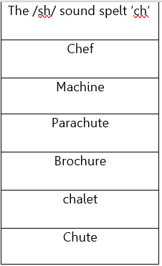
Mrs B’s group – work through the spelling rules below. There will also be Purple Mash activities assigned to you for each rule.
The /k/ sound spelt ‘ch’
Ache
Chorus
Stomach
Echo
Character
Chemist

Online games:
- https://www.spellzone.com/word_lists/games-13192.htm
- https://www.spellzone.com/word_lists/games-105.htm
- https://www.spellzone.com/word_lists/list-13410.htm
Mrs Parnell’s group - work through the spelling rules below. There will also be Purple Mash activities assigned to you for each rule.
The suffix -ous
Poisonous
Dangerous
Furious

Famous
Nervous
Mountainous
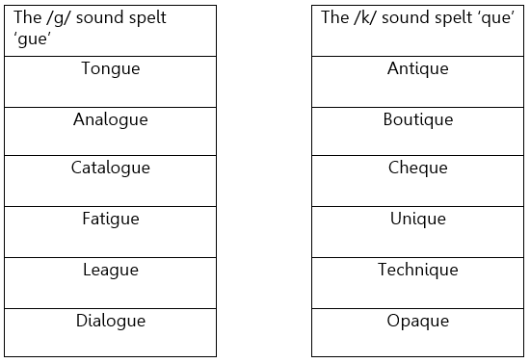

Online games:
- https://www.spellzone.com/word_lists/games-192313.htm
- https://www.spellzone.com/word_lists/list-13410.htm

Science
Last half term, the children began their ‘Rocks and Soils’ topic. Continuing with this, the children are going to be learning about fossilisation. Please begin by watching the following video and then completing the short quiz on the same page:
https://www.bbc.co.uk/bitesize/topics/z9bbkqt/articles/z2ym2p3
This video is also very informative:
https://www.nhm.ac.uk/discover/how-are-fossils-formed.html
Next, test your knowledge using the Fossil Quiz assigned to you on Purple Mash.
As an extension, why not create a Fossil Fact file or leaflet to present your findings?

