Please choose 2 activities to complete each week
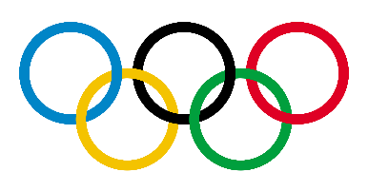  History  Research where the Olympic Games came from. What different events did they have?  Use the Purple Mash activity ‘Olympic History Comparison1’ to do this.  Extension: could you place a dot on a map of the world to show all the different countries the Olympic Games have been in? | 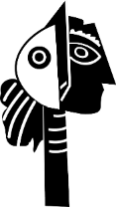  Art  Plan your very own sculpture. You will need to think about what you want to sculpt and the materials that you will use. I would love to see your planning which could include sketches of your design.  Can you make your sculpture? You can be really creative using items from home like playdoh, Kinex, Meccano or Lego. Perhaps you could find other materials such as items from your recycling or even wood if someone can help put it together safely. | 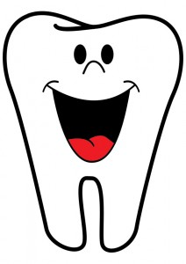  Science – Dental Hygiene  Complete some research on why we brush our teeth and what would happen if we didn’t keep our teeth and gums healthy. You could watch this video as a start:  https://www.youtube.com/watch?v=aOebfGGcjVw  Create a leaflet to give people tips and advice on how to take care of their teeth. You can use the ‘Healthy Teeth’ activity on Purple Mash to do this.
Design and Technology  Plan your family’s meals, drinks and snacks for a day. You will need to make sure you think about how to ensure that you are having a having a health balanced diet.  Display what food you will eat in a fun way to show us what you have chosen to eat.  Can you identify which foods are seasonal? Are there advantages to eating seasonal local food? If so tell us what they are.  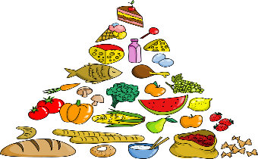  This Photo by Unknown Author is licensed under CC BY | Physical Education  Even though we are in lock down most of us are allowed out once a day to exercise.  Explain why is exercise so important for our physical and our mental health?  Design an exercise routine you can do at home. Perhaps you could do circuits such as skipping, jogging on the spot, step ups on bottom step of your stairs… | Geography  Draw a map with a key.  The more accurate the better.  Perhaps you could do a map of your garden or of the route you take for your daily exercise.  If you can’t get out at the moment can you draw a treasure map from your imagination? If you play a game like Minecraft can you create a map using that?  